NAME____________________________________CLASS: _______

SECOND TERM E-LEARNING NOTES
JS 3 (BASIC 9)
SUBJECT: COMPUTER SCIENCE

SCHEME OF WORK
WEEK TOPIC
1 Revision of First term work
2. Spreadsheet Packages:
First Period: (a) Meaning (b) Examples of spreadsheet package: (i) Excel (ii) LOTUS 1,2,3 (iii) Statview etc.
Second Period: (b) Uses of spreadsheet packages: (i) preparation of daily sales (ii) Budget
(iii) Examination result, etc.
3. Spreadsheet packages cont.
First & second
period: (a) Spreadsheet features and terminologies (i) Row (ii) Column (iii)) Cell
(iv) Worksheet (v) Chart (vi) Data range etc.
(b) Loading and exiting spreadsheet packages.
4. Worksheets
First Period: (a) Starting Excel worksheet: i.e. (i) opening a worksheet (ii) Data entry (iii) Editing (iv) saving (v) Retrieving worksheet
Second Period: (b) Formatting worksheet, i.e. (text, cell and column, naming, etc)
5. Worksheets cont.
First period: (c) Excel calculations: (i) Addition (ii) Subtraction (iii) Average (iv) Counting (v) Multiplication (vi) Division, etc
Second: (d) Printing of worksheets
6. Practical on excel calculation.
7. Graphs:
First period: (a) Creating Graphs. (i) Line graph (ii) Histograms (iii) Pie-charts (iv) Legends, etc.
Second Period: (b) Editing graphs
8. Graphs cont.
F & S period: (c) Formatting graphs: (i) Line graph (ii) Histograms (iii) Pie-charts (iv) Legends
9. Practical on Excel graphs.

10. Revision

WEEK 1. Revision of First term work
WEEK 2
TOPIC: SPREADSHEET PACKAGES I
Content: - Meaning and Definition of Spreadsheet Package
- USES OF SPREADSHEET PACKAGES

Sub-Topic 1: Meaning and Definition of Spreadsheet Package
A Package can be defined as software written to perform a particular task. Therefore, a Spreadsheet Package is a program that enables the computer user to carry out calculation-related tasks. Spreadsheets are majorly used for organizing and analyzing numeric data. They were designed to replace the pencil, calculator and the writing pad.
It is widely used in diverse range of discipline like Engineering, Mathematics, Science, Accounting, etc.

Examples of Spreadsheet Package.
- Lotus 1-2-3
- Microsoft Excel
- STATVIEW
- Quattro pro
- Easy Calc
- GS-Calc
- Super-Calc
- Visical

NOTE: For the purpose of this lesson, our focus shall be on Microsoft Excel because it is user-friendly, flexible and contains more advanced features.

Sub-topic 2:

USES OF SPREADSHEET PACKAGES
- For Statistical analysis
- For Mathematical purposes
- Regression analysis
- Budget management and control
- Preparation of daily sales report
- Stock / Inventory control analysis
- Preparation of examination results
- Accounting purpose
- Financial projection and analysis
- Preparation of Payroll, etc

EVALUATION:
1. What do you understand by Spreadsheet Package?
2. (a) Give FIVE examples of Spreadsheet Package
(b) State SEVEN uses of Spreadsheet Package

WEEKEND ASSIGNMENT
1. ............................. is a package that is majorly used for organizing and analyzing numeric data.
(a) Word-processing (b) Graphics (c) Spreadsheet (d) Mavis Beacon
2. Which of the following is NOT an example of spreadsheet package?
(a) MS Excel (b) GS-Calc (c) Adobe PageMaker (d) STATVEIW
3. Which of the following is a major function of spreadsheet packages?
(a) for financial projection and analysis (b) for compiling the names of staff in an organisation (c) for preparing official documents (d) for artistic display
4. The Spreadsheet package is referred to as a/an ................................. program
(a) System (b) Application (c) Calculation (d) Analysis

WEEK 3
TOPIC: SPREADSHEET PACKAGES II
CONTENT: - Spreadsheet Features and Terminologies
- Loading and Exiting Spreadsheet Packages
Sub-Topic 1:
Spreadsheet Features and Terminologies
To fully understand and use a spreadsheet package, one must be used to some terminologies. These terminologies include;
- Row
- Column
- Cell
- Active Cell
- Worksheets
- Workbook
- Chart
- Data Range
- Fill handle
- Moving border

ROWS:
A Row is a horizontal line of cells which runs from left to right in a worksheet. They can be identified by the numbers at the left hand side of the sheet numbered from 1 to 1,048,576

COLUMNS:
A Column is a vertical line of cells in a worksheet usually identified by letters across the top of the sheet. There are about 16,384 columns in Excel 2007.

CELL:
A Cell is the intersection of a row and a column. The highlighted rectangle on the cell is the cursor but is known as ‘cell pointer’ which enable users to move around the sheet. They can be identified by the combination of column header (e.g ‘A’) and the row header (e.g ‘1’) to give cell A1.

ACTIVE CELL:
The active cell is the cell that contains the cell pointer, while the active worksheet is the worksheet where the cell pointer is currently located.

WORKSHEET:
The worksheet (also known as spreadsheet) is the working area of the package where entering of data and calculations are handled. It consists of rows, columns, cells and a cell pointer where data are actually entered and manipulated.

WORKBOOK:
This can be simply defined as a collection of worksheets. Each workbook contains many worksheets just like a normal single book with a number of pages.

CHART:
A Chart is a graphical representation of data that enables you to understand the data at a glance. Examples of Charts includes Column (histogram), Pie chart, Bar Chart, Line Chart, Surface, Doughnut, etc.

DATA RANGE:
A group of highlighted cells in a worksheet is referred to as a Range.

FILL HANDLE:
This is a small black square at the corner of selected cells. The cursor changes to a black cross when moved to it.

MOVING BORDER:
This is an animated border that appears around a selected cell that has been cut or copied. Press the ESC key to cancel a moving border.
The features of a typical Microsoft environment is presented below;
Ribbon Bar
Title Bar
Menu Bar

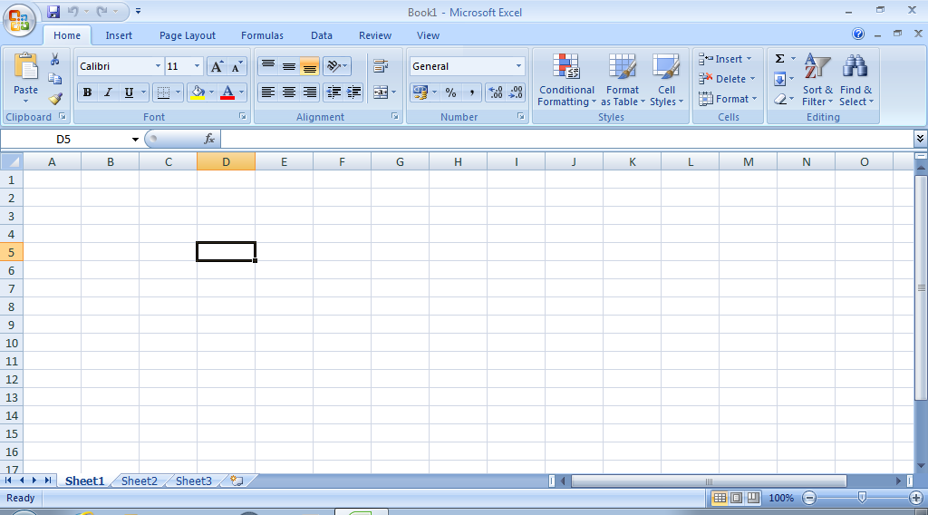
Cell Pointer
Office Button
Name Box
Active Cell
Row number
Horizontal Scrollbar
Vertical Scrollbar
Column letter Bar
Formula Bar
Sheet Tab
Status Bar

NOTE: Educators should please ensure that the Excel environment is carefully treated with the participation of the students.

Sub-topic 2:
LOADING AND EXITING SPREADSHEET PACKAGES
Loading the Spreadsheet Package
To load a spreadsheet package, take the following steps:
- Click on the START button
- Point to ALL PROGRAMS
- Point to Microsoft Office
- Click on Microsoft Excel
METHOD II
Double-click the Microsoft Excel icon on the desktop. The spreadsheet package opens. The active cell is cell A1 and the active worksheet is sheet1.

Exiting the Spreadsheet package
To exit a spreadsheet package, take any of the following steps:
- Click on the File menu and select Exit.
- Click on the Close button on the title bar
- Press ALT+F4.

EVALUATION:
1. Briefly explain the following terminologies:
(i) Row (ii) Column (iii) Cell (v) Workbook (vi) Data Range
2. Highlight the steps required to load and exit Microsoft Excel

WEEKEND ASSIGNMENT:
1. Which of the following is NOT a spreadsheet terminology?
(a) Fields (b) Cell (c) Workbook (d) Moving border
2. Which of the following key combinations can be used to exit a spreadsheet package?
(a) CTRL+F4 (b) Pgdn+F4 (c) DEL+F4 (d) ALT+F4
3. In Spreadsheet package, a group of highlighted cells in a worksheet is referred to as a .............
(a) Limit (b) Range (c) Boundary (d) worksheet
4. To cancel a moving border, simply press the ....................... key
(a) TAB (b) END (c) ALT (d) ESC
5. ................ is a graphical representation of data that enables you to understand the data at a glance. (a) Row (b) Active cell (c) Chart (d) Column
6. ............... is a small black square at the corner of selected cells.
(a) Cell pointer (b) Fill handle (c) Border (d) Marker

WEEK 4
TOPIC: WORKSHEET I
Sub-Topic 1: Definition of a Worksheet:
A Worksheet can be defined as the working area of the program where entering of data and calculations are handled. It consists of rows, columns, cells and a cell pointer.

Starting Excel worksheet: This entails the following
(i) opening a worksheet (ii) Data entry (iii) Editing (iv) saving (v) Retrieving worksheet

Opening a worksheet:
To create a new worksheet, follow the steps below:
- Open Microsoft Excel from the Start button
- Click on Office button to display a sub menu
- Select New
- Click on Create
- A new workbook will be displayed.

Method II:
- Open Microsoft Excel
- Press Ctrl + N

Data Entry:
There are three types of data that can be entered into an excel worksheet. These are Labels, Numbers and Formula.

Labels are made up of texts that are entered into the active worksheet. Examples are letters of alphabets (A-Z)

Numbers / values consists of numerals 0 – 9

Formulas are mathematical expressions which return calculated value.
A typical example of data entry is shown below;

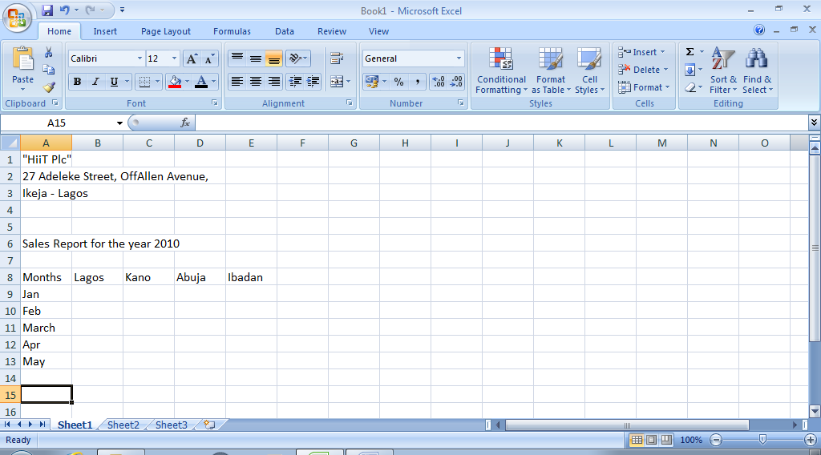

Fig. 4.1: Entering data into the worksheet.

NOTE: Educators should please ensure that students practise the act of entering data into the worksheet by entering the data shown in fig. 4.1 above.

Editing the Worksheet
Editing a worksheet means to either insert data, delete existing ones or to make corrections to the already existing data. Fig. 4.2 below shows the edited version of fig. 4.1

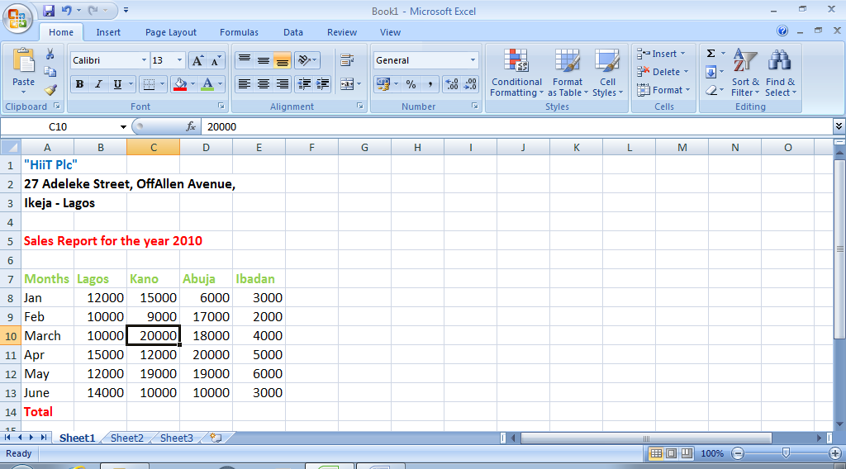
Fig. 4.2: Editing Worksheet
NOTE: Educators should please ensure that the students edit the previous excel sheet (fig 4.1) to give the excel sheet shown above (fig 4.2)

Saving a Worksheet
To save a worksheet for the first time, follow the steps below;
- Click on the Microsoft office Button
- Click on Save
- When the dialog box appears, in the save in box click on the arrow, a drop down menu appears.
- Select a location to save e.g My Document
- Type a file name in the File name box.
- Click on Save
Save in Box Arrow for Drop Down

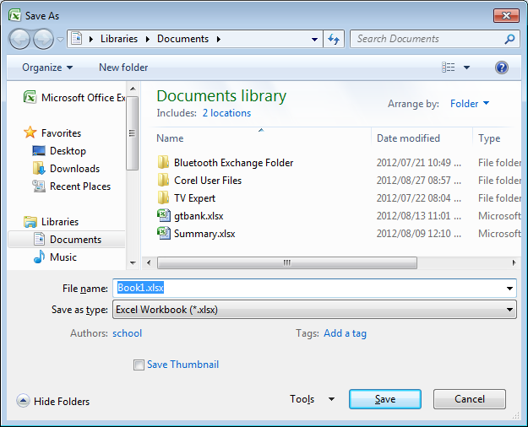
File Name Box Save Button
Fig 4.3: Save As Dialog Box
Subsequently, just press ctrl + S to continue saving the worksheet.

NOTE: Educators should please show the students other methods of saving a worksheet

Retrieving a Worksheet
To retrieve an existing or saved worksheet, follow the steps below;
- Load the spreadsheet package (Microsoft Excel in this case)
- Click on the File menu or the Microsoft Office button
- Click on Open, the open dialog box will be displayed
- Click on the arrow beside the Look in box
- Select My Document from the drop down menu
- Click on the File Name
- Click on Open

Sub-Topic 2:
Formatting Worksheet:
The general arrangement of data is known as ‘Formatting’. The contents of selected cells can be formatted using the formatting tool bar. Formatting changes the way numbers and text are displayed in a worksheet.

Changing Fonts:
NOTE: Educators should practically demonstrate the methods of changing font sizes, style, colour, attributes(bold, italics and underline), alignment(left, right, center), style, etc.

Formatting values in a range:
The number entered in the worksheet can be formatted to have currency symbols like the dollar ($). To follow numbers in a worksheet follow the under listed steps;
- Highlight the number(s) in the desired range
- Click on the arrow beside the number on the ribbon bar
- When the dialog box appears, click on the number tab
- Select Currency
- Click on the arrow beside the symbol to get a drop down menu
- Select the required symbol e.g dollar sign with 2 decimal places
- Click on OK

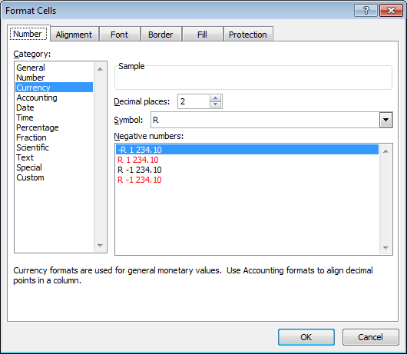
Fig. 4.4: The Format cells dialog box

NOTE: Educators should please guide the students to format the cells in fig. 4.2 above using the steps described above.

Adjusting the Column Width:
To adjust the column width so as to accommodate the contents of the cell, follow the steps below;
- Click on the cell to be adjusted
- Position the cell pointer on the column tab,
- The cell pointer changes to a cross
- Click and drag to the right to increase the column width
- Release the mouse button

NOTE: When the hash sign (#) is displayed inside a cell that contains data, it means the content of the cell is more than what the cell can accommodate. The column widths of that cell need to be adjusted.
Renaming the Worksheets
When MS Excel is opened, the sheets are named Sheet 1, Sheet 2, etc. To rename a worksheet:
- Right click on the sheet tab to be renamed
- Select Rename
- Type the name you wish to give to the sheet
- Press the Enter key

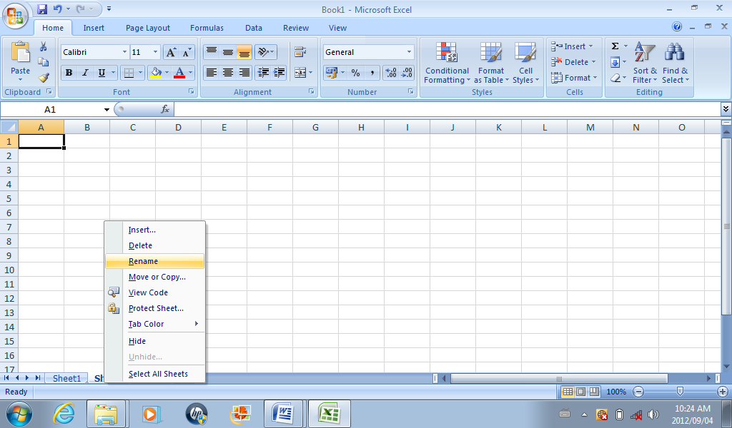
Fig. 4.4: Renaming the worksheet.

Inserting Rows or Columns:
To shift existing rows or columns to create blank rows or columns, follow the steps below;
- Select the current row or column where the new row or column would be inserted
- Click on Insert menu
- Click on rows or columns

EVALUATION:
1. (a) Define a Worksheet.
(b) State the THREE types of data that can be entered into a worksheet.
2. Highlight the steps required to do the following;
(a) Open a worksheet (b) Save a worksheet (c) Retrieve a worksheet
(d) Rename a worksheet

WEEKEND ASSIGNMENT:
1. .................... can be defined as the working area of the program where entering of data and calculations are handled.
(a) Worksheet (b) Workbook (c) Workcell (d) row
2. Which of the following cannot be found in a worksheet?
(a) Cell pointer (b) Column (c) Animations (d) Row
3. .................... are mathematical expressions which return calculated value.
(a) MS Excel (b) Formula (c) Equation (d) Function
4. To save a workbook for future reference, a ...................... must be given to it.
(a) File name (b) File title (c) Reference name (d) Reference title
5. ..................... changes the way numbers and text are displayed in a worksheet.
(a) Arrangement (b) Decoration (c) Formatting (d) Highlighting
6. ................... sign is displayed when the content of the cell is more than what the cell can accommodate. (a) ₦ (b) Σ (c) £ (d) #

WEEK 5
TOPIC: WORKSHEET II
Sub-Topic 1: EXCEL CALCULATIONS:
The basic and most powerful feature of Microsoft Excel is the ability to accept formula into the worksheet. A Formula is an instruction that is entered to tell Excel how to Add, Subtract, Multiply, Divide, or otherwise perform calculation by using the content of other cells.
It is advisable to construct formula that makes reference to cells in the worksheet so that the result can be instantly generated even the values are changed.

When working on Excel calculations, the following guidelines should be noted;
(i) To enter a formula, first select the cell that will contain the formula.
(ii) All formula must begin with equal (=) sign tells Excel to treat the cells contents as a formula.
(iii) The formula should not be more than 1024 characters.
(iv) The function name (e.g. SUM, AVERAGE) which is preceded by equal (=) sign must be selected and followed by the desired argument, i.e. =SUM(A5:F5). In this case, SUM is the function name and A5:F5 is the argument.

Addition: Using the SUM Function
The SUM function is used to add together a range of data or numbers. To sum up the values of a range of data:
- Open the worksheet containing data (as previously done in fig 4.2 above).
- Position the cell pointer on the desired cell i.e. the cell where the result should be displayed.
- Type equal sign, Select the function (i.e. SUM) and state the range of cells.
- MS Excel will highlight the range specified.
- Press the Enter key.
- The result is displayed.
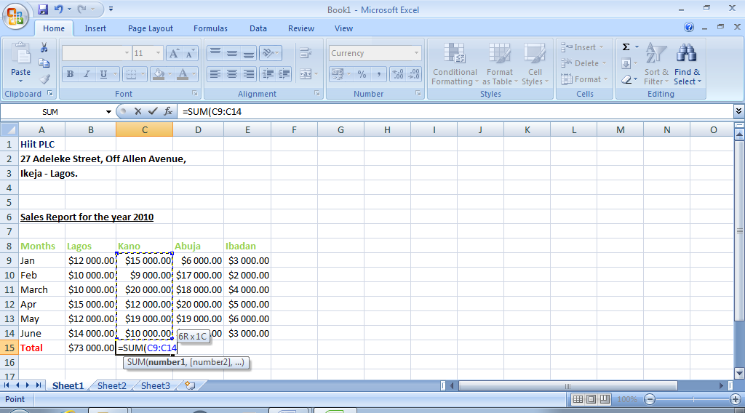
Fig 5.1: summing up a range of values
NOTE: Educators should kindly ensure that each student follow the steps above and should also endeavour to explain alternative methods using the ‘AUTOSUM’ symbol (Σ), and Addition sign(+).

Subtraction: Using the IMSUB Function
The IMSUB function is used to find the difference of two numbers. To find the difference of a range of data;
- Open the worksheet containing data (as previously done in fig 4.2 above).
- Position the cell pointer on the desired cell i.e. the cell where the result should be displayed.
- Type equal sign, Select the function (i.e. IMSUB) and state the range of cells, usually two cells.
- MS Excel will highlight the range specified.
- Press the Enter key.
- The result is displayed.

NOTE: Educators should kindly explain alternative methods using the Subtraction sign (-)

Average: It is also possible to use the spreadsheet package to find the average of certain values or group of numbers. To find average:
- Position the cell pointer in the desired cell where result is to be displayed
- Type “=AVERAGE (DATA RANGE)” in the formula bar
- Press the ENTER KEY
- The result is displayed in the cell

Count:
The count function is used to ascertain the number of cells within a specified range that contains values. To use the count function;
- Position the cell pointer in the desired cell
- Click on AutoSum (Σ) and select “Count”
- Press the ENTER KEY.

Multiplication:
The multiplication function is solely for multiplication of numbers just like in arithmetic. To multiply a range of data;
- Position the cell pointer on the desired cell i.e. the cell where the result should be displayed.
- Type equal sign, Select the function (i.e. PRODUCT) and state the range of cells.
- MS Excel will highlight the range specified.
- Press the Enter key.
- The result is displayed.
Also, the symbol (*) can be used.

Division:
To divide a range of values;
- Position the cell pointer on the desired cell i.e. the cell where the result should be displayed.
- Type equal sign, Select the function (i.e. QUOTIENT to display the integer portion of a division) and state the range of cells.
- MS Excel will highlight the range specified.
- Press the Enter key.
- The result is displayed.
Also, the symbol (/) can be used to display the exact result.

NOTE: Educators should please endeavour to expose the students to some other functions embedded in the worksheet program.

Sub-topic 2:
Printing of Worksheet
After the spreadsheet have been formatted and properly calculated the next thing is to get the worksheet printed. To print your worksheet, take the following steps:
- Highlight the range to be printed
- Click on the Office button and select Print
- Select the name of the printer from the Printer Name box
- Enter the number of copies to print
- Click on Preview button and select Page Set Up. Set all the necessary parameters like margins, page layout, paper size and grid lines (if necessary).
- Click on OK
- Click on Print.

EVALUATION
1. State THREE guidelines that must be followed when performing excel calculations
2. Highlight the major steps required to carry out the following calculations;
(a) Addition (b) Subtraction (c) Count (d) Average (e) Division

WEEKEND ASSIGNMENT
1. Which of the following signs can be used for multiplication in MS Excel?
(a) + (b) X (c) & (d) *
2. In Excel, the expression C4:F20 is usually referred to as a/an .......................
(a) Function (b) Function Name (c) Argument (d) Expression
3. In Excel, the function IMSUB is used for .......................
(a) Addition (b) Subtraction (c) Multiplication (d) Division
4. The .................. function is used to ascertain the number of cells within a specified range containing values.
(a) MAXIMUM (b) COUNT (c) SORT (d) AVERAGE

WEEK 6
DATE:………………………………….
Activity: PRACTICAL ON EXCEL CALCULATION

WEEK 7
DATE: ……………………..

TOPIC: GRAPH

CONTENT: - Creating Graph

Sub-Topic 1: CREATING GRAPH
GRAPH: A graph is a diagram showing the relationship that exist among variables, quantities (varies data), usually of two, each measured along one of a pair of axes at right angles. It may not be possible to plot a graph without value. The excel spreadsheet provides the values that are plotted.
Creating graph
To create a graph, you can either use the chart wizard or press the F11 key

Types of Chart
- Line graph
- Histograms
- Pie-charts
- Legends

1. Line graph: Line graphs are often used to plot changes in data over time, such as monthly temperature changes or daily changes in stock market prices. Line graphs have a vertical axis and a horizontal axis. If you are plotting changes in data over time, time is plotted along the horizontal or x-axis and your other data, such as rainfall amounts is plotted as individual points along the vertical or y-axis

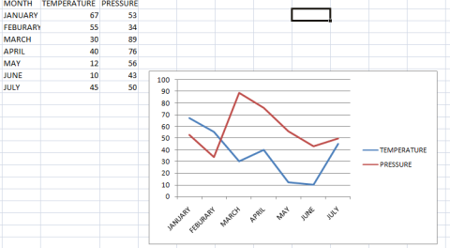

2. Histograms: A histogram consists of tabular frequencies, shown as adjacent rectangles, erected over discrete intervals (bins), with an area equal to the frequency of the observations in the interval. The height of a rectangle is also equal to the frequency density of the interval.

Sub-Topic 2: PIE CHART and LEGEND

3. PIE-CHART: Pie-charts, or circle graphs as they are sometimes known, are a little different from the other two types of graphs discussed.

For one, pie charts do not use horizontal and vertical axes to plot points like the others. They also differ in that they are used to chart only one variable at a time. As a result, it can only be used to show percentages. The circle of pie charts represents 100%. The circle is subdivided into slices representing data values. The size of each slice shows what part of the 100% it represents.

4. LEGEND: A legend is used to identify each series in a chart. Its contains on sample of the marker colour and pattern of each series.

EVALUATION
- What do you understand by the term chart
- List the various types of chart you are familiar with in MS-Excel

ASSIGNMENT
- Construct the following
- Histogram
- Pie chart
- Bar chart
Subject | English | Maths | Computer | Technology | science
Scores | 50 | 70 | 75 | 60 | 45

2. The table below gives the age of a group of pupils in a school
Age (yr) | 13 | 14 | 15 | 16 | 17
Number of pupils | 1 | 4 | 2 | 2 | 1
Draw a bar chart to show the information in the table

3. Represent the information in the table below on a line graph
Subject | English | Maths | Computer | Basic Sci. | Music
Time allotted | 100 | 120 | 100 | 100 | 100

WEEK 8
DATE: ………………..

TOPIC: - FORMATTING GRAPHS

CONTENT: - Changing Chart Type

SUB-TOPIC 1
CHANGING CHART TYPE
After creating a chart, you can change it to the type you want. The type you choose depends on how you want to present your data.
- Select the chart
- Within the chart, click the right mouse button OR
- Click on insert on menu bar
- Click on change Chart type
- Under Chart Type, list click to select the desired chart type (e.g, Column, Bar, Line, etc)
Under Chart sub-type list, click to select the chart sub-typed desired. You can view the chart sample by pressing it and hold to view sample button.
- Click on OK when satisfied

Changing from histogram to pie chart using the same data

ADDING AND EDITING CHARTS
Once you have created a chart, you can add more chart data series or copy additional chart data series from a worksheet or another chart. Microsoft Excel offers a variety of ways to edit your chart data
You can change a chart data series by:
- Adding a chart data series to a chart
- Adding or removing more data point to the existing chart data series.
- Plotting the data by rows or by columns.
To add or edit a chart data series with chart wizard tool
- Select the chart you want to edit
- Click the chart wizard tool
- Follow the instruction on the screen
The chart is automatically updated to reflect the new data

Adding more data to the present data gives us

Sub-Topic 2: FORMATTING A CHART

FORMATTING A CHART
You can change the font of chart text, change the horizontal and vertical alignment and rotate text to a vertical orientation. You can also change the pattern and color of the text area. The text is displayed in the front of the area pattern so that it is always visible. Microsoft Excel automatically formats the charts title and axes title as bold.
To format chart text with the standard tool bar
- To format all the text in a chart, select the chart by choosing select chart from the chart menu. To format a single piece of attached or unattached text, click the text to select it. To format tick-mark labels for an axis, click the axis to select it.
To format text that appears in a legend, click the legend; click the legend to select it.
- Click one of the formatting or alignment tools to format the text

EVALUATION
- List the steps involved in formatting chart text
- State the steps in adding or editing chart

WEEKEND ASSIGNMENT:
Objective Test:
- Which of the following is not a type of graph (a) Line graph (b) Pie Chart (c) Histogram (d) Bigram
- ……………………….. is a circle divided into sections (a) Bar Chart (b) Histogram (c) Pictogram (d) Pie- chart

Essay Test:
1. Construct a bar chart for the data below
No. of students | 5 | 3 | 8 | 7 | 2 | 8 | 6 | 10 | 1 | 4
Performances in Comp. studies Exam | 10 | 20 | 30 | 40 | 50 | 60 | 70 | 80 | 90 | 100

2. Change the above bar chart to line graph

WEEK 9
DATE…………….
TOPIC: COMPUTER GAMES
CONTENT: Computer Games
Sub-Topic 1: COMPUTER GAMES
Computer game is also called PC game, is a video game played on personal computer, rather than on a video game console OR Computer games are software programs used for relaxation and to learn some skills.
Video game is an electronic or computerized game played by manipulating images on a video display television screen. Examples of computer game include;
- Spider Solitaire 2. Packman 3. Space commander 4. Digger 5. Pinball 6. Chess 7. Heart
Some computer games are supplied by Microsoft windows while some are downloaded from internet. Computer games can be played using the following input devices:
- Keyboard (through the arrow keys)
- Joystick
- Mouse
- Game pad
Reasons for playing Computer games
- For the purpose of entertainment
- For educational purpose
- For teaching purpose
- To develops some skills

Types of games:
There are many types of computer games. These have been classified into three categories:
- Recreational games
- Skill enhancement
- Entertainment games

Sub-Topic 2: Recreational Games; Advantages/Disadvantages of Computer Games.
RECREATIONAL GAMES
These are games played at leisure time for relaxation after working for long period of time e.g. Free cell, Casino, heart

Skill Enhancement games
They are games designed for skill enhancement and recycling, Quizzing, puzzles, Mathematics games

Entertainment Games
These are types of games played to entertain friends and visitors e.g Musical games, Mimicking and guessing

ADVANTAGES OF COMPUTER GAMES
- It helps to stimulate (encourage) children and adult interest in learning these of computers.
- Computer games helps to develop habit of concentration e. Test Drive Game
- It can be used to manage or reduce stress condition
- Computer games are used for teaching and learning of different subjects, e.g Music, mathematics, English, Speed and accuracy e.t.c
- Computer games enhanced the physical well being of the player
- Computer games are useful for recreation, skill acquisition and entertainment.

DISADVANTAGES OF COMPUTER GAMES
- It wastes valuable time
- It jeopardizes the opportunity for doing other good things

Evaluation
- What is computer game
- Name three input devices used to play computer games

Weekend Assignment
- All the following are computer games except……… (a) Chess (b) Trojan (c) Packman (d) Pinball
- Computer games can be played using all the following except ………….. (a) Computer Keyboard (b) Mouse (c) Joystick (d) Digger
- Which of the following is not a reason for playing computer game
- For fraudulent purposes (b) For entertainment (c) For educational purpose (d) For teaching purposes
- ………….. is a computer software used for relaxation to learn skill (a) Anti virus (b) Computer (c) Games (d) Game pad
Essay
- Mention two reasons for playing game
- State four disadvantages of playing computer game.

WEEKS 10-13: REVISION AND EXAMINATION

