Scheme of work for jss3
Week 1; revision of last terms work
Week 2; building components [foundation]
Week 3; windows, doors and roofs
Week 4; wood work project
Week 5; wood work project
Week 6; metal joining
Week 7; metal work project
Week 8; motion in engineering
Week 9; simple electrical wiring
Week 10; wiring tools and materials
Week 11; revision
Week 12; examination

Week 1; revision
Wood processing
The major wood product categories are sawntimber, wood-based panels, woodchips, paper and paper products and miscellaneous others including poles and railway sleepers. During the last several decades, forest product processing technologies have undergone extraordinary advances in some of the above categories. Improvements have been achieved in terms of recovery rates, higher qualities in terms of durability and protection, higher utilization of NTFPs such as bagasse, various grain stalks and bamboo, as well as the development of new products such as reconstituted wood-panels. Progress has not been homogenous in all the forest product utilization categories. Even though there is only little information available on the subjects of technology acquisition, adaptation and innovation for the forest-based industrial sector (Contreras-Hermosilla and Gregersen, 1991), it is clear that sawmilling has been far less affected by the spread of innovations than the manufacturing of panel products. There is still a high number of outdated mills in operation which have very low recovery rates, frequently less than 40 percent.
The technological changes that have taken place within the Region have not occurred randomly. Many of the technologies that are increasingly adopted and adapted have been developed in industrial countries. Some of them, such as medium density fibreboard (MDF) production technologies had been in use, tested and refined for more than 25 years before they featured more prominently in the Region. Most the machinery is still imported, predominantly, from Europe. Others such as oriented strandboard (OSB) production does not exist yet in most countries of the Region and its market is underdeveloped.
The following four reasons account for the contemporary developments in those categories that have experienced changes and those that have remained largely stagnant in terms of modernization:
• decreasing raw material supply;
• reduced availability of large-sized timber;
• increasing responsiveness to environmental pressures; and
• government policies to develop domestic wood-based industries.
As a result of government support, the number of processing plants has increased substantially and products have become diversified. The first three factors disclose why the traditional sawnwood sector has lagged behind the other sectors. They also explain the declining importance of the plywood sector which has been significantly affected by a reduction in wood supplies as well as competition with MDF whose production costs are considerably lower. In Indonesia, the raw material shortage resulted in production capacities as low as 50 percent for some firms, while older facilities with inefficient machines opted to close down (Adhar, 1996). Excess capacities are also reported for Sabah (Tay and Abi, 1996), which did not, however, affect the lifting of the log export ban that had been imposed in 1993 (Anon, 1996d).
In general, the wood processing industry is currently undergoing major structural changes with a gradual switch from the production of timber products using large diameter trees to those utilizing smaller diameter from second cuts, as well as moving toward plantations and the estate sector. Product diversity has increased to such an extent and developments have been so variable that only three more recent developments will be used to illustrate which further changes might be expected in the following decade. For this purpose the developments in the MDF category, the increased use of rubberwood and the potential of oil palm as a raw material for the wood-based panel industry, will be described.

Medium Density Fibreboard Production
The recent developments in the MDF sector are very similar to the earlier developments in the plywood sector. The main difference is that the latter was a response to government policies promoting domestic wood-based industries while MDF production plants sprang up because of the raw material shortages that have become increasingly evident during the last few years and the opportunity of using formerly untapped resources. Another difference is in the installed capacity of MDF which lags behind the plywood sector. Globally, it stands at 15 million m³/year. By the end of 1996, the Asia-Pacific Region is expected to become the leader in MDF production with an installed capacity of well over 5 million m³/year (Anon, 1995a).
Important raw materials for MDF include radiata pine (New Zealand), mixed tropical species (Japan), rubberwood (Thailand), bagasse (Pakistan, China and Thailand) and cotton stalks (India) (Wadsworth, 1995). The only raw material used in Malaysia is rubberwood, in contrast to particleboard or cement-bonded products which rely more on a mixture of species and wood waste. The light colour of rubberwood and uniform texture provide an ideal fibre resource for MDF production.
The MDF production process involves in the first steps debarking and chipping. Cleaned chips are cooked in a digester and refined into wood fibres which are then mixed with resin and wax. The mixture of wet fibre, resin and wax is dried and transported to the mat former before it is pressed to produce a continuous mat. In the final processing stage it is trimmed, sanded and cut to specified dimensions. Depending on customer requirements board thickness varies between 2.5 and 32 mm.
MDF and OSB have emerged as price competitive alternatives to the more traditional products such as plywood, particleboard and hardboard. With similar characteristics to plywood products, their greatest advantage is that low quality and low value raw materials (including non-wood fibres) can be turned into high value and high quality wood-panels. This clarifies why their production costs are about 50 percent lower (Adhar, 1996). Because of the desirable and user-friendly physical properties and favourable machining properties, MDF has a variety of end-uses and can replace tropical hardwood timbers for furniture. The production process can virtually use all wood species of minimum log diameter down to 5 cm. In addition, it is marketed as an environmentally friendly product which relies on sustainable resources such as rubberwood, radiata pine and non-wood fibres. The combination of these advantages testify to the massive investment in MDF production plants.

The Rubberwood Success Story in Malaysia
Until about fifteen years ago, the commercial value of rubberwood as a raw material for the wood processing industry was negligible. Due to the high sugar content, rubberwood biodegrades rapidly. In addition, it is susceptible to insect infestations after felling. Notwithstanding these problems, rubberwood has always been an under-utilized raw material with potential, particularly with the onset of log shortages from natural forests. Hence, as is the case with MDF and oil palm (see below), the initial impetus for investigating its potential came from the need to search for alternative sources for an ailing sawmilling and wood processing industry, particularly in Malaysia (Hong, 1995). While Malaysia was not the first country to utilize rubberwood, it was the first one to export it successfully.
Today the significant utilization of rubberwood can be attributed to the combination of research and development by the Forest Research Institute Malaysia and the development of marketing strategies by private companies and related government agencies (Hong, 1995). At present, rubberwood comes exclusively from plantations established for latex production. With an expected increase in demand and shortage in supply, the growing of rubber trees for the sole purpose of timber production is envisioned. This would dramatically increase recovery rates which are currently as low as 25 percent.
Most affected by the research and marketing success have been the furniture and panel products industries. In Malaysia, rubberwood has out-performed many of the traditional light-coloured species used in the production of furniture. Its availability and low price has resulted in the expansion of the furniture industry. Of the approximate USD 600 million for furniture export values in Malaysia, around 70 percent is from rubberwood.
The growth in the MDF sector in Malaysia is also the direct consequence of rubberwood abundance. As reported by Hong (1995), rubberwood has all the required ingredients to make it successful in the wood-panel sector. It is a homogenous raw material, available in large volumes and a renewable resource - a very important criterion for the sensitized wood processing industry in Malaysia. The benefits from making rubberwood attractive for the wood processors and ultimately the consumer have been spread fairly widely. Today smallholders and farmers can sell their trees per truck load to the industry, not only on Peninsular Malaysia but also in Sarawak.

Oil Palm Fibre as an Alternative Raw Material
The wood processing industry has recently experienced shortages in rubberwood supply. There are a number of reasons for this latest development. First, climatic (prolonged wet periods) conditions render harvesting of rubberwood, particularly on steeper slopes, inefficient. One has to remember that rubber plantations were established for latex not for wood production. Second, the resource is not available in more desirable large blocks affecting economies of scale. And third, even rubberwood turns out to be a finite (at least in the short- to medium-term) resource as demand outstrips supply. Therefore, the industry is already in search of alternative raw materials. Acacia mangium is receiving increasing attention. Its characteristics are well known though many questions regarding its silviculture and suitability for the timber industry still remain.
The search has recently included oil palm, plantations of which are increasingly replacing those of rubber in Southeast Asia. In common with rubber, it is an under-utilized resource with potential application in a number of industrial sectors. The empty fruit bunches of oil palm are used as mulch, boiler fuel, fertilizer, and for the production of car cushions and mattresses. Research is currently investigating the use of oil palm fibres for various wood-based boards, pulp and paper, mushroom cultivation and as animal feed (Akmar et al., 1996). The fibrous strands of the trunks and fronds are suitable for manufacturing pulp and paper, chipboard, and cement/gypsum bonded particleboard (Anon, 1995b). The fibres of the empty fruit bunches can be used for laminated isotropic fibreboard, cementboard, and pulp.
Research results suggest that the quality and physical characteristics of fibreboard made from the empty fruit bunches of oil palms surpass those of particleboard. In general, their quality is comparable to rubberwood particleboard (Yayah et al., 1995). In Malaysia, the first companies have produced furniture from oil palm fibres. Its increased use is viewed as achieving zero waste in the oil palm industry (Anon, 1995b). This translates into substantial cost savings which partially explains the enthusiasm of some companies to venture into panel manufacturing.

Outlook
The current developments in the wood processing sector are a response to a mixture of emerging constraints and opportunities that have existed for a much longer time. Advanced machinery and technologies for more efficient wood use have existed in industrial countries for decades. However, their adoption was neglected in the Region (predominantly in the tropical countries) because first, the natural forests were viewed as an infinite resources, and second, limits to harvesting large-sized timber were not expected so soon. Looking at the processing capacity of wood processing mills and the future supply scenario of timber from natural forests, the main concern that has arisen is the future availability of logs. This concern has stimulated an entry into the reconstituted wood-panel industry as well as the use of formerly under-utilized or discarded raw materials, as the examples from Malaysia have revealed.
Wood-panel products with their advantages, in terms of cost and technical property, have developed from plywood to particleboard and MDF, through an evolution from using basically solid wood to using fibres of a variety of products. This development has not only produced more homogenous products, but reconstituted panel production also has much higher recovery rates than sawntimber or plywood. Furthermore, reconstituted panels can be made from a variety of products. Compared to solid wood and plywood, large uniform panel sizes free of any natural defects can be obtained (Yayah et al., 1995). The tremendous growth of the wood-based panel industry is clearly a reflection of the limited wood availability.
With further advances in lamination possibilities, special grades and properties, including moisture resistance, fire retardance and exterior grades, it can be safely assumed that the current growth rates will continue. The expected growth in ready-to-assemble furniture will increase the awareness of the special characteristics and advantages of wood-based panels, particularly MDF and OSB. In addition, new factories can be erected with relative ease. The decreasing supply of large diameter logs will require a further restructuring of the plywood industry. Depending on the success of marketing strategies for boards such as MDF or OSB, the tropical plywood sector will shrink faster than expected, at least in relative terms, as substitutes and more efficient uses are developed (Anon, 1995c). Reconstituted panels will not be able to substitute all solid wood products but laminating technologies will assist in making them attractive to consumers. Also, finger jointing technologies will allow manufacturers to arrived at desired length of the final products.
Vertical and horizontal integration of productive units will provide opportunities to increase employment and efficiency of wood use. Currently there are no incentive structures for reducing wood waste during harvesting operations in natural forests, or for transporting the waste to processing mills (Kadir et al., 1994). In fact, there is even no interest in extracting waste when no royalties and fees are charged (Shaharuddin, pers. comm., 1996).
The most logical way to overcome high extraction and transportation cost is to pre-process timber at the logging site. As discussed by Kadir et al. (1994), there are several institutional, social and political problems related to licensing portable sawmills. An alternative, particularly in the vicinity of reconstituted panel manufacturers, is the use of mobile chippers which will become viable once infrastructure has been improved and rubberwood has lost its competitive edge over wood waste. Mobile chippers will be particularly attractive for secondary forests where the mean diameter of trees can be expected to be far lower than in the "primary" forest.
As Wadsworth (1995, p. 23) explained for MDF, the development of wood product consumption does not lie in the "introduction of new technologies or exotic fibres, but rather, in the more widespread application of sound and vigorous marketing". Notwithstanding the need for better targeted marketing to increase the appeal of wood-based panels to consumers, it is also possible that new technologies will achieve greater structural properties of panels and that recycled materials such as plastic can be used in manufacturing environmentally friendly composites.
The previous discussion has omitted any mention of potential advances in sawmilling. In comparison to how other categories within the wood processing sector will be affected by technological changes, the developments in the sawmilling sector will be less dramatic. The older and least efficient mills will slowly be phased out and replaced with new mills capable of maintaining or even improving recovery rates while their supplies are changing to smaller diameter logs. Here again, the technologies are already available. It is only a matter of providing appropriate incentives to encourage producers to upgrade their facilities.
Pulp and paper have also seen enormous growth rates over the last decade. New technologies for pulping mixed tropical hardwoods created a market for salvage timber (Byron, 1996). A change that will affect the industry are stricter environmental regulations regarding effluent discharge. A more important aspect for the pulp and paper industry (particularly the large scale complexes) is whether it will be able to satisfy its raw material demand. Most manufacturers hope to eventually rely on plantations of fast growing trees only. Recent reports summarized by Nilsson (1996) showed that they may be overly optimistic. One alternative would be to substitute non-wood fibres for wood fibres (Wilson, 1995). At present the main non-wood pulping capacities are located in China (74 percent) and India (6 percent). The potential of non-wood fibres is great but their use has also several drawbacks. Therefore, it is doubtful that in the next ten to fifteen years "they will become a hot item for the pulp and paper industry to tackle", as Croon predicts (1995, cited in Nilsson, 1996, p. 24), or that we will experience an "agroforestry fibre revolution" as Wilson forecasts (1995, p. 13).

Summary
The technological developments that have taken place over the last couple of decades and will shape the future of the wood processing industries are mainly a response to declining raw material supplies, in particular the shortage of large diameterlogs. The sawnwood and plywood categories have reacted to shortages to some extent. Both have improved recovery rates and are able to handle smaller diameters today. However, in comparison to equipment used in industrial countries there is still a major gap.
Developments have been more pronounced in the wood-based panel categories. Not only has there been a rapid transformation from plywood to particleboard, but most processors have also switched to alternative resources. Thus, today Malaysia's MDF producers rely solely on rubberwood. In the future, it can be expected that some producers will rely on oil palm fibres or other non-wood fibres. However, the latter are available mainly seasonally incurring additional costs in logistics and storage.
The wood processing evolution that the Region has witnessed will continue over the next ten to fifteen years. As a result, the dependence on large-sized timber will decrease further, influencing traditional forest silviculture and other forestry practices. Secondary forests and plantations will become more attractive.
Moreover, the importance of reconstituted wood-panels will gain momentum in the Region with its growing middle class spending a significant amount of its income on furniture. Marketing strategies will play a significant role in reducing consumers' preferences for solid wood products and increasing the acceptability of panel products.
Assignment
- Define wood seasoning
- Define wood conversion

Week 2; building components [foundation]
A foundation (or, more commonly, base) is the element of an architectural structure which connects it to the ground, and transfers loads from the structure to the ground. Foundations are generally considered either shallow or deep.^{[1]} Foundation engineering is the application of soil mechanics and rock mechanics (Geotechnical engineering) in the design of foundation elements of structures.

Contents
- 1 Historic foundation types
  - 1.1 Earthfast or post in ground construction
  - 1.2 Padstones
  - 1.3 Stone foundations
  - 1.4 Rubble trench foundations
- 2 Gallery of shallow foundation types
- 3 Modern foundation types
  - 3.1 Shallow foundations
  - 3.2 Deep foundations
    - 3.2.1 Monopile foundation
- 4 Design
- 5 See also
- 6 References

Historic foundation types
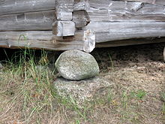
The simplest foundation, a padstone. Latvian Ethnographic Open Air Museum

Earthfast or post in ground construction
Buildings and structures have a long history of being built with wood in contact with the ground.^{[2][3]} Post in ground construction may technically have no foundation. Timber pilings were used on soft or wet ground even below stone or masonry walls.^{[4]} In marine construction and bridge building a crisscross of timbers or steel beams in concrete is called grillage.^{[5]}

Padstones
Perhaps the simplest foundation is the padstone, a single stone which both spreads the weight on the ground and raises the timber off the ground.^{[6]} Staddle stones are a specific type of padstones.

Stone foundations
Dry stone and stones laid in mortar to build foundations are common in many parts of the world. Dry laid stone foundations may have been painted with mortar after construction. Sometimes the top, visible course of stone is hewn, quarried stones.^{[7]} Besides using mortar, stones can also be put in a gabion.^{[8]} One disadvantage is that if using regular steel rebars, the gabion would last much less long than when using mortar (due to rusting). Using weathering steel rebars could reduce this disadvantage somewhat.

Rubble trench foundations
Main article: Rubble trench foundation
Rubble trench foundations are a shallow trench filled with rubble or stones. These foundations extend below the frost line and may have a drain pipe which helps groundwater drain away. They are suitable for soils with a capacity of more than 10 tonnes/m² (2,000 pounds per square foot).

Gallery of shallow foundation types
- 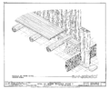
Drawing of Poteaux-en-Terre post in ground type of wall construction (this example technically called pallisade construction) in the Beauvais House in Ste Genevieve, Missouri, U.S.A.
- 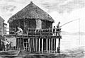
PSM V24 D321 A primitive stilt house in Switzerland on wood pilings.
- 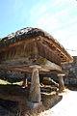
A granary on staddle stones, a type of padstone
- 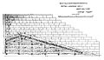
Black Eagle Dam - cross-section of construction plans for 1892 structure
- 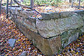
Davis House dry-laid stone foundation ruin, Gardiner, NY
- 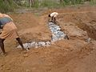
A basic type of rubble trench foundation
- 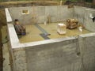
Typical residential poured concrete foundation, except for the lack of anchor bolts. The concrete walls are supported on continuous footings. There is also a concrete slab floor. Note the standing water in the perimeter French drain trenches.

Modern foundation types

Shallow foundations
Main article: Shallow foundation
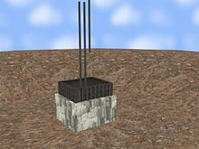Play media
Shallow foundation construction example
Shallow foundations, often called footings, are usually embedded about a metre or so into soil. One common type is the spread footing which consists of strips or pads of concrete (or other materials) which extend below the frost line and transfer the weight from walls and columns to the soil or bedrock.
Another common type of shallow foundation is the slab-on-grade foundation where the weight of the structure is transferred to the soil through a concrete slab placed at the surface. Slab-on-grade foundations can be reinforced mat slabs, which range from 25 cm to several meters thick, depending on the size of the building, or post-tensioned slabs, which are typically at least 20 cm for houses, and thicker for heavier structures.

Deep foundations
Main article: Deep foundation
A deep foundation is used to transfer the load of a structure down through the upper weak layer of topsoil to the stronger layer of subsoil below. There are different types of deep footings including impact driven piles, drilled shafts, caissons, helical piles, geo-piers and earth stabilized columns. The naming conventions for different types of footings vary between different engineers. Historically, piles were wood, later steel, reinforced concrete, and pre-tensioned concrete.

Monopile foundation
Main article: Monopile foundation
A monopile foundation is a type of deep foundation which uses a single, generally large-diameter, structural element embedded into the earth to support all the loads (weight, wind, etc.) of a large above-surface structure.
A large number of monopile foundations^{[9]} have been utilized in recent years for economically constructing fixed-bottom offshore wind farms in shallow-water subsea locations.^{[10]} For example, a single wind farm off the coast of England went online in 2008 with over 100 turbines, each mounted on a 4.74-meter-diameter monopile footing in ocean depths up to 16 metres of water.^{[11]}

Design
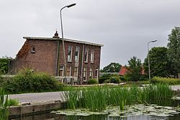
Inadequate foundations in muddy soils below sea level caused these houses in the Netherlands to subside.
Foundations are designed to have an adequate load capacity depending on the type of subsoil supporting the foundation by a geotechnical engineer, and the footing itself may be designed structurally by a structural engineer. The primary design concerns are settlement and bearing capacity. When considering settlement, total settlement and differential settlement is normally considered. Differential settlement is when one part of a foundation settles more than another part. This can cause problems to the structure which the foundation is supporting. Expansive clay soils can also cause problems.

WALLS; Building wall
See also: American historic carpentry
The purposes of the walls in buildings are to support roofs, floors and ceilings; to enclose a space as part of the building envelope along with a roof to give buildings form; and to provide shelter and security. In addition, the wall may house various types of utilities such as electrical wiring or plumbing. Wall construction falls into two basic categories: framed walls or mass-walls. In framed walls the load is transferred to the foundation through posts, columns or studs. Framed walls most often have three or more separate components: the structural elements (such as 2×4 studs in a house wall), insulation, and finish elements or surfaces (such as drywall or panelling). Mass-walls are of a solid material including masonry, concrete including slipform stonemasonry, log building, cordwood construction, adobe, rammed earth, cob, earthbag construction, bottles, tin cans, straw-bale construction, and ice.
There are three basic methods walls control water intrusion: moisture storage, drained cladding, or face-sealed cladding.^{[2]} Moisture storage is typical of stone and brick mass-wall buildings where moisture is absorbed and released by the walls of the structure itself. Drained cladding also known as screened walls^{[3]} acknowledges moisture will penetrate the cladding so a moisture barrier such as housewrap or felt paper inside the cladding provides a second line of defense and sometimes a drainage plane or air gap allows a path for the moisture to drain down through and exit the wall. Sometimes ventilation is provided in addition to the drainage plane such as in rainscreen construction. Face-sealed also called barrier wall or perfect barrier^{[3]} cladding relies on maintaining a leak-free surface of the cladding. Examples of face sealed cladding are the early exterior insulation finishing systems, structural glazing, metal clad panels, and corrugated metal.
Building walls frequently become works of art, externally and internally, such as when featuring mosaic work or when murals are painted on them; or as design foci when they exhibit textures or painted finishes for effect.

Curtain wall
Budapest Wall
Main article: Curtain wall (architecture)
In architecture and civil engineering, curtain wall refers to a building facade that is not load-bearing but provides decoration, finish, front, face, or historical preservation.

Precast Compound Wall
Precast Compound Wall^{[4]} are Ready to use. it can be fast to install compare to brick and other walls, low cost compare to brick walls,

Mullion wall
Main article: Mullion wall
Mullion walls are a structural system that carries the load of the floor slab on prefabricated panels around the perimeter.

Murno Gladst Wall
Main article: Murno Gladst Fence
A tall, deep-base exterior security wall which deters intrusion by climbing and tunneling. Also known as a Murno Gladst Fence^{[5]}

Partition wall
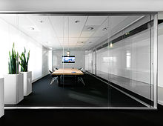
Glass Partition Wall
A partition wall is a wall that separates rooms, or divides a room. Partition walls are usually not load-bearing. Partition walls are constructed of many materials, including steel panels, bricks, blocks of clay, terra-cotta, concrete, or glass blocks.
Some partition walls are made of sheet glass. Glass partition walls are a series of individual toughened glass panels mounted in wood or metal framing. They may be suspended from or slide along a robust aluminium ceiling track.^{[6]} The system does not require the use of a floor guide, which allows easy operation and an uninterrupted threshold.
A timber partition consists of a wooden framework, supported on the floor or by side walls. Metal lath and plaster, properly laid, forms a reinforced partition wall. Partition walls constructed from fibre cement backer board are popular as bases for tiling in kitchens or in wet areas like bathrooms. Galvanized sheet fixed to wooden or steel members are mostly adopted in works of temporary character. Plain or reinforced partition walls may also be constructed from concrete, including pre-cast concrete blocks. Metal framed partitioning is also available. This partition consists of track (used primarily at the base and head of the partition) and studs (vertical sections fixed into the track typically spaced at 24", 16", or at 12").
Internal wall partitions, also known as office partitioning, is usually made of plasterboard (drywall) or varieties of glass. Toughened glass is a common option, as is low-iron glass (better known as opti-white glass, which increases light and solar heat transmission.
Wall partitions are constructed using beads and tracking that is either hung from the ceiling or fixed into the ground.^{[7]} The panels are inserted into the tracking and fixed. Some wall partition variations specify their fire resistance and acoustic performance rating.

Party wall
Main article: Party wall
Party walls are walls that separate buildings or units within a building. They provide fire resistance and sound resistance between occupants in a building. The minimum fire resistance and sound resistance required for the party wall is determined by a building code and may be modified to suit a variety of situations. Ownership of such walls can become a legal issue. It is not a load-bearing wall and may be owned by different people.

Infill wall
Main article: Infill wall
An infill wall is the supported wall that closes the perimeter of a building constructed with a three-dimensional framework structure.

Fire wall
Main article: Firewall (construction)
Fire walls resist spread of fire within or sometimes between structures to provide passive fire protection. A delay in the spread of fire gives occupants more time to escape and fire fighters more time to extinguish the fire. Such walls have no windows, and are made of non-combustible material such as concrete, cement block, brick, or fire rated drywall—and have wall penetrations sealed with special materials. A doorway in a firewall must have a rated fire door. Fire walls provide varying resistance to the spread of fire, some intended to last one to four hours. Firewalls, generally, can also act as smoke barriers when constructed vertically from slab to roof deck and horizontally from an exterior wall to exterior wall subdividing a building into sections. When constructed in this manner the fire wall can also be referred to as an Area Separation Wall.

Shear wall
Main article: Shear wall
Shear walls resist lateral forces such as in an earthquake or severe wind. There are different kinds of shear walls such as the steel plate shear wall.

Knee wall
Main article: Knee wall
Knee walls are short walls that either support rafters or add height in the top floor rooms of houses. In a ​1 ¹⁄₂-story house, the knee wall supports the half story.

Cavity wall
Main article: Cavity wall
Cavity walls are walls made with a space between two "skins" to inhibit heat transfer.

Pony wall
Pony wall (or dwarf wall) is a general term for short walls, such as:
- A half wall that only extends partway from floor to ceiling, without supporting anything
- A stem wall—a concrete wall that extends from the foundation slab to the cripple wall or floor joists
- A cripple wall—a framed wall from the stem wall or foundation slab to the floor joists
Assignment
- Define foundation
- Mention 4 types of foundation

Week 3; windows

Window
From Wikipedia, the free encyclopedia
This article is about the part of a building. For the graphical user interface element, see Window (computing). For the operating system, see Microsoft Windows. For other uses, see Window (disambiguation) and Windows (disambiguation).
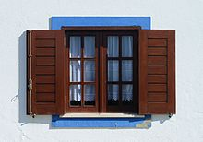
Window of traditional design in Porto Covo, Portugal
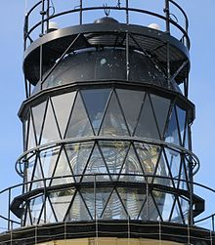
Cylindrical lattice window of Sumburgh Head Lighthouse (Shetland).
A window is an opening in a wall, door, roof or vehicle that allows the passage of light, sound, and air. Modern windows are usually glazed or covered in some other transparent or translucent material, a sash set in a frame^{[1]} in the opening; the sash and frame are also referred to as a window.^{[2]} Many glazed windows may be opened, to allow ventilation, or closed, to exclude inclement weather. Windows often have a latch or similar mechanism to lock the window shut or to hold it open by various amounts.
Types include the eyebrow window, fixed windows, single-hung and double-hung sash windows, horizontal sliding sash windows, casement windows, awning windows, hopper windows, tilt and slide windows (often door-sized), tilt and turn windows, transom windows, sidelight windows, jalousie or louvered windows, clerestory windows, skylights, roof windows, roof lanterns, bay windows, oriel windows, thermal, or Diocletian, windows, picture windows, emergency exit windows, stained glass windows, French windows, panel windows, and double - and triple paned windows.
The Romans were the first known to use glass for windows, a technology likely first produced in Roman Egypt, in Alexandria ca. 100 AD. Paper windows were economical and widely used in ancient China, Korea and Japan. In England, glass became common in the windows of ordinary homes only in the early 17th century whereas windows made up of panes of flattened animal horn were used as early as the 14th century. In the 19th century American west, greased paper windows came to be used by itinerant groups. Modern-style floor-to-ceiling windows became possible only after the industrial plate glass making processes were fully perfected.

Doors and windows - Building Construction
- 1. Semester : 3rd Year : 2nd Bachelor of Engineering (BE) CIVIL ENGINEERING Subject : Building Construction Gujarat Technological University (GTU) Crating By : ASHISH VASAVA
- 2. DOORS AND WINDOWS♣ Topics⎫ Figures⎫
- 3. • Definition and function • Location of door in a building • Components of a door • Sizes of doors • Door frames • Technical terms • Types of doors • Recommended Dimension for windows • Types of windows • Fixtures and Fastening 1. Hinges 2. Bolts 3. Handles 4. Locks Topics⎫
- 4. Definition and Function⎫ • Definition of door : – A door may be defined as “an open able barrier or as a framework of wood, steel , aluminum, glass or a combination of these materials secured in a wall opening”. • Function of door : – It is provided to give access to the inside of a room of a building. – It serves as a connecting link between the various internal portion of building. – Lighting and ventilation of rooms. – They admit ventilation and light. – Controls the physical atmosphere within a space by enclosing it, excluding air drafts, so that interiors may be more effectively heated or cooled. – They act as a barrier to noise. – Used to screen areas of a building for aesthetic purposes, keeping formal and utility areas separate.
- 5. Location of door in a building⎫ • The number should be kept as minimum. • It should meet the functional requirement. • It should preferably be located at the corner of the room, nearly 20 cm from corner. • If in a room, more than 2 doors are there, they shall be located facing each other.
- 6. Components of a door:♣ a) Door frame b) Door shutter Door frame HEAD JAMB/POST HOLDFAST F.L. HORN REBATE
- 7. TOP RAIL BOTTOM RAIL INTERMEDIATE RAILS STYLE PANEL FRIEZE RAIL Door shutter
- 8. SIZES OF DOORS¬ The common width-height relations used: Width = 0.4 – 0.6 Height Height = (width +1.2)m General sizes used: a) Residential External door – 1.0 x 2.0 to 1.1 x 2.0 m Internal door - 0.9 x 2.0 to 1.0 x 2.0 m Bath & WC – 0.7 X 2.0 to 0.8 x 2.0 m Garages for cars – 2.25 x 2.25 m to 2.40 x 2.25 m b) Public 1.2 x 2.0 m or 1.2 x 2.1 m or 1.2 x 2.25 m Common Criterion for sizes of Door used in India : Height = Width + (1.20 meters) Width = 0.4 × Height OR
- 9. DOOR FRAMES⎫ • Materials frames – Timber – Steel – Aluminum – Concrete – Stone • Materials for shutter – Timber – Plywood – Glass – Block
- 10. FLOOR SURFACE 300 300 50 to 60 GROOVE FOR SHUTTER 12 mm HOLD FAST POST 75 × 100 HEAD 75 × 100 DOOR FRAME♣
- 11. • A door frame is an assembly of horizontal and vertical members forming an enclosure to which door shutters are fixed • The vertical members are known as jambs or posts. • The top horizontal member is known as head. • The horizontal projections of the head are known as horns. • A rebate cut of about 12 mm is provided all-round the frame to receive door shutter. DOOR FRAME♣
- 12. Types of Doorsϖ – On the basis of working operations 1. Hinged doors 2. Revolving doors 3. Sliding doors 4. Swing doors 5. Folded door 6. Collapsible doors 7. Rolling shutter 8. Battened type 9. Framed and paneled 10. Glazed/Sash 11. Flushed 12. Louvered 13. Wire gauged doors 14. Metal Covered Plywood Door
- 13. • Most doors are hinged along one side to allow the door to pivot away from the doorway in one direction but not in the other. The axis of rotation is usually vertical. • The most common door type. It is a simple & rigid. • The panel swings, opens and closes, on hinges. • Hinged doors require a minimum amount of maintenance and cleaning, they are not expensive, and have an excellent insulating ability. • However, they take up precious room space to swing in. Hinged doorsϖ
- 14. Revolving doorsϖ Such types are provided in public buildings, like banks, museums, hotels, offices etc. • A revolving door normally has four wings/leaves that hang on a center shaft and rotate one way about a vertical axis within a round enclosure. The central shaft is fitted with ball bearing arrangement at the bottom, which allows the shutters to move without any jerk and making noise. • The radiating shutters may be fully paneled, fully glazed or partly glazed. The glass doors allow people to see and anticipate each other while walking through. Vertical rubber pieces are provided at the rubbing end of the shutter to prevent drought of air. • People can walk out of and into the building at the same time. • The door closes automatically when not in use.
- 15. • In these doors, the shutter slide horizontally along tracks with the help of runners and rails. often for space or • Sliding glass doors are common in places where there is no space to swing the door. • Such doors are very popular for use for the entrances to commercial structures and also in residential buildings for aesthetic considerations. . • Sliding doors consist of either one, two or three doors that slide by each other on a track depending upon the size of opening and space available for sliding. • They are pretty easily cleaned and maintained. • These doors sound insulation is pretty poor usually, and they must be of high quality and fitted exactly in their tracks or else they may slide out of them. • When fully open these doors will allow half the space of the opening in double sliding doors, or one third if triple. Sliding doorsϖ
- 16. Sliding doorsϖ • Sliding doors move along metal, wood, or vinyl tracks fitted into their frames at the top and bottom. To ease their movement, sliding doors often have plastic rollers attached to the top and bottom or to the bottom only. • The door is hung by two trolley hangers at the top of the door running in a concealed track while at the bottom, rollers are provided to slide the shutter in a channel track.
- 17. Swing doorsϖ • The shutter is fitted to its frame by special double action hinges. • The hinges permits the shutter to move both ways, inward as well as outward. • The doors are not rebated at the meeting styles. • To open the door, a slight push is made and the spring action brings the shutter in closed position. The return of the shutter is with force and thus, the door shall be either fully glazed Or provided with a peep hole at eye level, to avoid accidents.
- 18. Folded doorsϖ • Made of many narrow vertical strips or creases that fold back to back into a compact bundle when doors are pushed open, these strips or creases will be hanged from the top, and run on a track. They save space as they do not swing out of the door opening, though their sound and weather isolation is poor. Folding doors are usually pretty noisy, and considered not so durable
- 19. Collapsible Doorϖ Such doors are used in garages, workshops, public buildings etc. to provide increased safety and protection to property. The doors do not require hinges to close or open the shutter nor the frame to hang them. It acts like a steel curtain. The door is made up from vertical double channels (20x10x2 mm), jointed together with the hollows on the inside to create a vertical gap. These channels are spaced at 100-120 mm apart and braced with diagonal iron flats. These diagonals allow the shutter to open or closed. The shutter operate between two rails, one fixed to the floor and other to the lintel. Rollers are mounted at the top and bottom.
- 20. Rolling shutterϖ These are commonly used for shops, godowns, stores etc. The door shutter acts like a curtain and thus provides adequate protection and safety against fire and thefts. The shutter is made up of thin steel slabs called laths or slates about 1.25 mm thick interlocked to each other and coiled upon specially designed pipe shaft called drum mounted at the top. The shutter moves in two vertical steel guide channels installed at their ends. The channel is made up of steel sheets and deep enough to accommodate the shutter and to keep it in position. A horizontal shaft and spring in the drum which allow the shutter to coiled in or out. These may be manually operated for smaller openings (upto 10 sq.m.). Above 10 sq. m., they may be operated manually.
- 21. Battenedϖ & ledged doors • These doors consist of vertical boards called battens which are nailed or screwed to the horizontal members, called ledges . Often the battens are a-bout 15 to 18 cm wide and 2 to 3 cm thick. Doors made with narrow battens like these have a better appearance. – With Braces • This is a ledged and battened door to which braces have been added to prevent sagging. These braces must slope upwards from the hinge edge of the door, and they are housed with a skew notch into the ledges.
- 22. Framedϖ & Paneled Door – These doors consist of a frame made up of (a) Stiles (b) a top rail (c) sometimes an intermediate rail (d) into this framework a plywood panel (e) is fitted – This panel may fit into a groove or a rebate.
- 23. • These are provided where the visibility of the interior of the room is required. Glazed or Sash Doorsϖ
- 24. • The flush door with a framed core is a type of door that we frequently make in Rural Building. This door consists of a frame which has stiles, top and bottom rails, and narrow intermediate rails. It is covered on each side by a sheet of plywood Plywood-covered flush doors cannot be used where they will be exposed to rain and sun. Flush Doorsϖ
- 25. • These permit free ventilation through them and at the same time maintain the privacy of the room. Louvered Doorsϖ
- 26. • Wire gauge or fly proof door shutters are fixed to provide free air circulation and prevent mosquitoes, flies, insects etc. from entering into the building. Wire gauged doorsϖ
- 27. • These are composite doors of plywood and mild steel and are reasonably fire proof. Metal Covered Plywood Doorϖ
- 28. WINDOWS⎫
- 29. Recommended Dimension for windowsϖ Sr.No. Designation Size of Opening (mm) Size of Frame Window (mm) Size of Window Shutter (mm) 1 6 WS 12 600×1200 590×1190 500×1100 2 10 WT 12 1000×1200 990×1190 460×1100 3 12 WT 12 1200×1200 1190×1190 560×1100 4 6 WS 13 600×1300 590×1290 500×1200 5 10 WT 13 1000×1300 990×1290 460×1200 6 12 WT 13 1200×1300 1190×1290 560×1200 • WS = Window opening with single shutter • WT = Window opening with double shutters
- 30. TYPES OF WINDOWSϖ 1. Pivoted Windows 2. Double-Hung Windows 3. Sliding Window 4. Casement Windows 5. Glazed Windows 6. Louvered Windows 7. Metal Windows 8. Bay Windows 9. Clerestory Windows 10.Corner Windows 11.Dormer Windows 12.Awning Windows 13.Skylight
- 31. Fixed Windowϖ • In this type, the glass pane is permanently fixed in the opening of the wall. • The shutter can’t be opened or closed. • The function is limited to allowing light and or permit vision in the room. • No rebates are provided to the frame. • The shutters are fully glazed. • In homes they are generally decorative windows near doors, stairwells and high- places or are used in combination with other styles.
- 32. • In this type of window, the shutter is capable of rotating about a pivot fixed to window frame. • The frame has no rebate. • The shutter can swing horizontally or vertically. Vertical pivotedHorizontal pivoted Pivoted windowsϖ
- 33. Double-hung windowsϖ It has two panes, top and bottom that slide up and down in tracks called stiles. The most common used windows today. When open, these windows allow air flow through half of its size. The two parts are not necessarily the same size. Traditionally, each shutter is provided with a pair of counterweights connected by cord or chain over pulleys. When the weights are pulled, the shutters open to required level. It is possible to have controlled ventilation. Sash windows may be fitted with simplex hinges which allow the window to be locked into hinges on one side, while the rope on the other side is detached, allowing the window to be opened for escape or cleaning. Nowadays, most new double-hung sash windows use spring balances to support the sashes.
- 34. • Special frames called boxed or cased frame is used, which consists of two vertical members spaced apart to create a groove to slide the shutter. • A parting bead is provided in the groove of the frame to keep the two shutters apart. • Only the bottom sash slides upward in a single-hung window. In single-hung windows the top sash is fixed and can’t be moved.
- 35. • Has two or more sashes that overlap slightly but slide horizontally within the frame. • Suitable openings or grooves are left in the frame or wall to accommodate the shutters when are shutters are opened. Sliding Window or Slider:ϖ
- 36. • Casement windows are hinged at the sides. • When fully opened, offer the maximum amount of ventilation. • Operates like a hinged door, except that it opens and closes with a lever inside the window. • The shutter consists of styles, top rail, bottom rail and intermediate rail. • Depending upon the design, the frame can have additional vertical and horizontal members i.e. mullion and transom respectively. • The panels may be either glazed, unglazed or partly glazed and are fixed in the grooves made in rails and styles. Casement windowsϖ
- 37. • This is a type of casement window where panels are fully glazed. • The frame has styles, top rail and a bottom rail. • The space between top and bottom rail is divided into number of panels with small timber members called, sash bars or glazing bars. • The glass panels are cut 1.5-3.0 mm smaller in size than the panel size to permit movement of sash bars. • Glass panes are fixed to sash bars by putty or by timber beads. Glazed windowϖ
- 38. They are provided for the sole function of ventilation and not for the vision outside. The styles are grooved to receive a series of louvers which may be of glass or wood slates. The louvers re usually fixed at 450 inclination sloping downward to the outside to run-off the rain water. The windows provide light and ventilation even if closed. Louvered windowϖ Such windows are recommended for bath, WC, workshops etc., where privacy is more important. Venetian shutters uses louvers which can be opened or closed. The louvers are pivoted at both ends in the frame and in addition each blade is connected to a vertical batten by hinge.
- 39. These are very popular in public buildings and can be made up of mild steel, stainless steel, aluminum, bronze etc. Mils steel being cheapest of all, they are widely used. The windows can be fabricated for the required size using light rolled steel sections. They can be fixed directly to the wall opening in a wooden frame or in the steel frame. While fixing, care has to be taken that the members of the frame are not subjected to any structural loads to prevent damage. Thus, the size of the window opening is kept slightly more than the frame size so as to allow some clearance between the two. Metal Windows:ϖ The window is fixed into the opening only after masonry and lintel work is over and fully set.
- 40. The window projecting outward from the external walls . Wide and decoratively impressive allow for 180° view. A multi-panel window, with at least three panels set at different angles to create an extension from the wall line. it is commonly used in cold country where snow often falls. They may be triangular, circular, rectangular or polygonal in plan. Bay windowϖ
- 41. • These are provided to permit light and ventilation to a room having more height than the adjoining rooms or when the ventilation is restricted. • Generally provided near the top of main roof and they open above the slab of adjoining rooms. • The shutters are generally pivoted at centre. • The shutter can be opened or closed by means of two chords, each attached to the rails of the shutter. • The shutter must swing in such a way that the upper part opens inside the room and lower part opens outside, to exclude rain water. Clerestory windowϖ
- 42. • These are provided at the corner of the room. • Light and air is admitted from two directions. • The jamb post at the corner is made of heavy section. Corner windowϖ
- 43. • The windows provided at the dormer end and gable end of the sloping roof to provide light and ventilation to the enclosed space below the roof. Dormer window and Gable windowϖ
- 44. • Awning windows are hinged at the top and open outward. They are designed to provide ventilation without letting in rain, etc. • Awning windows can be used alone or in vertical or horizontal groups in combination with additional awning windows, other types of windows, or above doors. • Awning windows Hopper windows Awning windowsϖ
- 45. These are fixed windows on the sloping roofs. Admit natural light and help distribute light more evenly throughout the room. Considered an energy saver feature. In addition to reducing the need to use electric lights, it can deliver warmth in the winter and cooling in the summer, minimizing the need for fuel-based heating and air conditioning. On winter days, the sun’s radiant energy can shine through a south- or west-facing skylight to warm interior surfaces. And in the summer, a ventilating skylight can promote air circulation by releasing the warm air that naturally rises. The opening for the window is made by cutting common rafters. The framework consist of trimming pieces, curb frames, bottom rail and top rail. The opening is treated with lead flashings to ensure water proofing. Skylights may be plastic or glass, fixed or operable, and made in any number of sizes and styles. Skylightϖ
- 46. o Skylight
- 47. Fixtures and Fasteningϖ 1. Hinges 2. Bolts 3. Handles 4. Locks
- 48. Counter flap hinge Parliamentary hinge Nar-madi hinge Gamet hinge Strap hinge Pin hinge Hingesϖ
- 49. Double acting hinge Spring hinge
- 50. Boltsϖ AL drop bolt Barrel bolt Flush bolt Espagnalette bolt Hspandstaple bolt
- 51. Bow type Handle Wardrobe Handle Lever Handle Door Handle Handlesϖ
- 52. Locksϖ Pad lock Rim lockMortise lock Cupboard lock Lever handle lock
- 53. References From :¬ • Dr. R.P. Rethaliya - Books of Building Construction •
Assignment
- Define door
- Mention 5 types of door

Week 4&5 ; wood work project
The roofs of San Cristóbal de las Casas, Mexico
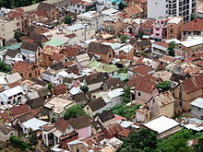
Roofs of Antananarivo, Madagascar
A roof is part of a building envelope. It is the covering on the uppermost part of a building or shelter which provides protection from animals and weather, notably rain or snow, but also heat, wind and sunlight. The word also denotes the framing or structure which supports that covering.^{[1]}
The characteristics of a roof are dependent upon the purpose of the building that it covers, the available roofing materials and the local traditions of construction and wider concepts of architectural design and practice and may also be governed by local or national legislation. In most countries a roof protects primarily against rain. A verandah may be roofed with material that protects against sunlight but admits the other elements. The roof of a garden conservatory protects plants from cold, wind, and rain, but admits light.

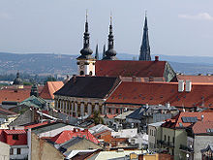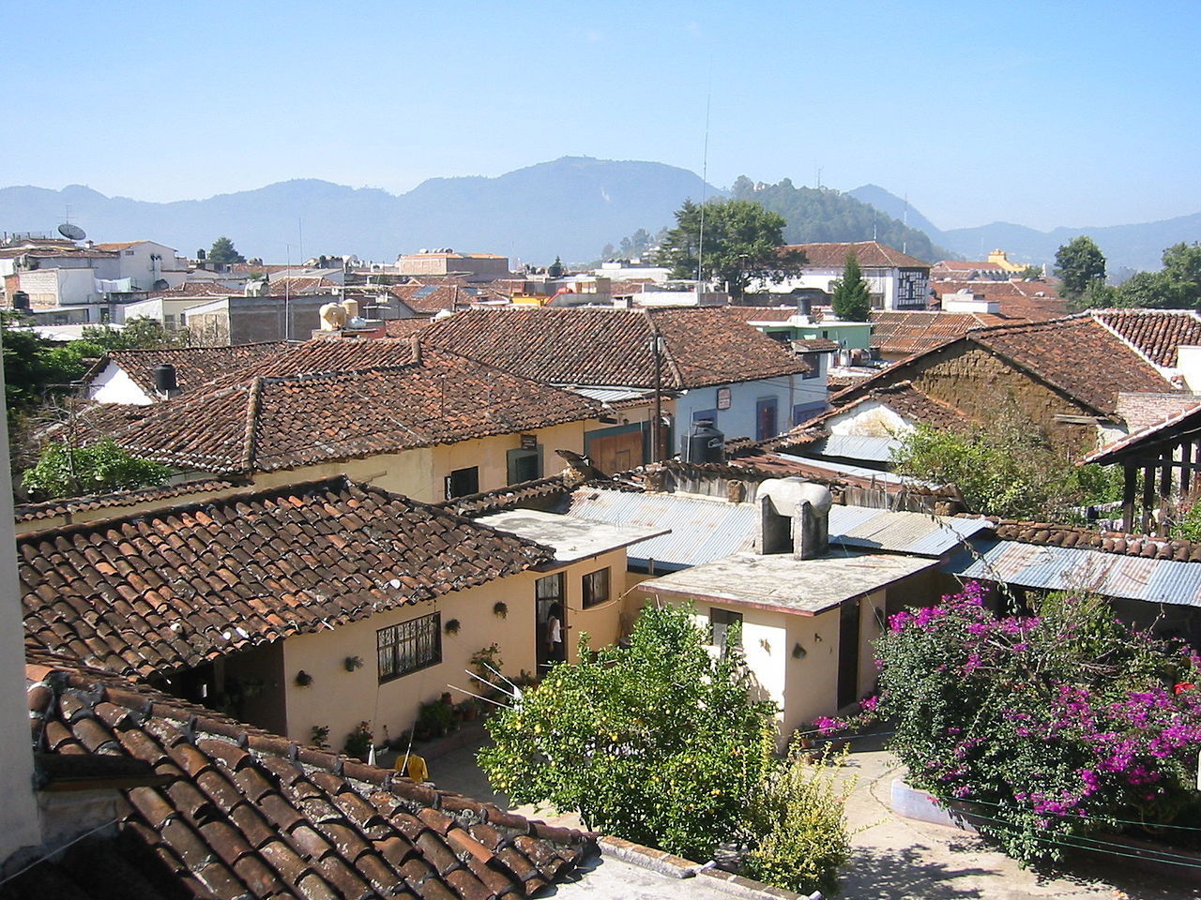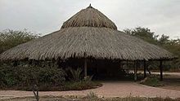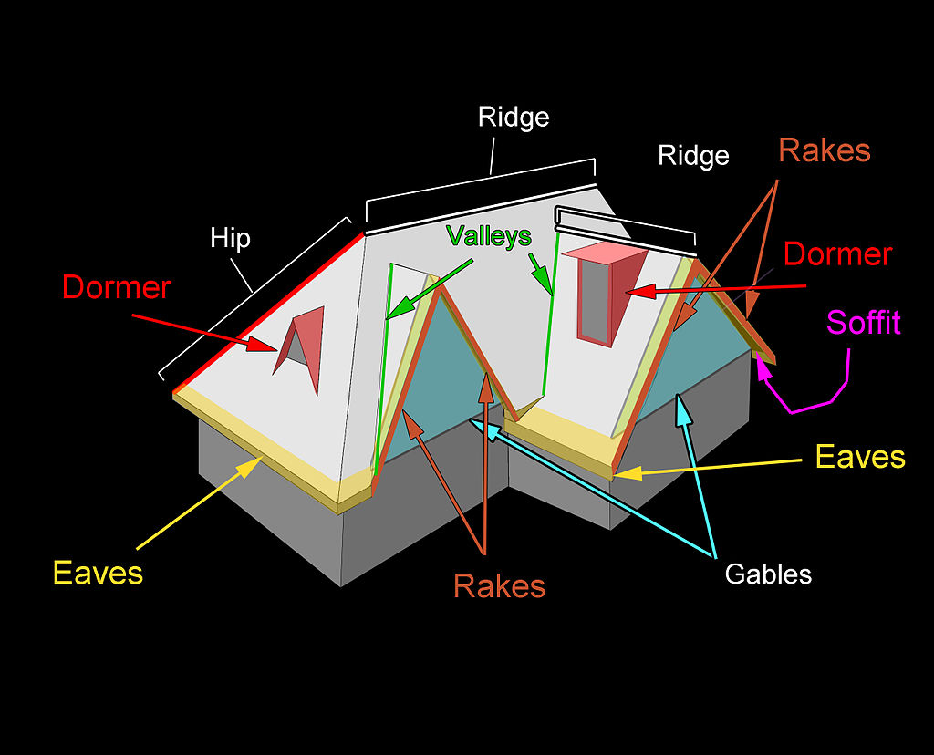
Assignment
  - Define roof
  - Mention 5 types of roof

Week 6&7; metal joining
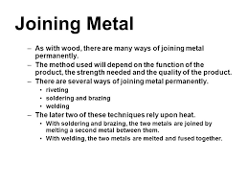

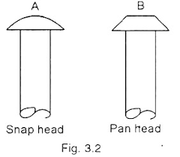
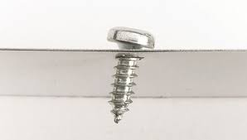

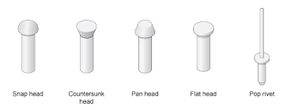
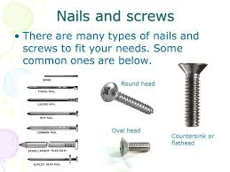

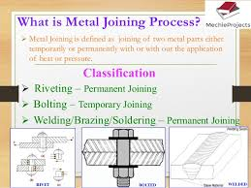

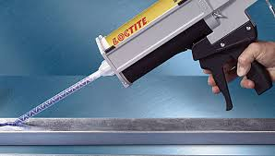

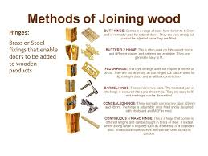

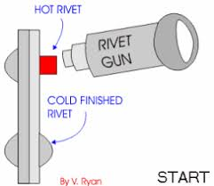

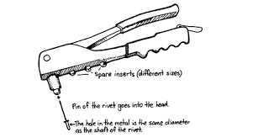
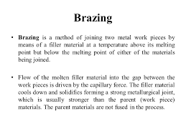

5 days ago

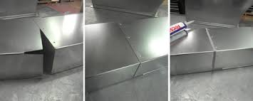

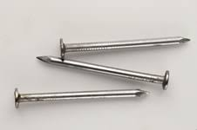
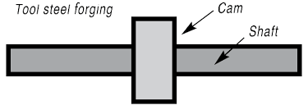

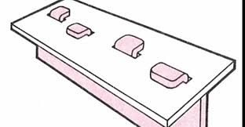

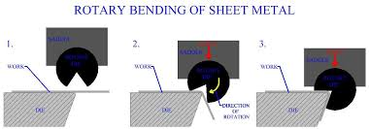
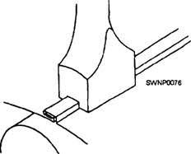

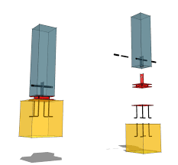
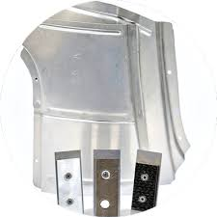

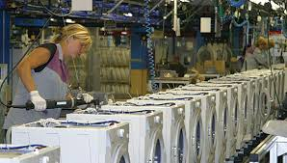
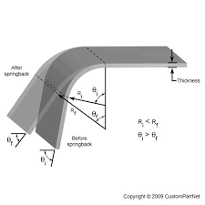
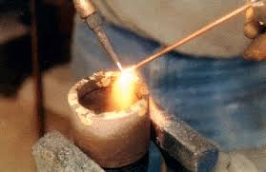
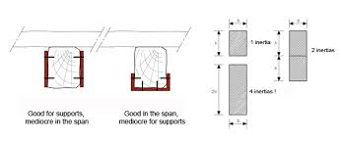

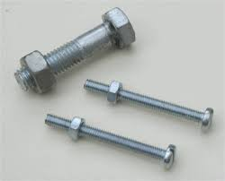

Assignment
- Mention 4 methods of joining metal
- What is riveting

Week 8; motion in engineering
Definition:
Motion can be defined as the movement of a body (object) from one point to another with the application of force.
Types of Motion
At this level, the two types of motion to be considered are Linear Motion and Rotary Motion.
Linear Motion: This is the motion of a body moving in a straight line. For instance, a push-pull link mechanism is a simple machine that operates with linear motion. E.g.

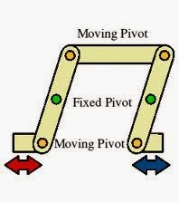

Rotary Motion: This is motion of a body moving in a circular form. Examples of circular motion is the rotation of a fan, vehicle tyres, the handle of the clock, etc. e.g.

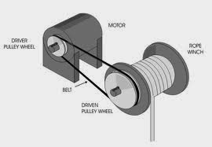

Transmission of Motion
For any engine to function, motion must be transmitted from one part of the engine to other parts. For instance, in a car, motion is often transmitted from the car engine to the wheels. This is possible because of the motion transmission system in the car.
The transmission system in a car includes the gearbox and the clutch.

Function of the Clutch: The function of the clutch is to disconnect two shafts running at different speeds, that is, the engine crankshaft and the gearbox shaft.
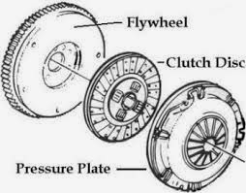

Types of Car Engines
1.Front- Engine Rear-Wheel Drive: This is an engine that consists of a clutch, a gear box, a propeller shaft and a rear axle. Most cars in Nigeria operate on this type of engine.

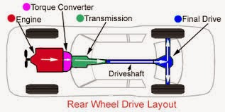

2. Front-Engine Front Wheel Drive: In this type of engine, every other parts mentioned in 1 above is present except for the propeller shaft. Transmission is directly from the gearbox to the rotating wheels.

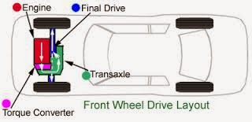

3. Rear-Engine Rear-Wheel Drive: In this type of engine, there is no propeller shaft also. The clutch, engine, gearbox are all engineered at the back of the car. Example is Volkswagen cars.

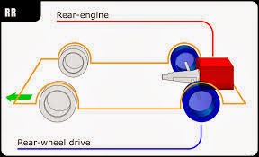

4. Front-Engine 4-Wheel Drive: This is a more recent technological advancement in the engineering of cars. There is no propeller shaft and most times no mechanical gearbox. The gear system is a hydraulic system. This car contains of the brake and the accelerator only, with all 4 wheels connected to the gear box.
e.g. Mechanical Gear System and Hydraulic Gear System.

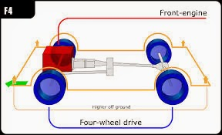

Control of Rotary Motion-Brakes
Brakes are meant to bring bicycles and cars in motion to a stop. Kinetic energy in a moving object is absorbed by the brake. This produces heat on the brake as kinetic energy is converted into potential energy. As the brake absorbs heat, the vehicle slows down until it finally comes to a stop.

How Brakes Work
There are different types of brakes. However, the principle of how the brake works is the use of friction. If the brake in a car or bicycle is pressed against the rotating drum or disc or wheel, the resulting friction between the pad and the drum or wheel slows down the rotating wheels, until they eventually come to a stop. E.g.
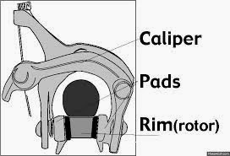
A Bicycle Brake.

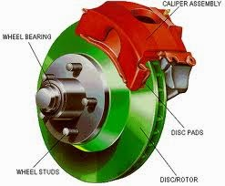
A Disc Brake.

Conversion of Rotary Motion to Linear Motion
In some machines, it is necessary for a change from one form of motion to another along it’s line of operation. For instance, a sewing machine will need to convert linear motion from the moving pedal to rotary motion at the wheel and finally to linear motion again at the needle.
The piston-crank mechanism of a car engine is another example of converting rotary motion at one point of an engine to rotary motion at another point of the same engine. (teacher will explain more). E.g.

Other examples of machines involved in converting one form of energy to another are;
Screw jack, Rack and piston steering system, Crankshaft and cylinder, Metalwork table vice, Woodworker’s vice, Pipe vice, G-clamp, etc.
assignment
(i) define motion
ii. list the two types of motions

Week 9; electrical house wiring
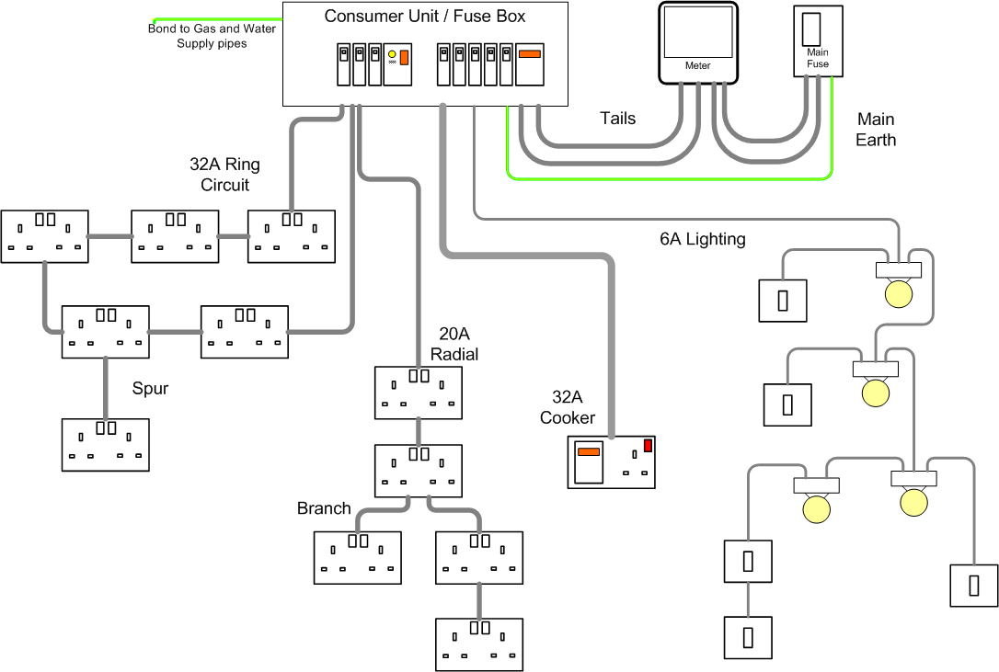

Assignment
- Define house wiring
- Explain series and parallel wiring

Week 10; tools and materials for house wiring
Top Electrical Tools List:
• Pliers
• Screwdrivers and nut drivers
• Wire strippers
• Utility Knife
• Fishing tools
• Measuring devices
• Labeling machines
• Power drills and drivers, hammer/drills
• Power saws
• Voltage Detectors/ Multimeter
HAND TOOLS
Every electrician needs basic hand tools to perform everyday tasks. Fortunately, today's basics are better than older models, providing more comfort and safety than their predecessors. Manufacturers have made tools more 'ergonomically correct,' and improved designs help cut down on hand and wrist injuries often caused by repetitive movement. Plus, they make it easier to perform the same motion over and over because the tools just feel more comfortable. While today's designs may provide more safety and comfort, they're still the basic hand tools electricians have been using for years.
Pliers
Two of the most common tools an electrician can't work without are side-cutting pliers and long-nose or needle-nose pliers.
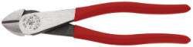
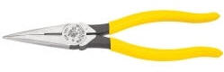
Klein is the most recognized hand tool name in the electrical industry. Top sellers include classic models such as the high-leverage side-cutting pliers for heavy-duty cutting and connector crimping, and six-inch long-nose pliers. Klein's ergonomic Journeyman series pliers are also quite popular. These tools have contoured and cushioned handles that feature a pliable outer surface and hard, black inner material providing a more comfortable grip without sacrificing tool strength and durability. They also have a contoured thumb area and a flared thumb rest that further improves their feel and gripping power.
Screwdrivers and nut drivers
Electricians need several screwdrivers and nut drivers to work with various types of fasteners and applications. For electricians who want one tool that adapts to many uses, Klein's 10-in-1 screwdriver/nut driver set with numbers 1 and 2 Phillips; 1/4-inch, 3/16-inch slotted, 5/16-inch and 1/4-inch nut drivers; numbers 10 and 15 TORX; and numbers 1 and 2 square-recess bits. Everything fits into the same chrome-plated, heat-treated shaft with a comfortable cushion-grip handle. Replacement bits are available.
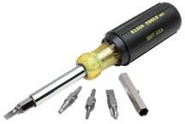
Wire strippers
In this category, Ideal Industries' T-Stripper line of wire strippers is a top seller.
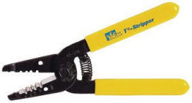
They have been an industry standard for almost 50 years. Best sellers are the Reflex wire stripper and the T-Stripper. The Kinetic Reflex T-Stripper is a strong new addition to the line.
Ergonomic designs are one reason for their popularity. Curved handles are designed to fit an electrician's natural grip and reduce repetitive motion fatigue. Non-slip Santoprene textured grips provide more control. A thumb guide promotes comfort while focusing kinetic energy for faster wire stripping.
Razor Blade Knife (Utility Knife)
Although some people use utility knifes for things they shouldn't, like stripping their Romex wiring, these tools do come in handy. You will find you use this tool quite a bit during your wiring project, even if it's just to open boxes.
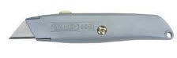
Fish tapes and poles
Fish tapes: The Ideal Tuff-Grip line of fish tapes is a strong seller at Graybar.
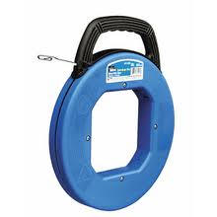
Handles on impact-resistant cases are large and comfortable, so a secure grip can be maintained, even when wearing work gloves. Tape materials are suited to any type of job.
Fish tapes are used more for conduit/commercial applications. Not all residential wiring project will require a fish tape.
Fish poles: Fish pole wire-installation tools facilitate wire pulling in drop ceilings, down walls or under raised floors. There are several Greenlee models, including the 12- and 24-foot Fish Stix kits and the new 15-foot Glo Stix that glows for better visibility in dark environments. The lightweight design makes them easier to use than heavier models.
Again, a fish pole is not required for all wiring projects. For a DIYer, keep in mind this tool is available if you get into a situation where it is needed.
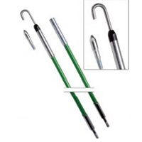
Measuring devices
Laser measuring tools are becoming more popular, but no electrician's tool belt is without a basic tape for simple measurements. Those with rare earth magnetic tips that stick to iron and steel surfaces permit fast, one-person measurements. Most folks already have a tape measure but if not you can pick one up at any hardware store or online.

Labeling machines
Properly labeling work at installation saves time when making the final connections. Labeling wires including electrical, Ethernet, and coax as you install the wire makes the final panel connections much quicker. A labeling machine can be used to label these wires. It can also be used to create labels for your electrical panel which is very handy.

Assignment
- Mention 5 tools for house wiring
- What is conduit wiring

Week 11; revision
Week 12; examination

