Scheme of work for jss1
Week 1; revision of last terms work
Week 2; types of building
Week 3; uses of building material
Week 4; drawing instrument
Week 5; care of drawing instrument
Week6; board practice
Week 7; board practice [lettering]
Week 8; free hand sketching
Week 9; sketching of work shop hand tools
Week 10; work bench fittings
Week 11; revision
Week 12; examination
Week 1; Home › Road Safety › Guidelines for Pedestrians

Guidelines for Pedestrians
The most important safety tip to reduce pedestrian injuries and fatalities is to pay attention. You can significantly reduce your chances of being in a collision with a motor vehicle by obeying traffic rules and being aware of dangers posed by cars in your vicinity. Make eye contact with drivers if possible and make sure that they can see you.

Pedestrians must
- Where possible, avoid walking next to the kerb with your back to the traffic. If you have to step into the road, look both ways first.
- Wear or carry something light coloured, bright or fluorescent in poor daylight conditions. When it is dark, use reflective materials (e.g. armbands, sashes, waistcoats and jackets), which can be seen, by drivers using headlights, up to three times as far away as non-reflective materials.
- Young children should not be out alone on the pavement or road ( see Rule 7 ). When taking children out, walk between them and the traffic and hold their hands firmly. Strap very young children into push-chairs or use reins.
- Always walk on the footpath, they are meant for you. Where there is no footpath, walk in the right side margin of the road so that you can see the traffic coming in the opposite direction.
- Cross roads where there are pedestrian crossings. They have been painted at great cost for your convenience.
- Where there are no pedestrian crossings, watch the traffic on both sides and cross when it is safe.
- You MUST NOT walk on motorways or slip roads except in an emergency.
- Never walk on the main carriageway, it could be fatal.
- Do not read newspapers or look at hoardings while walking on the road.
- Do not greet friends on the road. Take them to the footpath or the side margin.
- Do not come on to the main road while waiting for a bus. Stay on the footpath at earmarked bus stoppage.
- Where there are barriers, cross the road only at the gaps provided for pedestrians. Do not climb over the barriers or walk between them and the road.
- Do not run after a moving bus. Follow safety rules on the road and live long.
- You MUST NOT get on to or hold on to a moving vehicle.
- Don't "Drink and Walk." If you've been drinking, take a cab or a bus, or let someone sober drive you home.
- When walking at night, wear retroany type of crossing you should always check that the traffic has stopped before you start to cross or push a pram onto a crossing . Always cross between the studs or over the zebra markings. Do not cross at the side of the crossing or on the zig-zag lines, as it can be dangerous. You MUST NOT loiter on zebra, pelican or puffin crossings.

We must follow the six-step crossing code whenever we have to cross the road
THINK
What is a safe place to cross? Where can I see all the traffic properly? Make sure you are not hidden behind a parked car.
STOP
At the edge of the road where you have decided to cross.
LOOK and LISTEN
Look both ways, many time, to see if there is any traffic coming.
WAIT
For all the traffic to pass, and for road to be clear.
CROSS
Walk straight across the road.
KEEP LOOKING and LISTENING
Keep looking in all directions as you cross the road until you get to the other side.
Question
- What is safety guideline
- Who is a pedestrian

Week 2;

Types of building
The word ‘building’ is commonly considered to refer to an enclosed structure within which people can perform activities. The Building Regulations suggest that the word 'building' refers to: ‘...any permanent or temporary building but not any other kind of structure or erection’. For more information see: Construction works.
There are many ways of classifying types of building, including:
- Construction type.
- Use.
- Size.
- Style.
- Period.
- Design (for example, form, structure etc).
- Performance (for example, energy consumption, accessibility etc).
- Legal definition.
- Nature of occupancy / ownership.
This article presents a list of common types of building alphabetically (rather than by any one type of classification) with links to articles providing further information

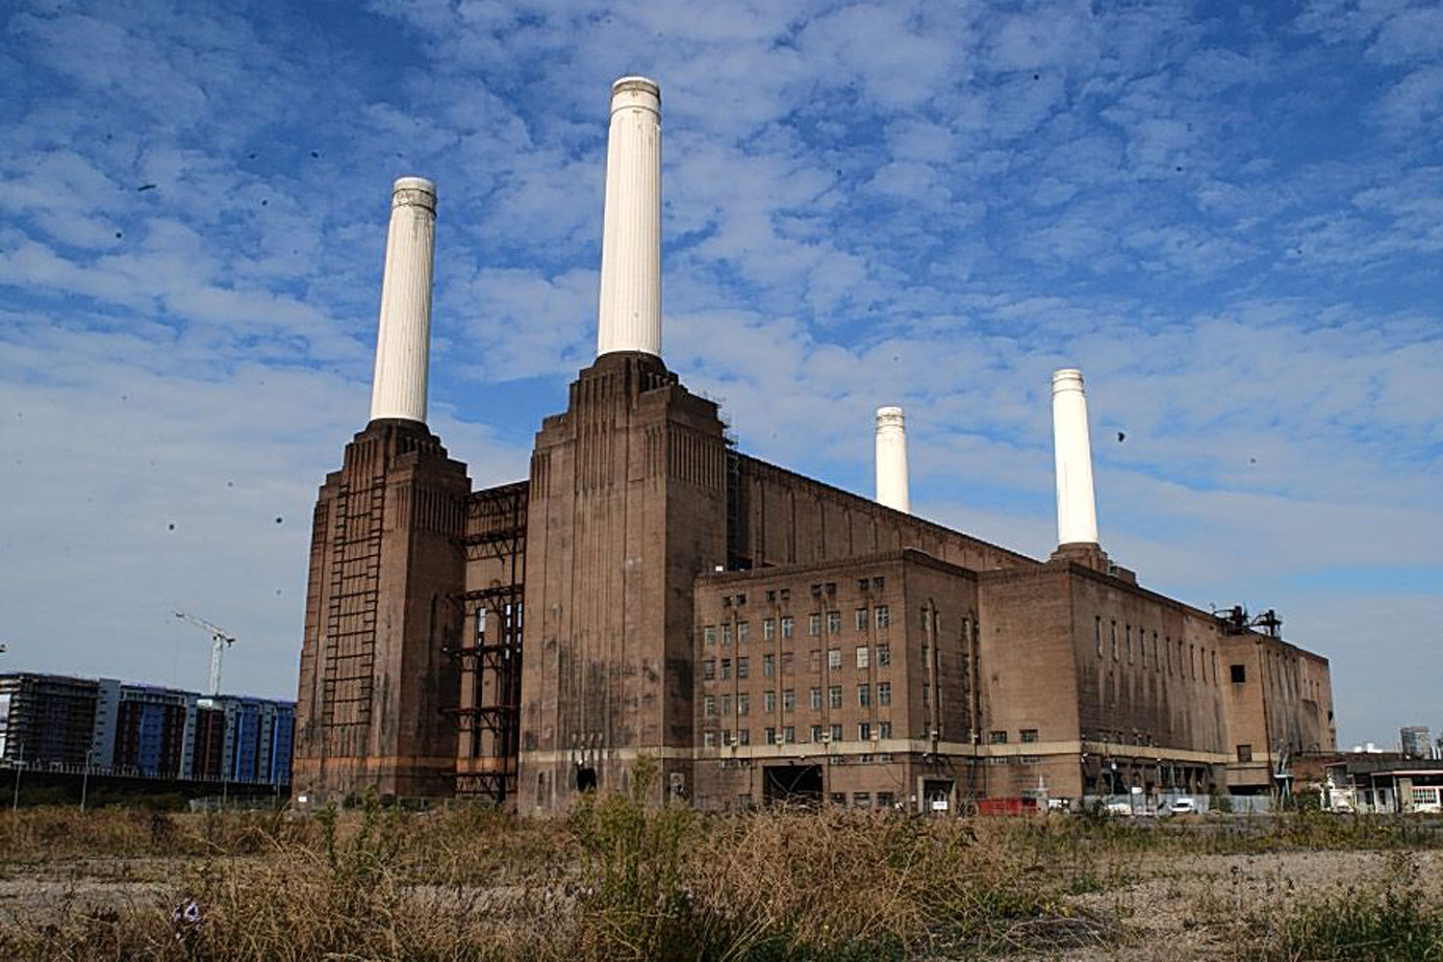
 |  |  | 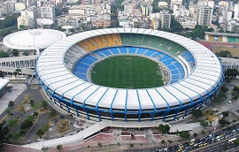
 |  | This article needs additional citations for verification. Please help improve this article by adding citations to reliable sources. Unsourced material may be challenged and removed. (December 2013) (Learn how and when to remove this template message)
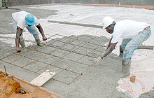
Concrete and metal rebar used to build a floor.
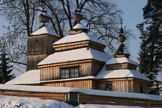
Wooden church in Bodružal in Slovakia.
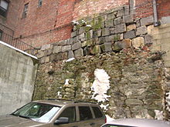
This wall in Beacon Hill, Boston shows different types of brickwork and stone foundations.
Building material is any material which is used for construction purposes. Many naturally occurring substances, such as clay, rocks, sand, and wood, even twigs and leaves, have been used to construct buildings. Apart from naturally occurring materials, many man-made products are in use, some more and some less synthetic. The manufacture of building materials is an established industry in many countries and the use of these materials is typically segmented into specific specialty trades, such as carpentry, insulation, plumbing, and roofing work. They provide the make-up of habitats and structures including homes.^{[1]}

Contents
- 1 The total cost of building materials
  - 1.1 Economic costs
  - 1.2 Ecological costs
  - 1.3 Energy costs
  - 1.4 Social costs
- 2 Naturally occurring substances
  - 2.1 Brush
  - 2.2 Ice and snow
  - 2.3 Mud and clay
    - 2.3.1 Wet-laid clay walls
    - 2.3.2 Structural clay blocks and bricks
  - 2.4 Sand
  - 2.5 Stone or rock
  - 2.6 Thatch
  - 2.7 Wood and timber
- 3 Man-made substances
  - 3.1 Fired bricks and clay blocks
  - 3.2 Cement composites
  - 3.3 Concrete
  - 3.4 Fabric
  - 3.5 Foam
  - 3.6 Glass
  - 3.7 Gypcrete
  - 3.8 Metal
  - 3.9 Plastics
  - 3.10 Papers and membranes
  - 3.11 Ceramics
- 4 Building products
- 5 Testing and certification
- 6 See also
- 7 References
- 8 External links

The total cost of building materials
This section needs expansion. You can help by adding to it. (April 2014)
In history there are trends in building materials from being natural to becoming more man-made and composite; biodegradable to imperishable; indigenous (local) to being transported globally; repairable to disposable; chosen for increased levels of fire-safety, and improved seismic resistance.. These trends tend to increase the initial and long term economic, ecological, energy, and social costs of building materials.

Economic costs
The initial economic cost of building materials is the purchase price. This is often what governs decision making about what materials to use. Sometimes people take into consideration the energy savings or durability of the materials and see the value of paying a higher initial cost in return for a lower lifetime cost. For example, an asphalt shingle roof costs less than a metal roof to install, but the metal roof will last longer so the lifetime cost is less per year. Some materials may require more care than others, maintaining costs specific to some materials may also influence the final decision. Risks when considering lifetime cost of a material is if the building is damaged such as by fire or wind, or if the material is not as durable as advertised. The cost of materials should be taken into consideration to bear the risk to buy combustive materials to enlarge the lifetime. It is said that, 'if it must be done, it must be done well'.
Assignment
- Mention 5 types of building
- Mention 5 building materials
Week 3; uses of building materials
Unit 10 Construction Materials — Types and Uses
131
sand, coarse and fine aggregates, admixtures,
and water. When first mixed, it is
plastic
(able to
flow and be shaped) and can be cast to take the
shape of the formwork provided.
Hardening of the concrete is caused by a
chemical reaction between the cement and water
called
hydration.
Most mixtures of concrete set
within 4–12 hours, depending on the tempera-
ture, the volume of the pour, type of cement, and
admixtures. When the temperature is below 70°F
(20°C), the reaction slows. Very little chemical
reaction takes place below 40°F (4°C), and
almost none occurs at 32°F (0°C). The rule of
thumb is: if you are comfortable, the concrete is
comfortable. Concrete continues to harden for
months after the initial set, but most placements
reach their compressive or design strength within
28 days. Forms can be removed after one to
several days or when the concrete can support
itself. This should be determined by an engineer.
Types of Cement
Cement
binds the concrete mix together.
There are a number of types of cement. The
most common, used for general construction, is
called
Type I Normal Portland cement.
Another
variation used in construction is
white Portland
cement.
It is light-colored and used chiefly for
architectural effects. White Portland cement is
made from carefully selected raw materials and
develops the same strength as the normal gray-
colored Portland cement.
Types of cement include:
•
Type I, Normal Cement (most common)
•
Type II, Moderate Sulfate Resistance
(slow-reacting)
•
Type III, High Early Strength (fast-setting)
•
Type IV, Low Heat of Hydration (low heat
generation)
•
Type V, High Sulfate Resistance
These other types of cements, along with
aggregates and admixtures, are available to
produce special types of concrete. Type IV is low
heat generation for large construction building
foundation projects, such as dams. Others have
high early strength to produce concrete that sets
faster than normal, permitting earlier form removal
and thus speeding construction. Still others are
more resistant to deterioration caused by sulfates
and alkalis in the soil.
D
B
Gravel
Head wall
A
Rip-
rap
C
Sand
Pea gravel
Figure 10-2.
Samples of drawing symbols for gravel. A—Plan view
of a headwall with rip-rap used to prevent erosion from
drainage water outflow. This type of structure would be
found on a site plan. B—Plan view of a gravel
driveway. C—Section view of sand layer above pea
gravel. D—Section view of crushed gravel.
132
Section 3 Specifications and Materials
Concrete Mixes
A concrete mix should be designed to
produce the desired result. Characteristics and
properties of concrete depend on the materials,
and their proportions, that make up the mixture.
This will determine the workability, strength, dura-
bility, economy, volume stability, and appearance
of the finished hardened concrete. Enough water
is added to make the mix plastic, so that it will
flow into the forms. Too much water, however, will
reduce the strength and durability of the
concrete, so the contractor needs to be careful. A
typical mix would consist of 10% cement, 15%
water, 25% fine aggregates, 45% coarse aggre-
gates, and 1% to 5% entrained or entrapped air.
Any material added to the concrete mix —
other than cement, sand, aggregate, and water
— is known as an
admixture.
Admixtures are
used to make the mix more workable, retard or
speed up hardening, increase freeze resistance,
or increase chemical resistance. Common admix-
tures to concrete include
air-entrainment,
used to
improve durability in freeze/thaw environments;
retarders,
used to slow down the initial set of
fresh concrete, especially in hot weather;
accel-
erators,
used to speed up the initial set of fresh
concrete in cold weather;
water reducers
, used to
reduce the amount of water required for a desired
workability and water-to-cement ratio for strength,
and
coloring agents
, used for altering the color of
the concrete mixture. Concrete is typically trans-
ported to the jobsite in a ready-mix truck.
Reinforced Concrete
Concrete has great compressive strength, but
very little tensile (pulling) strength. To overcome this
weakness, concrete is cast around steel
rein-
forcing bars
. These bars (commonly referred to as
“rebar”) have high tensile strength. As the concrete
hardens, it grips the steel to form a bond. The size
of the bar is indicated by the bar number, which is
a multiple of 1/8
′′
. For example, a #4 bar is 1/2
′′
in
diameter (4
×
1/8
′′
= 1/2
′′
). See
Figure 10-3.
Refer
to Unit 12 for more information.
Reinforcing bars are round in shape, with
projections (called
deformations
) formed in the
rolling process to strength bonding with the
concrete. Bars are placed after the forms are
constructed,
Figure 10-4.
The concrete is then
cast around the bars.
Figure 10-3.
Reinforcing steel bars (“rebar”). Bar diameters are identified by a number that is a multiple of 1/8
′′
. From left, bars
shown are #18, #14, #11, #9, #8, #7, #6, #5, #4, #3. The #18 bar is 2 1/4
′′
in diameter; the #3 bar is 3/8
Division 06 – Wood
and Plastics
Wood continues to be one of the chief
building materials,
Figure 10-20
. It is used for
structural framing (rough carpentry), trim, floors,
walls, and cabinetry (finish carpentry and archi-
tectural woodwork). Relative to its weight, wood
has high strength in compression, tension, and
bending. It also has excellent impact resistance.
While steps have been taken to substitute other
materials, wood remains a valuable and widely-
used residential construction material.
Figure 10-18.
This steel frame is designed to support the entire
weight of the building.
Figure 10-19.
Open-web steel joists combine strength with light
weight.
Wood Classification
Woods are broadly classified as either hard-
woods or softwoods. There are many varieties
used for construction. These classifications are
not an exact measure of hardness or softness
(because this varies) but a general classifica-
tion based on type of tree. In addition to hard-
ness or softness, woods vary in strength,
weight, texture, workability, and cost. Building
specifications usually indicate the type and
grade of lumber to be used in different parts of
the construction.
Assignment
- State 5 uses of building materials
- What is the function of cement in building

Week 4; drawing instrument

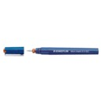

Technical pens
More

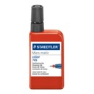

Drawing ink
More

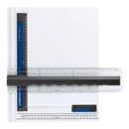

Drawing boards
More

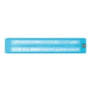

Lettering guides
More

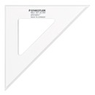

Rulers & set squares
More

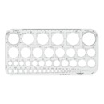

Drawing accessories
More

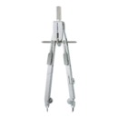

Compasses

Chapter - 1A
DRAWING INSTRUMENTS
AND THEIR USES
Drawing Instruments are used to prepare neat and accurate Drawings. To a greater extent, the ac-
curacy of the Drawings depend on the quality of instruments used to prepare them. The following is the list
of Drawing Instruments and other materials required.
a)
Drawing Board
b)
T-square or Drafter (Drafting machine)
c)
Set Squares
d)
Protractor
e)
Drawing Instrument Box
f)
Drawing Sheet
g)
Drawing Pencils
h)
Drawing Pins/Clips
a) Drawing Board :
Drawing board is made from strips of well seasoned soft wood generally 25 mm thick. It is cleated
at the back by two battens to prevent warping. One of the shorter edges of the rectangular board is pro-
vided with perfectly straight ebony edge which is used as working edge on which the T-square is moved
while making Drawings.
Battens
Working edge
(ebony)
Fig. 1A.1
Note:
When Minidrafter (Drafting machine) is used to prepare Drawings, the working edge is not
used.
2
Computer Aided Engineering Drawing
Drawing board size:
Drawing boards are made in various sizes. The selection of Drawing board depends on the size of
drawing paper used. The sizes of Drawing board recommended by Bureau of Indian Standards (B.I.S) is given
below
Standard size of Drawing boards
Designation
Size (mm)
Designation
Size (mm)
B0
1500 × 1000
B3
500 × 350
B1
1000 × 700
B4
250 × 350
B2
700 × 500
b) T-square :
T-squares are made from hard wood. A T-square consists of two parts namely the stock and the
blade joined together at right angles to each other by means of screws and Pins as shown in figure 1A.2. The
stock is made to slide along the working edge and the Blade moves on the Drawing board.
Wo r k i n g e d g e
Blade
Stock
Screws
Fig. 1A.2
The working edge of T-square is used to draw parallel lines, vertical lines or inclined lines at 30
°
, 60
o
to the horizontal using set squares.
Drafting machine (or Drafter):
In a Drafting machine, the uses and advantages of T-square, set square, scales, protractors are
combined. One end of the Drafter is clamped at the left top end of the Drawing board by a screw provided
in the drafter.
An adjustable head with a Protractor is fitted at the other end of the Drafter. Two blades made of
transparent celluloid material are fitted to the adjustable head and are perfectly perpendicular to each other.
These blades are used to draw parallel, horizontal, vertical and inclined lines. The blades always move parallel
to the edges of the board. Use of Drafting machine helps in reducing the time required to prepare Drawing.
Drawing Instruments and their Uses
3
Scale
Scale
Potractor
Angle
Drawing sheet
Drawing board
Parallel bar arm
Parallel bar arm
Fig. 1A.3
c) Set Squares :
Set squares are generally made from Plastic or celluloid material. They are triangular in shape with
one corner, a right angle triangle. A pair of set squares (30
°
–60
°
) and 45
°
(45
°
set square are generally pro-
vided with Protractor) facilitate marking of angles as shown in figures 1A.4 and 1A.5.
They are used to draw lines at 30
°
, 60
°
and 45
°
to the vertical and horizontal.
mm
g
. 1A.6. 45 Set Square with Protractor
0
d) Protractor:
Protractors are used to mark or measure angles between 0 and 180
°
. They are semicircular in shape
(of diameter 100mm) and are made of Plastic or celluloid which has more life. Protractors with circular shape
capable of marking and measuring 0 to 360
°
are also available in the market.
180
e) Drawing Instrument Box :
It consists of the following
a) Large size compasses,
b) Large size divider,
c) Small size bow pen, bow divider, and
d) Lengthening bar
f) Drawing sheet:
They are available in many varieties and good quality paper with smooth surface should be selected
for Drawings which are to be preserved for longer time. Sizes of Drawing Sheets recommended by Bureau
of Indian Standards (B.I.S) is given below,
Drawing Instruments and their Uses
5
Standard size of Drawing sheet
Designation
Size (mm)
Designation
Size (mm)
A0
1189 × 841
A3
420 × 297
A1
841 × 594
A4
297 × 210
A2
594 × 420
A5
210 × 148
g) Drawing Pencils:
The accuracy and appearance of a Drawing depends on the quality of Pencil used to make Draw-
ing. The grade of a Pencil lead is marked on the Pencil. HB denotes medium grade. Increase in hardness
is shown by value put in front of H such as 2H, 3H etc., Softer pencils are marked as 2B, 3B, 4B etc. A
Pencil marked 3B is softer than 2B and Pencil marked 4B is softer than 3B and so on. Beginning of a Draw-
ing may be made with H or 2H. For lettering and dimensioning, H and HB Pencils are used.
h) Drawing Pins and clips:
These are used to fix the Drawing sheet on the Drawing board.
Compass:
Compass is used for drawing circles and arcs of circles. The compass has two legs hinged at one
end. One of the legs has a pointed needle fitted at the lower end where as the other end has provision for
inserting pencil lead. Circles upto 120mm diameters are drawn by keeping the legs of compass straight. For
drawing circles more than 150 mm radius, a lengthening bar is used. It is advisable to keep the needle end
about 1mm long compared to that of pencil end so that while drawing circles, when the needle end is pressed
it goes inside the drawing sheet by a small distance (approximately 1mm).
assignment
- List 5 uses of drawing instrument
- Draw set squares
week 5; care of drawing instruments

Cleaning, maintaining and preserving your Drawing material

Art Material
Rate this article
Top of Form
Give Cleaning, maintaining and preserving your Drawing material 1/5
Give Cleaning, maintaining and preserving your Drawing material 2/5
Give Cleaning, maintaining and preserving your Drawing material 3/5
Give Cleaning, maintaining and preserving your Drawing material 4/5
Give Cleaning, maintaining and preserving your Drawing material 5/5
Bottom of Form
Every medium has its frailties. It's up to you to take care of them!

1. Rules of thumb

Caution: fragile media!
- When transporting your tools and drawing, carefully put your media away in cases. Charcoal is very volatile and drops its pigments on your paper and on the table, not to mention graphite pencils, color pencils and pastels, which roll, fall and break.
- Try, as best as you can, to keep your workspace clean. You should always have a clean, dry rag or absorbent paper nearby to wipe your hands.
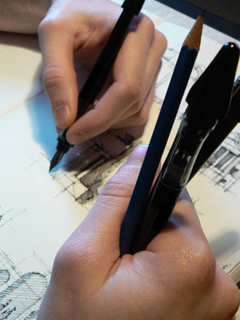

2. Caring for your tools with leads
​
The leads in graphite pencils and color pencils often break, even inside their wood casings. Protect them from shocks. When working with several pencils at once, avoid constantly laying them down and picking them up again. It's better to hold them in the hand that isn't drawing.
To properly clean your color pencils after sharpening them, pass over the lead with a paintbrush to remove the color residue.
Tip: Sharpen your pencils by hand. Sharpening your pencils with a knife or utility knife gives you better control of the form, length and support you give to your lead. You can also use lead in a mechanical pencil, which is more solid.

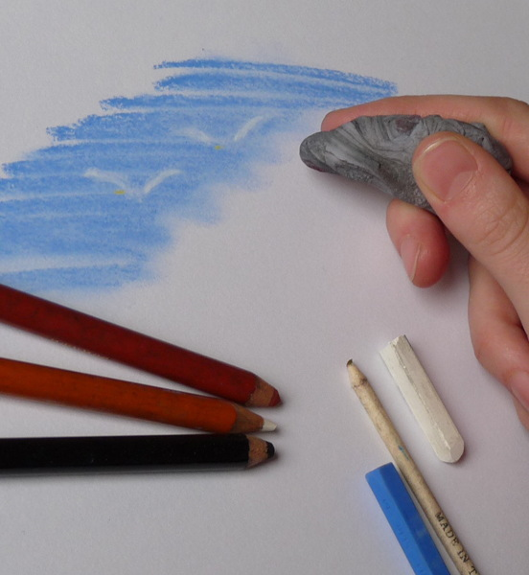

3. Clean your erasers

If your eraser soils your drawing, it's too dirty...
- Clean classical erasers by rubbing them with a cotton cloth or washing them in soapy water (don't forget to dry them before using them).
- Kneaded erasers are self-cleaning. By kneading them, you enclose the charcoal pigment inside the eraser and use a clean part. When the eraser becomes saturated with pigment, throw it out.

4. Fix your media

Charcoal, dry sanguine and chalk are all unstable media. To preserve your creations, fix them on the paper.
Assignment
- How can we care for drawing instruments [explain]
Week 6; board practice

Saturday, 26 October 2013

JSS 1. TOPIC 5: DRAWING PRACTICE: Drawing Instruments and Materials

Drawing practice is simply technical drawing. Technical drawing is the language used by engineers and architects to interpret objects, symbols, lines, curves and conventional representations on paper.

Drawing Instruments:
Drawing instruments are tools used in technical drawing that do not get consumed while using them. They include the following:
(i). Drawing Board: This is a flat wooden board with a smooth, rigid surface. It is suitable for A3 paper.
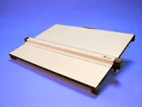
(ii). Tee-square: This is a T-shape instrument containing a head and a stock. It is used for drawing all horizontal lines and for setting the paper on the board.
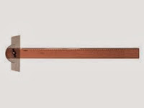

(iii). Set-square: We have the 45⁰ and 30⁰/60⁰ set-squares. They are used for drawing vertical and angled lines.
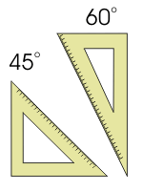
(iv). Rules: This is a 30cm wooden or plastic instrument, used for measuring lengths and for dimensioning scaled drawings.
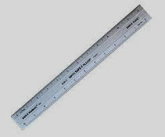
(v). Protractor: The protractor is used for measuring angles in degrees.
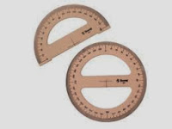
(vi). French curves: This instrument is used to draw different shapes of curves.
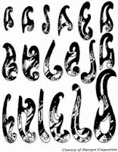

(vii). Drawing set: This is a pack containing different drawing items like pair of compasses, divider, etc.

Drawing Materials:
Drawing materials on the other hand, are items that get consumed with use. They include the following:
(i). Drawing paper: The paper commonly used for technical drawing is the A3 paper. Other drawing papers are the A1, A2, A4, etc, depending on the work to be done.
(ii). Pencil: The 2H pencil is used for construction lines, ‘H’ is for lettering and thickening of visible lines. The HB pencil is good for free-hand sketching.
(iii). Pencil sharpeners: This is a material used to sharpen all pencils to a conical point shape.
(iv).Emery cloth: Instead of re-sharpening the pencil, this material is used to restore sharpness to the pencil.
(v). Brush: The brush is used to remove dirt from the paper after erasing.
(vi). Eraser: This material is used to remove mistakes. It is made of soft quality rubber.

Care and Storage of Drawing Instruments and Materials.
To care for their drawing instruments, students should do the following:
(i). Do not use any sharp objects on the edges of the drawing board.
(ii). When not in use, cover the face of the board to avoid dust.
(iii).The Tee-square should not be used as a sword or staff to play with.
(iv). Never use any sharp object on the edges of your set-squares.
(v). When you are not working with your instruments, keep them on their sheaths and packs.
(vi). Drawing paper should be kept in a flat file or jacket.

REVIEW QUESTIONS
(i). Define drawing practice.
(ii). What is the difference between drawing instrument and drawing material?
ASSIGNMENT
State the uses of the following drawing instruments and drawing materials:
i. Tee square
ii. Sketch pad
iii. Set square
iv. Eraser
v. HB pencil
Week 7; board practice [lettering]

JSS 1. TOPIC 5: DRAWING PRACTICE: Drawing Instruments and Materials

Drawing practice is simply technical drawing. Technical drawing is the language used by engineers and architects to interpret objects, symbols, lines, curves and conventional representations on paper.

Drawing Instruments:
Drawing instruments are tools used in technical drawing that do not get consumed while using them. They include the following:
(i). Drawing Board: This is a flat wooden board with a smooth, rigid surface. It is suitable for A3 paper.
(ii). Tee-square: This is a T-shape instrument containing a head and a stock. It is used for drawing all horizontal lines and for setting the paper on the board.

(iii). Set-square: We have the 45⁰ and 30⁰/60⁰ set-squares. They are used for drawing vertical and angled lines.
(iv). Rules: This is a 30cm wooden or plastic instrument, used for measuring lengths and for dimensioning scaled drawings.
(v). Protractor: The protractor is used for measuring angles in degrees.
(vi). French curves: This instrument is used to draw different shapes of curves.

(vii). Drawing set: This is a pack containing different drawing items like pair of compasses, divider, etc.

Drawing Materials:
Drawing materials on the other hand, are items that get consumed with use. They include the following:
(i). Drawing paper: The paper commonly used for technical drawing is the A3 paper. Other drawing papers are the A1, A2, A4, etc, depending on the work to be done.
(ii). Pencil: The 2H pencil is used for construction lines, ‘H’ is for lettering and thickening of visible lines. The HB pencil is good for free-hand sketching.
(iii). Pencil sharpeners: This is a material used to sharpen all pencils to a conical point shape.
(iv).Emery cloth: Instead of re-sharpening the pencil, this material is used to restore sharpness to the pencil.
(v). Brush: The brush is used to remove dirt from the paper after erasing.
(vi). Eraser: This material is used to remove mistakes. It is made of soft quality rubber.

Care and Storage of Drawing Instruments and Materials.
To care for their drawing instruments, students should do the following:
(i). Do not use any sharp objects on the edges of the drawing board.
(ii). When not in use, cover the face of the board to avoid dust.
(iii).The Tee-square should not be used as a sword or staff to play with.
(iv). Never use any sharp object on the edges of your set-squares.
(v). When you are not working with your instruments, keep them on their sheaths and packs.
(vi). Drawing paper should be kept in a flat file or jacket.

REVIEW QUESTIONS
(i). Define drawing practice.
(ii). What is the difference between drawing instrument and drawing material?
ASSIGNMENT
State the uses of the following drawing instruments and drawing materials:
i. Tee square
ii. Sketch pad
iii. Set square
iv. Eraser
v. HB pencil
April 3, 2017 by admin 1 Comment
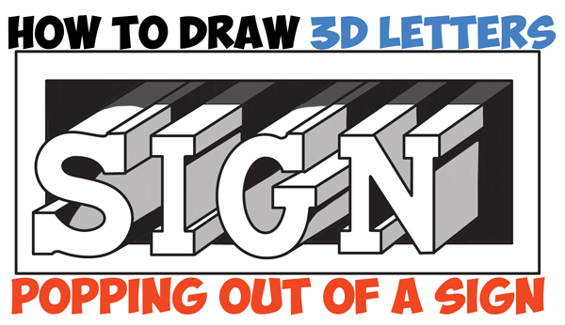
Today I'll show you how to draw letters popping out of a sign or piece of paper. The following easy step by step drawing tutorial will guide you through the process. Happy Drawing!
Posted in: How to Draw Cool Stuff, Lettering and Drawing Letters Tagged: 3-d letters, 3-dimensional letters, 3d lettering, 3d letters, cool lettering, cool letters, drawing type, lettering, letters popping out, typography

How to Draw Cool 3D Interlocking Letters in Easy Step by Step Drawing Tutorial for Kids and Beginners
December 11, 2016 by admin Leave a Comment
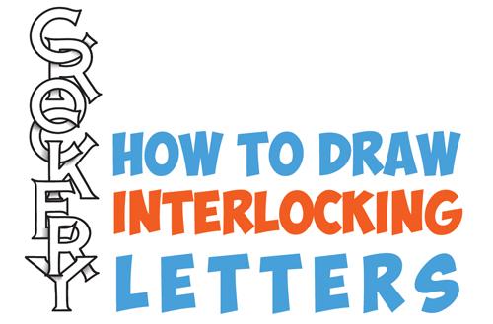
Today I'll show you how to draw these cool 3-dimensional letters. Each of these letters is interlocked together...they are hanging off of each other. This is a really cool, yet easy lettering effect that you will enjoy drawing or doodle. Happy Drawing!
Posted in: How to Draw Cool Stuff, Lettering and Drawing Letters Tagged: 3d letters, cool letters, how to draw cool letters, interlocked letters, interlocking letters, overlapped letters, overlapping letters

How to Draw 3D Letters, Stacked and at an Angle – Easy Step by Step Drawing Tutorial for Beginners
November 18, 2016 by admin Leave a Comment
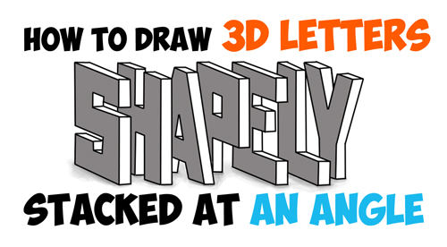
Today I'll show you how to draw cool 3D letters that are turned at a sharp angle (45 degrees towards the viewer) and stacked. We will guide you through the steps so that it is easy for you to learn how to draw. We will also show you how to cast a shadow.
Posted in: How to Draw Cool Stuff, Lettering and Drawing Letters Tagged: 3-dimensional letters, draw 3d letters, drawing 3d letters, how to draw 3d letters, how to draw letters at an angle, letters at an angle, stacked letters

How to Draw Cool 3D Letters Wrapped Around, Over, and Under Notebook Paper Lines – Easy Steps Drawing Tutorial for Kids
November 16, 2016 by admin 2 Comments
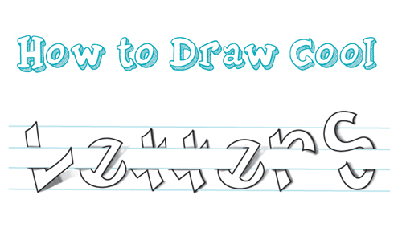
Today I will show you how to draw these cool 3-dimensional letters that seem to be going around, under, and over notebook paper. This is a cool and fun doodling idea for when you are bored. The following simple step by step drawing instructions / lesson will guide you through the steps of drawing these cool letters. Have fun!
Posted in: drawing lessons for kids, Drawing Tricks, How to Draw Cool Stuff, Lettering and Drawing Letters Tagged: 3d letters, cool lettering, how to draw 3d letters, how to draw cool letters, how to draw letters, lettering, notebook paper, notebook paper effect, notebook paper illusion

Learn How to Turn 6 Lines into The Coolest Letter S – Easy Step by Step Drawing Tutorial for Kids
May 10, 2016 by admin 2 Comments
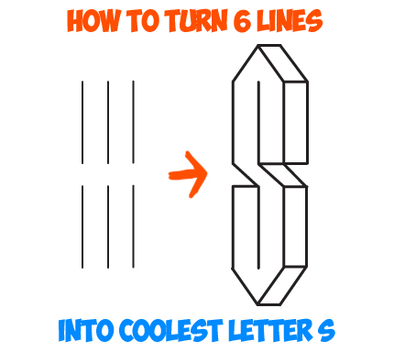
When I was growing up in the 80s and 90s, this was one of my favorite things to doodle. It is so easy to draw and it makes you look like you are a fantastic drawer. And I wasn't the only one to draw this cool, 3d looking letter 'S'...all the kids were doing it. Learn how to draw this easy futuristic letter 'S' starting with 6 lines.
Posted in: drawing lessons for kids, How to Draw Cool Stuff, Lettering and Drawing Letters Tagged: 3-dimensional letters, 3d letters, cool drawing, doodles, doodling, fun drawing, letter s

How to Draw 3-Dimensional Letters with 2 Point Perspective – Simple Drawing Tutorial
April 8, 2016 by admin Leave a Comment
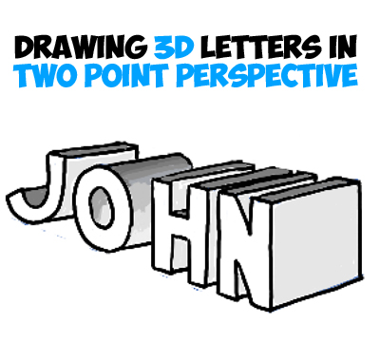
Making these 3 dimensional letters looks like a lot of work, but trust me, drawing these are easy. All you have to do is learn the perspective drawing techniques and you will be able to draw anything with depth and 3-dimensionality. Find out how now.
Posted in: How to Draw Cool Stuff, Lettering and Drawing Letters, Perspective Drawing Tagged: 2 point perspective, 3-dimensional letters, 3d letters, angular perspective, drawing 3d letters, how to draw 3d letters, letters in 2 point perspective, letters in perspective, two point perspective

How to Draw 3D Letters in One Point Perspective – Perspective Drawing Tutorial
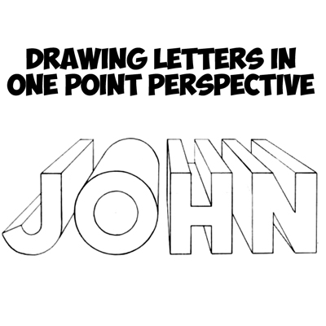
Assignment
- Write letter a- z using lettering drawing
Week 8; free-hand sketching

01. Pencil grip

Think of the pencil as charcoal in a wooden sheath
When I draw, I use not the tip but the side of the lead in order to maximise its utility. Holding my pencil like I would charcoal also keeps it sharper longer. When covering large areas, I shade with my pencil perpendicular to the line I'm drawing to get wide, soft lines; for details, I hold my pencil parallel to my lines to get sharp, narrow marks. The only time I use the point is when I'm working on intricate details.

02. Shading techniques

Shading with unified lines versus with patches
I like to shade in two main ways: the first is with all of my lines going in the same direction, which makes my shading appear more cohesive. This pencil drawing technique also helps my details pop out from the lines I'm using for shading.
The second method I use is working in patches, which help define shape. Patches of lines go around the form, which help keep things in perspective. This technique is also great for backgrounds and adding texture.

03. Line weight

Line weight can help define solidity and volume
The next drawing technique concerns line weight. Having control over my line weight is a great way to separate objects from one another, and can help emphasise shadows. Thicker lines can fade and disappear into the shadows, which can help convey the 3D form.
I try to avoid outlining my drawings because this tends to make things look flat and deadens the 3D effect. Breaks and spaces in my lines show form in the lights and shadows.

04. Sketch language

Use light lines to explore and dark lines to commit
When I start drawing, I plan and explore using loose lines, and avoid committing too early with hard, dark lines. As I progress my lines will change; checking and rechecking my work is vital. I darken my lines and add details at the end. I don't focus on one area for too long to prevent overdrawing.
When drawing something symmetrical, I focus on the spaces between the lines, and of course keep reevaluating as I go along.
Assignment
- What is free hand sketching
- Draw hammer with free hand sketching

Week 8; free hand sketching [work shop tools]
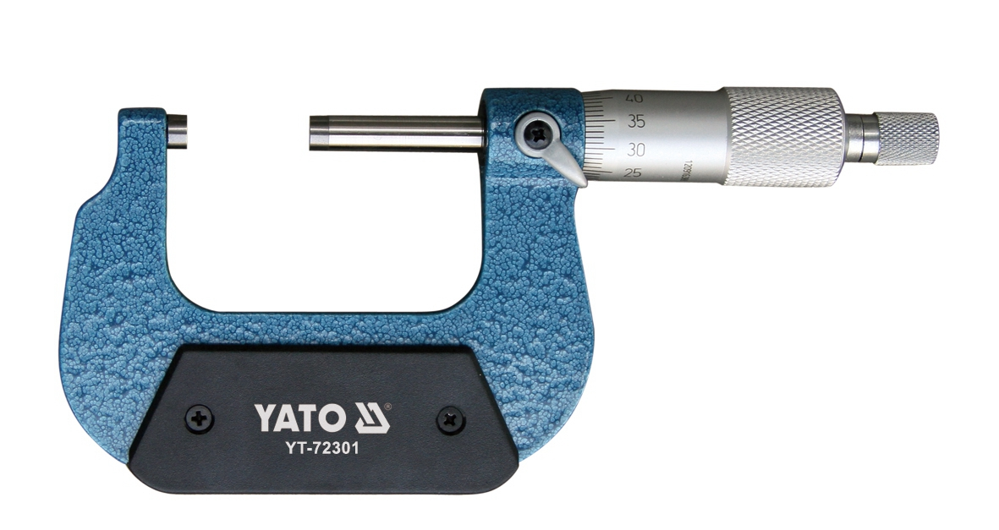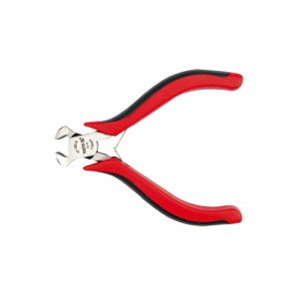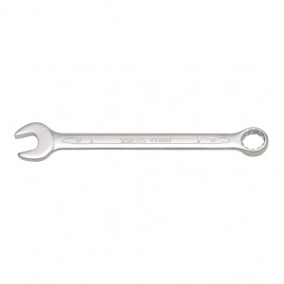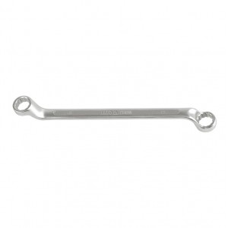
Week 9; freehand sketching
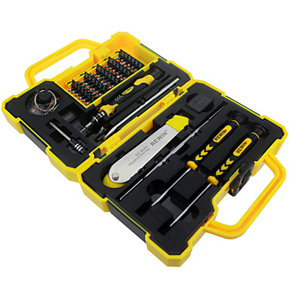

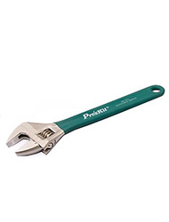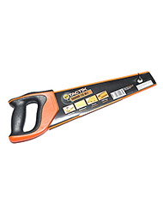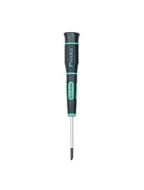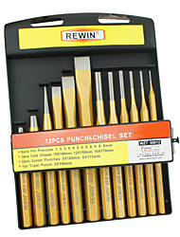

Question
- Draw mallet
- Draw hack saw with freehand sketching

Week 10; work bench fittings
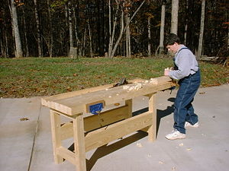
A basic bench
A workbench is a table used by woodworkers to hold workpieces while they are worked by other tools. There are many styles of woodworking benches, each reflecting the type of work to be done or the craftsman's way of working. Most benches have two features in common: they are heavy and rigid enough to keep still while the wood is being worked, and there is some method for holding the work in place at a comfortable position and height so that the worker is free to use both hands on the tools. The main thing that distinguishes benches is the way in which the work is held in place. Most benches have more than one way to do this, depending on the operation being performed.

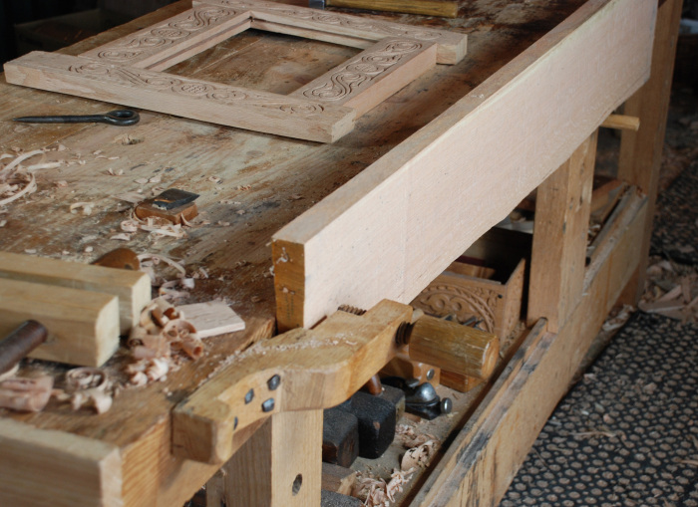
Assignment
- Mention five work bench appliances
- What is the function of work bench

