E-NOTE FOR CHEMISTRY SS1

SCHEME OF WORK FOR SECOND TERM SS1 CHEMISTRY.

WEEKS TOPICS
- REVISION OF FIRST TERM /INTRODUCTION TO MOLE CONCEPT.
- CALCULATIONS IN TERMS OF AVOGADRO’S CONSTANT,EMPIRICAL FORMULA AND MOLECULAR FORMULA
- WRITING AND BALANCING OF CHEMICAL EQUATIONS.
4&5 STATE, ILLUSTRATIONS AND VERIFICATION OF CHEMICAL LAWS.
6. CHEMICAL COMBINATIONS OR BONDING.
7. THE KINETIC THEORY OF MATTER.
8. GAS LAWS AND CALCULATIONS.
9. GAY-LUSSAC’S LAW
10. AIR & FLAME.

WEEK 1
INTRODUCTION TO MOLE CONCEPT
Matter is defined as anything that has mass and occupies space it is made up of discrete of tiny particles such as atoms, molecules and ions.

ATOM: This is the smallest particle of an element which can participate/take part in a chemical reaction. E.g., O, N, F, S, Cl, Na, He etc.
NOTE: Atoms cannot exist separate.

MOLECULE: This is the smallest particle of a substance that is capable of independent existence and still retains the chemical properties of that substance. Examples H₂, 0₂, F₂, S₈, Cl₂, H₂O, NaCl etc.

NOTE: A molecule is formed when two or more atoms are chemically joined together. The combination of atoms of the same type produces molecules of an element while the combination of different types of atoms produce molecule of a compound. The molecule does not lose its identity.

ATOMICITY: This is the number of atoms in a molecule of an element, most gaseous elements are diatomic. Examples comprise of noble gases and metals respectively. Example He, ,Ar, Ne, Ca, Mgetc.P₄ tetra atomic element 0₃ triatomic element S₈ polyatomic element.

IONS: These are atoms or group of atoms which possesses an electric charge. There are two types of ions namely:
i. Cations which results from the loss of electrons by the atom of a metal to become positively charge. Example, K⁺, Na⁺, Ca²⁺, Al³⁺, Cr³⁺, Ag⁺, Pb²⁺, NH₄⁺

ii. Anions which results from the gain of electrons by the atom of non metal to become negatively charge. Example 0⁻², Cl⁻, F⁻, S⁻², N⁻³, 0H⁻, S0₄²⁻, Cr₂0₇²⁻, MnO₄⁻ etc.

RELATIVE FORMULAE MASS
The relative formulae mass of a substance can be defined as the number of times the mass of one
Formulae unit of the substance is heavier than one twelfth of the mass of one atom of carbon 12
i.e.

RELATIVE FORMULAE MASS
Mass of 1 formulae unit of a substance ¹_{/12} x mass of atom of Carbon -12.

RELATIVE ATOMIC MASS (RAM)
The relative atomic mass (RAM) of an element is the mass of one atom of the element. R.A.M
not a whole number because of the existence of the phenomenon of isotopy.

NOTE: R.A.M has no unit.

DEFINITION:
The relative atomic mass of an element can be defined as the number of times the average mass
Of atom of the element is heavier than one twelfth of the mass of one atom of carbon-12.
R.A.M.=mass of I atom of the element
¹/₁₂ x mass of I atom of carbon

NOTE:
a. Carbon is used as a standard
b. The instrument used for measuring relative atomic mass is called mass spectrometer

RELATIVE MOLECULAR MASS (Mr/Rmm) of a substance is the mass of one molecule of the substance. The r.m.m. is the sum of the R.A.M. of all the atoms present in the molecule.

NOTE: The r.m.m has no unit.

DEFINITION
The relative molecule mass of an element or a compound is the number of time the mass of one
Molecule of the element or compound is heavier than one twelfth of the mass of one atom of
Carbon-12.
R.m.m. = Mass of 1molecule of substance
¹/₁₂ x mass of atom of carbon -12

= mass of 1 molecule of substance x 12
Mass o atom of carbon -12
Example
1. Calculate the relative molecular masses of each of the following
a) H₂S0₄ (b) Al₂ (S0₄) ₃

c) Fe S0₄ 7H₂0
(H=1, S=32, 0=16, Al=27, Fe = 56)

SOLUTION
- = ₂ H + ₁S + ₄0
= 2 x 1 + 32 + 4 x 16
2 + 32 + 64 = 98

b. Al₂ (S0₄)₃
= 2Al + 3^{S} + 12 ⁰
= (2x27) + (3x32) + (12x16)

54 + 96 + 192
= 342

c. FeS0₄. 7H₂0
= Fe+ S+₄0 + 7 (2H+0)
= 56 + 32 + (4x16) + (7x18)
= 56 + 32 + 64 + 126
= 278

Exercises
Calculate the R.m.m. of the following compounds
i. Calcium hydroxide Ca (OH) ₂
ii. Lead (ii) trioxonitrate Pb (N0₃)₂
iii. Ammoniumtrioxocarbonate (IV) (NH₄)₂C0₃
iv. Iron (IV) tetraoxo sulphate (VI) Fe₂ (S0₄)₃
v. FeS0₄.Al₂ (S0₄)₃.12H₂0
(R.a.m = Ca=40, 0=16, H=1,Pb = 207, N=14, C=12, Al=27, S=32, Fe =56)

MOLE
The mole can be defined as the amount of substance which contains Avogadro’s number of particles. The particles may be of different kinds, which may be atoms, molecules, ions, electrons, protons neutrons etc. Hence it is very necessary to state the type of particle involved.

NOTE:
. Mole is a unit of measurement
. The Avogadro’s number is constant and the value is 6.02 x10²³ atoms or molecules or ions or electrons or protons or neutrons etc.

. For a reaction to occur, the particles of reactants must come together to form certain number of particles of product.

. Very large numbers of particles are to be worked with; hence it is difficult to measure individual particles in the reaction. To this effect, a unit for measuring the amount of particles in a given mass of a substance is designed and this is called a MOLE.

. From experimental work, it was found that 1 mole of substance = 6.02 x 10²³ particles. This number is called AVOGADRO’S NUMBER.

. Therefore, a mole of any substance is the amount of that substance that contains the Avogadro’s number. Example just as 1 dozen of egg = 12 eggs so is 1 mole of oxygen
atoms contain 6.02 x 10²³ oxygen atoms.

. 30₂ moles of oxygen molecules or 6 moles of oxygen atoms.

. 3MgS0₄ = 3 moles of MgS0₄ molecules or 3 moles of magnesium atom, 3 moles of sulphur atoms and 12 mole of oxygen atoms.

. 2H₂ + 0₂ 2H₂0 2moles of hydrogen molecules reacts with 1 mole of oxygen molecule to produce 2 moles of water.

MOLAR MASS

The mass of one mole of any substance expressed in grams unit = g/mol
Examples:
Chlorine gas (Cl₂)
= 35.5 x 2, = 71g /mole
Carbon dioxide gas (C0₂)
= 12 + (16 x 2) = 44g/mol

THE MOLE CONCEPT

The mole can be expressed in the following ways:
i. The mole in terms of formula
ii. The mole in term of relative molecular man (R.A.M)
iii. The mole in terms of Avogadro’s number
The mole in term of the molar volume

NOTE: The expression of the mole in different ways mentioned above is known as the MOLE CONCEPT.

A. MOLE IN TERMS OF THE FORMULA
The mole can be expressed as:
Element: Mole = mass of the element
- Relative Atomic Mass of Element

OR
Compound: = Mole mass in grams
Or molecule R.M.M

Example:
Calculate the number of moles of atoms, present in 40_{g} of calcium carbonate or calciumtrioxo
Carbonate (IV) (C_{a}C0₃)

Solution:
Mass of C_{a}C0₃ = 40g
R.M.M. C_{a}C0₃ = (40 + 12 +16)
= 100glmol
Mole (n) = Mass is g
R.M.M C_{a}C0₃
N = 40g
100g/mole
= 0.4 mole

QUESTION
1.A molecule is the smallest particle of
(A) a matter that can exist in Free State
(B) an element that can exist in Free State
(C) a radical that can exist in Free State
(D) a lattice that can exist in Free State
2. 3NH₃ is
(A) three moles of ammonium
(B) three moles of ammonia
(C) six moles of ammonia
(D) six moles of ammonium

1. How many moles of substance are present is
a. 35g of oxygen gas (0₂)
b. 140g of sodium chloride (NaCl)
c. 150g of carbon dioxide gas (C0₂)
(0 – 16, Na = 23, C1 = 35.5, C =12)
2. Calculate the grams molecular mass for the following compounds
(a) Na₂C0₃ (b) H₃ P0₄
(c) Fe₂ (S0₄)₃ (d) Al₂ 0₃

(Ca = 4⁰, C=16, H = 1,
P=31, Fe = 56, S =32, Al = 27)

3.Determine the number of grammes of substance contained in 0.5 moles of hydrogen chloride gas (HCl) (Cl=35.5, H=1).

WEEK 2

MOLE IN TERMS OF THE RELATIVE ATOMIC MASS OR RELATIVE MOLECULAR MASS OF ASUBSTANCE.
The mole can be expressed in terms of the R.A.M of an element or the R.M.M. of a substance/molecule/compound this:
1 mole of any substance = the R.A.M. of the substance or the R.M.M of the substance.

NOTE:
1 mole of Na (_{g}) = 23g mole
1 mole of 0₂ (aq) = 16g mole
1 mole of 0₂ (g) = 16 x 2 = 32glmol
1 mole of C0₂ (g) = 12 + 16 x 2 = 44g1mol
1 mole of H₂S0₄ (aq) = (2 x 1) + 32 +64 = 98glmol

Example:
1. Calculate the number of moles present in 11g of carbon dioxide or carbon (iv) oxide (C0₂) gas
Solution:
1 mole C0₂ (_{g}) = Rmm of C0₂ (_{g})
1 mole of C0₂ = 12 + (16x2) = 44g g/mol
:. 44g of C0₂ = 1 mole of C0₂ (g)
1 g of C0₂ = 1/44 mole of C0₂ (g)
:. 11g of C0₂ = 1/44 x 11 mole of C0₂ (g)
= 0.25 mole of C0₂ (g)

- Determine the number of grammes of substance present in 0.05 of sodium carbonate (sodium trioxocarboante IV) (Na₂ C0₃).

Solution:
1 mole Na₂ C0₃ = Rmm of Na₂ C0₃
1 mole Na₂C0₃ = (23 x 2) + 12 + (16 x 3)
= 106glmol
:. 0.05 mole Na₂ C0₃
Of Na₂ C0₃
= 0.055moles

MOLES IN TERMS OF NUMBER

The term number takes into consideration the number of particles such as atoms, ions, molecules, electrons, protons, and neutrons etc, contained by a certain amount of a substance.

NOTE: The number of particles taking part and formed in a chemical reaction can be determined.

Avogadro determined the actual number of atoms of carbon in 12.00g of ¹²₆C isotope in various ways. He found out that 12.00g of ¹²₆C contains 6.02 x 10²³ atoms of carbon. He worked with a large number by elements, compounds and ions and came to the conclusion that:
a. The gram atomic man of all elements always contains the same number of atoms.
b. The gram molar mass of all compounds always contain the same number of molecular.
c. The gram formula mass of all ions also contain the same number ions.

Avogadro established that the number of particles (ions, atoms, molecules, electrons, protons etc.) present in one gram meformula (atomic, ionic, molecular etc.) mass of a substance is 6.02 x 10²³.

This value is called the Avogadro’s number or constant N^{A}

NOTE: This number of particle is contain and in one mole of any substance
1 mole = 6.02 x 10²³ particles
Example:
1. Calculate the number of particles
i. 44g of iron (II) sulphide (Fes)
ii. 5.5g of manganese (Mn)
iii. 8g of oxygen molecule (0₂)
iv. 8g of oxygen atom (0)
(Mn – 55, 0-16, Fe =56, S=32)
Mole = mass of given substance (g)
(n) Gram atomic/molar mass

ii. Mole of Mn = 5.5g
55 g/mole
Number of particles
= N^{A} x n
: .1 mole of Mn = 6.023 x 10²³ atoms

0.1mole Mn
= 0.1 x 6.023 x 10²³ atoms
= 6.023 x 10 ²² atoms

ii. Mole of Fe = massing of Fes
n G|.M.M

= 44g = 44g
(56 +32) 88g1mole
= 0.5 mole

1 mole fess = 6.023 x 10²³molecules
:. 0.5 mole= 6.023 x 10²³ x .05
= 3.012 x 10²³ molecules of Fes

iii. Mole of 0₂ = massing
G.M.M

Gmm of 0₂ = 16 x 2 = 32/gmole
:. Mole = 8 g
32/gmole
= 0.25 mole
1 mole of 0₂ = 6.023 x 10²³ mole of 0₂
:. 0.25 moles of 0₂
= 6.023 x 10²³ x 0.25 molecules
= 1.506 x 10²³ molecules of 0₂

iv. G.m.m of oxygen = 16g/mole
Mole of 0 = massing of 0
G.a.m

= 8g
16g/mole
= 0.5mole
1 mole of 0 = 6.023 x 10²³ atoms of 0
:. 0.5 mole of 0
= 0.5x 6.023 x 10²³ atoms
= 3. 012 x10²³ atoms of 0

2. A sample of nitric (trioxonitrate (v) acid contains 1.2 x 10²³ molecules of the acid.

Calculate
a. The number of moles
b. The mass of the acid (HN0₃) in the sample
(N^{A} = 6.023 x 10²³particles mol-¹, H=1, N=14, 0=16)

a. 1 mole of HN0₃ acid =
6.02 x 10²³molecules

1 mole = 1 mole
6.02 x 10²³
:. 1.2 x 10²³molecules
= 1 x 1.2 x 10²³
6.02 x 10²³

= 1.2 mole
6.02
= 0.2 mole
b. mole = mass of substance on g
G. m. m of substance
mmHN0₃
= 1x 14 + (16 x 3)
= 63g/mole
Mass of HN⁰3
= mole x G.m.m.
0.2 mole x 63 g
Mole
= 12.6g

THE MOLE CONCEPT IN TERMS OF VOLUME
There three states of matter solid, liquid and gas. A good example of a substance that can form
the three states is water.

NOTE: Matter can change its state when there is a considerable change in KE.

The effect of temperature and pressure in which more pronounced in gaseous sate because f the
Volume it occupies compared to the and solid and liquid states which have a definite
Volume.

Experimentally, it has been proved that the gramme molar mass amount of any gaseous substance
will always occupy a volume of 22.4dm³ at standard temperature and pressure (s.t.p) and 24dm³
at room temperature and pressure (r.t.p), standard temperature = 0^{0C}or 273k and standard
pressure = 760 mmHg or 1.01x10⁵ Nm⁻²

NOTE: 1 mole of any gaseous substance = molar volume of a gas at s.t.p. i.e.

1 mole of 0₂ (32g) = 22.4dm³ at s.t.p
1 mole of C0₂ (44g) = 22.4dm³ at s.t.p
1 mole of N₂ (28g) = 22.4dm³ at s.t.p
1 mole of S0₂ (64g) = 22.4dm³ at s.t.p
1 mole of C1₂ (71) 22.4dm3 at s.t.p

Examples:
1. Calculate the volume occupied by 5 moles of carbon dioxide (carbon (iv) oxide) at s.t.p

SOLUTION:
1 mole of gas at s.t.p = 22.4dm³
1 mole of C0₂ = 22.4dm3 at s..t.p
5 mole of CO₂ =5 x 22.4 at s.t.p
= 112.0dm³ at s.t.p

2. Determine the number of mole present in 11.2dm³ of nitrogen (IV) oxide (nitrogen dioxide) = N0₂ (g) at s.t.p
Mole = volume
G.m.v

1 mole of N0₂ (g) = 22.4dm³ at s.t.p
:. 22.4dm of N0 (g) = 1 mole of N0₂ at s.t.p
1 dm³ of N0₂ (g) =
1 ofN0₂ (g) at s.t.p
22.4dm³
:.11.2dm³ of N0₂(g)
= 1 x 11.2dm3 of N0₂ (g) at s.t.p

22.4dm³ = 11.22m³ of N0₂ (g) at s.t.p
= 0.5mole of N0₂ at s.t.p

- How many grammes of gas are present in 5600cm³ of chlorine gas at s.t.p? (Cl=35.5)

SOLUTION:
1 mole of Cl₂ (g) = Rmm of Cl₂ = molar volume of gas at s.t.p.
Rmm of Cl₂₀ = 35.5 x 2 = 71g/mol
1 mole of Cl₂= 71gl/mol = 22400cm³ of Cl₂ at s.t.p.= 71 g
22400
:. 5600cm3 of Cl₂= 71 x 5600
22400 = 17.56g of Cl₂

- Calculate the number of molecules of hydrogen gas present in 2.24dm₃ of the gas at s.t.p

SOLUTION:
1 mole H₂ (g) = Avogadro’s No of molecule =
Molar volume of H₂ at s.t.p
1 mole H₂(g) = 6.0₂ x 10²³ molecules =
: .22.4dm3 of H₂ (g) at s.t.p
Molecules of H₂ (g) at s.t.p
1dm3 = 6.02 x 10²³
22.4
: .2.24dm3 = 6.02 x 10²³ x 2.24
22.4 1

- 6.02 x 10²² molecules of H₂(g)

5. Calculate the volume at s.t.p which would occupy 2.5.6g of 5₈vapour (S = 32)

SOLUTION
Mole of substance = massing
G.m.m
G.m.m. of S₈ = 32 x 8
Mole of S₈
= 2.56g
256g/mole
= 0.01mole

Volume (dm³) = mole x molar volume (22.4dm³)
1mole of S₈vapour = 22.4dm³ at s.t.p
1mole of S₈vapour
= 0.01 x 22.4dm³
= 0.224dm³

SUMMARY
i. 1mole of any Rmm of = Na.GMV
Substance substance of
Gaseous gas at s.t.p

This summary holds for a gaseous substance only

ii. 1 mole of = Rmm of = Avogadro’s
Any substance substance number
Solid/liquid (N^{A})

This summary holds for solid and liquid substances

1.A volume of a gas was found to weigh 5.6g and when corrected to s.t.p measured 4.48dm³. Calculate the G.mm. of the gas

2. Calculate the number of:
a. atoms in 2.5mole of Na (sodium)
b. ions present in 0.5 moles of copper (II) ions (Cu²⁺)

3.. A volume of a gas Z was found to weigh 6.5g and when corrected to s.t.p it measured 4.84dm3. Calculate the G.m.m of the gas Z
(H =1, S=32, 0=16)

EMPIRICAL AND MOLECULAR FORMULAE
Empirical formula: The formula which shows the simplest ratio of the atoms of the elements that make up a compound.
Molecular formula: The formula which shows the actual number of atoms present in one molecule of the element or compound.
Exercise:Ethanoic Acid
Mol. Formula = CH₃COOH or C₂ H₄ O₂
2 atoms of carbon, 4 atoms of H₂ and 2 atoms of O₂
Empirical formula = CH₂O Ratio 1: 2: 1

Note: the 3rd type of formula is structural formula

CH₃COOH = H-C-C=O-H

OH

CALCULATIONS INVOLVING E.F AND M.F
Exercise 1: A compound has the following % composition by mass, C= 40%, H= 6.67% and O = 53.3% calculate the E.F of the compound. If its ml. mass is 180, find its mol. Formula (C=12, H= 1, O= 16)
Answer: E.F = CH₂O
M.F = C₆H₁₂O₆
Note: M.F = (E.F)n = Rmm
- Rmm = 2 x v.d
Where mass is given instead of % composition, it can still be used i.e. mass = % composition.

Exercise 2: the analysis of a compound gave the Hg results:
5.2g of the compound contained 1.935g of carbon,
3.2g of the compound contained o.46g of hydrogen,
1.2g of the compound contained 0.6g of oxygen.
Calculate the E.F (C = 12, O= 16, H=1)

Solution: C H O
% Composition 1.935 x 100% 0.46 x 100% 0.6 x 100%
52 3.60 1.2

37.2% 12.8% 50%

37.2%12.8%50%
12 1 16
Note: if 5.2g has been for all the components i.e. no 3.6g and 1.2g, then you solve directly.

Exercise 3: 6g of metal x reacts completely with 23.66g of chlorine to form 29.66g of the metallic chloride.
- Find the E.F of the metallic chloride
- If the v.d of the compound is 133.5
- Find its mol. Formula (x = 27, Cl = 35.5)

Solution: x Cl
- Mass composition 6 23.66
⁶/₂₇^{23.66}/_{35.5}
0.22 0.67
0.220.67
0.22 0.22
1 3
E.F = XCl₃

- mol. Mass
v.d = 133.5
mol mass = 133.5 x 2 = 267

(XCl₃)n = 267
27 + [35.5 x 3]n = 267
133.5n = 267

n= 267 =2
133.5

Mol. Formula = (XCl₃)₂ = X₂Cl₆

Exercise 4: A hydrocarbon on combustion given 0.704 g of CO₂ and 0.216g of H₂O. If the relative mol. Mass of the compound is 54, calculate E.F. and M.F.
Solution: Hydrocarbon contains carbon and hydrogen only.
Rmm of CO₂ = 44g, RAM of Carbon = 12
Rmm of H₂O = 18g, RAM of Hydrogen = 2
4 4g of CO₂ → 12g of C
Therefore 0.704g CO₂ → x
X = ¹²/₄₄ x 0.704 = 0.192 of C

18g of H₂O → 2g of H
Therefore 0.216g → x
X = 0.216 x 2 = 0.024g of hydrogen
18
C H
Mass composition 0.192 0.024
RAM 12 1
0.1920.024
12 1
0.0160.024
0.016 0.016
= 1 : 1.5
2 3
E.F = C₂H₃
M.F = (E.F)n = mm
(C₂H₃)n = 54
27n = 54
n = 2
Therefore M.F = C₄H₆
Note: Where the V.D and RMM are not given use this formula to get V.D.
v.d = mass of a certain vol. of a gas
mass of an equal vol. of H₂

PERCENTAGE OF ELEMENT
- Calculate the percentage by mass of nitrogen in HNO₃ (H = 1, N = 14, O = 16)
Solution :Percentage by mass of N = molar mass of N x 100%
Molar mass of HNO₃
= 14
1 + 4 + (16 x 3)
14 x 100% = 22.2%
63

- Calculate the percentage by mass of all the component elements in NaNO₃ ( Na = 23, N= 14, O= 16)

Solution:
%by mass of Na = 23 x 100% = 27%
85
% by mass of N = 14 x 100% = 16.5%
85
% by mass of O = 3 x 16 x 100% = 56.5%
85
QUESTIONS
1. A volume of a gas Z was found to weigh 6.5g and when corrected to s.t.p it measured 4.84dm3. Calculate the G.m.m of the gas Z
(H =1, S=32, 0=16)
2. Calculate the number of:
a. atoms in 2.5mole of Na (sodium)
b. ions present in 0.5 moles of copper (II) ions (Cu²⁺)

3. A compound contains 40 C, 6.66% H and a certain % of O. Calculate the E.F. If its mol. mass is 180. Calculate M.F.
4. 5.05g of a compound was found to contain 4g of Ca and 0.35g of S and 0.70g of Oxygen calculate its E.F (Ca = 40, S= 32, O=16)
5. A gaseous hydrocarbon contains 92.3% C, and 7.7% hydrogen by mass. 300cm³ of the hydrocarbon weighs 0.301g and under the same conditions of temperature and pressure;
6. 300cm³ of H weighs 0.023g.
- Find the E.F of the hydrocarbon
- Determine the M.F of the hydrocarbon (C = 12, H =1).
1.The relative atomic mass of calcium atom is 40.This means that
(A).the mass of calcium is 40g
(B).the calcium is 40 times heavier than that of 1 atom of hydrogen
(C).calcium is 40 times that of 1g of hydrogen
(D).calcium is related to hydrogen through 40 digits
2. The relative molecular mass of lead (ii ) trioxonitrate (v) is (Pb=108,N=14,O=16).
(A).170 (B).222 (C).232 (D).132
3. Which is heavier?1 mole of PbCl₂ ,1 mole of H₂ and 1 mole of pb(NO₃)₂?
(A) .PbCl₂ (B).H₂ (C).None of them (D).Pb(NO₃)₂
4. How many toms are contained I mole of hydrogen molecule.
(A).18.09x10²³atoms(B).12.06 x10²³atoms
(C).6.02x10²³atoms (D) 6.02 x10²³ molecules

6.The percentage of oxygen in sulphur (iv)oxide is (s=32, o=16)
(A).5% (B).50% (C).500% (D).25%

7. The empirical formula of C₆H₆ is
(A).CH (B).C₃H₃ (C).C₆H₆ (D).3CH

7 .If the relative molecular mass of CH₂O IS 60, calculate the empirical formula.(C=12,H=1)
(A) .4 (B).1 (C).2 (D).3

WEEK 3

Balancing Chemical Equations

Atoms are neither created nor destroyed during any chemical reaction. Chemical changes merely rearrange the atoms.
The statement above is supported by:
- Law of conservation of mass/matter
- Law of definite proportions
- Law of multiple proportions
Chemical reactions are represented in a concise way by chemical equations.
2 H₂ + O₂ → 2 H₂O
- The reacting substances, called reactants, are located on the left side of the arrow.
- The substances formed, called products, are located on the right side of the arrow.
- In a chemical equation, the + sign is read as "reacts with" and the arrow is read as "produces".
- Numbers in front of the formulas are coefficients, indicating the relative number molecules or ions of each kind involved in the reaction.
Coefficients of 1 are never written - they are understood.
- Numbers to the lower right of chemical symbols in a formula are subscripts, indicating the specific number of atoms of the element found in the substance.
- Subscripts of 1 are never written - they are understood.
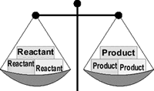
A chemical equation must have the same number of atoms of each element on both sides of the arrow. When this condition is met, the equation is said to be balanced.
To count atoms, multiply the formula's coefficient by each symbol's subscript.

For example: 2Al₂(SO₄)₃
- For Al - coefficient of 2, times subscript of 2 = 4 aluminum atoms
- For S - coefficient of 2, times subscript inside parenthesis of 1, times subscript outside parenthesis of 3 = 6 sulfur atoms
- For O - coefficient of 2, times subscript inside parenthesis of 4, times subscript outside parenthesis of 3 = 24 oxygen atoms
The order in which the following steps are performed is important. While shortcuts are possible, (and you will learn about one), following these steps in order is the best way to be sure you are correct.
Balance equations "by inspection" with these steps:
- Check for diatomic molecules.
- Balance the metals (not Hydrogen).
- Balance the nonmetals (not Oxygen).
- Balance oxygen.
- Balance hydrogen.
- The equation should now be balanced, butrecount all atoms to be sure.
- Reduce coefficients (if needed). ALL coefficients must be reducable before you can reduce. An equation is not properly balanced if the coefficients are not written in their lowest whole-number ratio.
HINT: NEVER change subscripts to balance equations.
The physical state of each substance in a reaction may be shown in an equation by placing the

following symbols to the right of the formula:
- (g) for gas
- (l) for liquid
- (s) for solid
- (aq) for aqueous (water) solution
Stoichiometry is the quantitative study of chemical changes.
The most common type of stoichiometry calculation is a mass-mass problem. Generally, a mass-mass problem looks like this: "given this amount of reactant, how much product will form?"
Steps in solving a mass-mass problem:
- Write a balanced equation for the reaction.
- Write the given mass on a factor-label form.
- Convert mass of reactant to moles of reactant.
- Convert moles of reactant to moles of product.
- Convert moles of product to grams of product.
- Pick up the calculator and do the math.
Mass-Mass Sample Problem:
If iron pyrite, FeS₂, is not removed from coal, oxygen from the air will combine with both the iron and the sulfur as coal burns. If a furnace burns an amount of coal containing 125 g of FeS₂,
how much SO₂ (an air pollutant) is produced?
1. Write a balanced equation showing the formation of iron (III) oxide and sulfur dioxide.
4 FeS₂ + 11 O₂ → 2 Fe₂O₃ + 8 SO₂
2. Write the mass information given in the problem.
3. Convert grams of FeS₂ to moles of FeS₂.
4. Changes moles of FeS₂ (reactant) to moles of SO₂ (product).
This ratio comes from the coefficients in the balanced equation. Notice that the ratio was reduced from 8 : 4 to 2 : 1 when placed in the dimensional analysis form. While reducing is not

absolutely necessary (the ratio will cancel properly even if not reduced), a good chemistry student notices such things and will do it.
5. Convert moles of SO₂ to grams of SO₂ .
6. All units have been canceled except for grams of SO₂ (product). The problem has been solved. Pick up the calculator and do the math.

Stoichiometry
The limiting reactant is the reactant that is completely consumed in the reaction.
- The limiting reactant is not present in sufficient quantity to react with all other reactants.
- The reaction stops when the limiting reactant is completely consumed.
- Any remaining reactants are considered "excess reactants".
- The amount of product formed is determined by the "limiting reactant".
Steps in solving a limiting reactant problem:
- Write a balanced equation for the reaction.
- Convert both reactant quantities to moles.
- Determine the moles of product that could be formed by each reactant.
- The least amount in step #3 identifies the limiting reactant.
- Use that number of moles of product to determine the mass produced.
A limiting reactant problem example: What mass of water can be produced by 4 grams of hydrogen gas reacting with 16 grams of oxygen gas?

The problem solution:
1. Write a balanced equation for the reaction.
2 H₂ + O₂ → 2 H₂O
2. Convert both reactant quantities to moles.
Using the mole ratio from the equation, determine the moles of water that could be formed by each reactant.

4. Oxygen produces the least amount of water.
- 16 grams of oxygen cannot produce as much water as 4 grams of hydrogen. In other words, 16 grams of oxygen will be used up in the reaction before 4 grams of hydrogen.
- Oxygen is the "limiting" reactant.
- Use oxygen for the calculation of product amount.
5. Complete the problem by converting moles of H₂O to mass of H₂O.
The theoretical yield for this problem is 18 grams. If you performed this reaction in the lab, your actual yield might be less. Can you think of reasons why?
Limiting Reactant Problems
Percent Yield
- The quantity of product that is calculated to form when all the limiting reactant is used up is called the theoretical yield.
- The amount of product actually obtained in a reaction is called the actual yield.
- The actual yield is almost always less than (and never greater than) the theoretical yield.
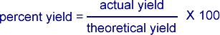

Sample problem:
Given the reaction:
Fe₂O_{3(s)} + 3CO_{(g)} → 2Fe_{(s)} + 3CO_{2(aq)}
A. If you start with 155 g of Fe₂O₃ as the limiting reactant, what is the theoretical yield of Fe?
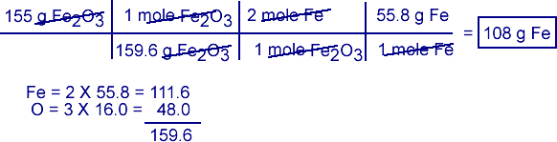
B. If the actual yield of Fe was 87.9 g, what was the percent yield?
EVALUATION
- S₈ + O₂ → SO₃
- HgO → Hg + O
- Zn + HCl → H₂ + ZnCl₂
- Na + H₂O → NaOH + H₂
- C₁₀H₁₆ + Cl → C + HCl
- 5.Si₂H₃ + O₂ → SiO₂ + H₂O
- Fe + O → Fe₂O₃
- FeS₂ + O₂ → Fe₂O₃ + SO₂
- Fe₂O₃ + H₂ → Fe + H₂O
- K + Br →
- C₂H₂ + O₂ →
- H₂O₂ → H₂O + O₂
- C₇H₁₆ + O₂ → CO₂ + H₂O
- SiO₂ + HF →
- KClO₃ → KCl + O₂
- KClO₃ → KClO₄ + KCl
- P₄O₁₀ + H₂O → H₃PO₄
- Sb + O → Sb₄O₆
- Fe₂O₃ + CO → Fe + CO₂
- PCl₅ + H₂O → HCl + H₃PO₄
- H₂S + Cl → S₈ + HCl
- Fe + H₂O → Fe₃O₄ + H₂
- N + H → NH₃
- N₂ + O₂ → N₂O
- CO₂ + H₂O → C₆H₁₂O₆ + O
- SiCl₄ + H₂O → H₄SiO₄ + HCl
- H₃PO₄ → H₄P₂O₇ + H₂O
- Al(OH)₃ + H₂SO₄ → Al₂(SO₄)₃ + H₂O
- Fe₂(SO₄)₃ + KOH → K₂SO₄ + Fe(OH)₃
- H₂SO₄ + HI → H₂S + I + H₂O
- Al + FeO →
- P₄ + O₂ → P₂O₅

K₂O + H₂O → KOH
- Na₂O₂ + H₂O → NaOH + O
- C + H₂O → CO + H
- H₃AsO₄ → As₂O₅ + H₂O
- Al₂(SO₄)₃ + Ca(OH)₂ →
- FeCl₃ + NH₄OH →
- Ca₃(PO₄)₂ + SiO₂ → P₄O₁₀ + CaSiO₃
- N₂O₅ + H₂O → HNO₃
- Al + HCl
- H₃BO₃ → H₄B₆O₁₁ + H₂O
- Mg + N →
- NaOH + Cl → NaCl + NaClO + H₂O
- Li₂O + H₂O → LiOH
- CaC₂ + H₂O → C₂H₂ + Ca(OH)₂
- Fe(OH)₃ → Fe₂O₃ + H₂O
- Pb(NO₃)₂ → PbO + NO₂ + O
- Ca + AlCl₃ → CaCl₂ + Al
- NH₃ + NO → N + H₂O
- H₃PO₃ → H₃PO₄ + PH₃
- Fe₂O₃ + C → CO + Fe

- FeS + O₂ → Fe₂O₃ + SO₂
- NH₃ + O → NO + H₂O
- Hg₂CO₃ → Hg + HgO + CO₂
- SiC + Cl → SiCl₄ + C
- Al₄C₃ + H₂O → CH₄ + Al(OH)₃
- Ag₂S + KCN → KAg(CN)₂ + K₂S
- Au₂S₃ + H → Au + H₂S
- ClO₂ + H₂O → HClO₂ + HClO₃
- MnO₂ + HCl → MnCl₂ + H₂O + Cl

1.From XNH₃(g)+YO₂-ZNO(g)+QH₂O(g)
The value of Z is
(A) .4 (B) .7 (C).6 (D).5
2.One molecule of oxygen atoms
(A).has a molar mass of 32g (B).has 6.02x 10²³
(C).can be represented as O2 (D) .has a formula mass of 16
(E) Contains Avogadro’s number of atom
3.The numerical coefficients in a balanced equation give
(A).the number of moles of reactants and products
(B).the molar mass of the reactants and products
(C).the number of moles of reactants only
(D).the number of molecules and atoms of products
(E).the mass ratio of the reactants

WEEK 4 & 5
STATE,ILLUSTRATION AND VERIFICATION OF CHEMICAL LAWS
Law of Conservation of Mass

In 1774, Joseph Priestley isolated the gas oxygen by heating mercuric oxide. Soon thereafter, Antoine Lavoisier claimed that oxygen is the key substance involved in combustion (burning). He also demonstrated that when combustion is carried out in a closed container, the mass of the final products of combustion exactly equals the mass of the starting reactants. This led to the statement of the Law of Conservation of Mass:
Law of Conservation of Mass
Mass is neither created nor destroyed in chemical reactions.

In an experiment, 63.5g of copper combines with 16g of oxygen to give 79.5g of cupric oxide (a black oxide of copper). This is in agreement with the law of conservation of mass.

Science today knows that matter can be converted into energy (and vice-versa). Hence, during all chemical and physical changes, the total mass+energy before the change is equal to the total mass+energy after the change. Still, as there is no detectable change in mass in an ordinary chemical reaction, the law of conservation of mass is still valid.

Silicon dioxide, made up of elements silicon and oxygen, contains 46.7% by mass of silicon. With what mass of oxygen will 10g of silicon combine?
100g of silicon dioxide contains : 46.7g of silicon,
or : (100 – 46.7) i.e. 53.3g of oxygen.

∴ 10g of silicon will contain 10100 × 53.3=5.33g of oxygen.
Law of Definite Proportions / Constant Composition

In the years following Lavoisier, the French chemist Joseph Proust formulated a second fundamental law of chemical science – the Law of Definite Proportions.
Law of Definite Proportions (Law of Constant Composition)
In a given compound, the constituent elements are always combined in the same proportions by mass, regardless of the origin or mode of preparation of the compound.

What this law means is that when elements react chemically, they combine in specific proportions, not in random proportions.

A sample of pure water, whatever the source, always contains 88.9% by mass of oxygen and 11.1% by mass of hydrogen.

The compound cupric oxide may be prepared by any one of the following methods –
• Heating copper in oxygen.
• Dissolving copper in nitric acid and igniting the cupric nitrate formed.
• Dissolving copper in nitric acid, precipitating cupric hydroxide, and strongly heating the cupric hydroxide.
– and in each case, the ratio copper:oxygen by mass is always constant.

2.16g of mercuric oxide gave on decomposition 0.16g of oxygen. In another experiment 16g of mercury was obtained by the decomposition of 17.28g of mercuric oxide. Show that these data conform to the law of definite proportions.

Experiment 1:

Mass of mercuric oxide = 2.16g
Mass of oxygen evolved from it = 0.16g
∴ Mass of silicon in the compound = 2.16 - 0.16 = 2.00
∴ silicon:oxygen ratio = 2.000.16 = 12.5 : 1

Experiment 2:
Mass of mercuric oxide = 17.28g
Mass of silicon in it = 16.00g ∴ Mass of oxygen in the compound = 17.28 - 16.00 = 1.28g
∴ silicon:oxygen ratio = 16.001.28 = 12.5 : 1
In both cases, the silicon to oxygen ratio is the same, thus conforming to the law of definite proportions.

QUESTIONS
(a) Two different sample, 1 and 2 of Zinc oxide were obtained from different sources. When heated in a stream of hydrogen they wre reduced to yield the results below.

Zinc Oxide | Mass of Oxide | Mass of Zinc left
Sample 1 | 20.0g | 16.22g
Sample 2 | 26.4g | 21.7g
Show that the result above explains the law of constant composition.

(b) If 12.0g of carbon is heated in air, the mass of the product obtained could either be 44.0g or 28.0g depending on the amount of oxygen present. What law does this information support?

WEEK 6
CHEMICAL BONDING
INTRODUCTION
Though the periodic table has only 118 or so elements, there are obviously more substances in nature than 118 pure elements. This is because atoms can react with one another to form new substances called compounds . Formed when two or more atoms chemically bond together, the resulting compound is unique both chemically and physically from its parent atoms.
Let's look at an example. The element sodium is a silver-colored metal that reacts so violently with water that flames are produced when sodium gets wet. The element chlorine is a greenish-colored gas that is so poisonous that it was used as a weapon in World War I. When chemically bonded together, these two dangerous substances form the compound sodium chloride, a compound so safe that we eat it every day - common table salt!
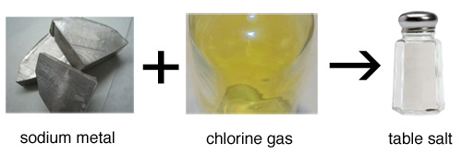
In 1916, the American chemist Gilbert Newton Lewis proposed that chemical bonds are formed between atoms because electrons from the atoms interact with each other. Lewis had observed that many elements are most stable when they contain eight electrons in their valence shell. He suggested that atoms with fewer than eight valence electrons bond together to share electrons and complete their valence shells.
While some of Lewis' predictions have since been proven incorrect (he suggested that electrons occupy cube-shaped orbitals), his work established the basis of what is known today about chemical bonding.

MAIN TYPES OF CHEMICAL COMBINATION
- Electrovalent/ionic combination
- Covalent classified into:
- Ordinary covalent
- Coordinate or dative covalent.

EXAMPLES OF ELECTROVALENT
- Formation of NaCl
 | Na atom | Cl atom
Before | 11  2,8,1 | 17  2, 8, 7
After | 11  2,8 | 18  2,8,8
Equation: Na – e → Na⁺Cl + e →Cl
Na + Cl Na⁺ + Cl⁻

Diagram
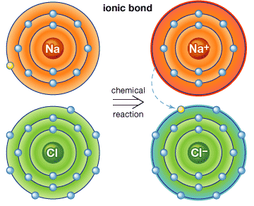

Na = 2, 8, 1 Cl = 2,8,7 Na⁺ = 2,8 Cl = 2,8,8
- FORMATION OF MgO
 | Mg | O
Before | 12 = 2,8,2 | 8= 2,6
After | 12 = 2,8 | 8 = 2,8

Equation: Mg – 2e → Mg 2⁺ O + 2e⁻ → O²⁻
Mg + O → Mg²⁺O²⁻

FORMATION OF MgCl₂
 | Mg | Cl
Before | 12 = 2,8,2 | 17 = 2,8,7
After | 12 = 2,8 | 17 = 2,8,8

Equation
Mg – 2e → Mg²⁺Cl + 2e → 2Cl

Diagram
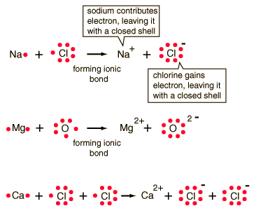
PROPERTIES
- Electrostatic forces of attraction are strong
- Consist of ions
- In terms of structure, they exist as solids at room temperature, arranged in orderly manner to form crystals ie. =ve ion
- surrounded be –ve ion and vice verse e.g.
NaCl crystals
=Cl⁻ ion
=Na⁺ ion
They are hard. If force is applied, it gets scattered but does not change shape
- High mpt and bpt because of strong bond between ions. E.g. NaCl melts at 801⁰ C and its bpt 1467⁰C.
- Soluble in polar solvents e.g. water, ethanol but insoluble in non-polar solvent e.g. benzene, CCl₄

HOW?
When NaCl for example is placed in water, the

water surrounds individual ions (Na⁺Cl⁻) in the surface and exposes the inner layers of NaCl ions.
- Good conductors or electrolytes of electricity.
Reason: the ions are free to move about when in a liquid state or in solution.

Covalent Bonds
Covalent chemical bonds involve the sharing of a pair of valence electrons by two atoms, in contrast to the transfer of electrons in ionic bonds. Such bonds lead to stable molecules if they share electrons in such a way as to create a noble gas configuration for each atom.
Hydrogen gas forms the simplest covalent bond in the diatomichydrogen molecule. The halogens such as chlorine also exist as diatomic gases by forming covalent bonds. The nitrogen and oxygen which makes up the bulk of the atmosphere also exhibits covalent bonding in forming diatomic molecules.
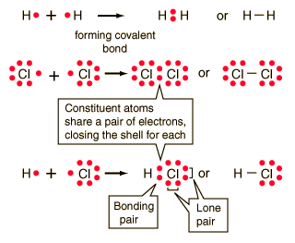 | Covalent bonding can be visualized with the aid of Lewis diagrams.

EXAMPLES OF COVALENT COMPOUNDS
- Formation of a hydrogen molecule H₂
- Formation of HCl
- Formation of H₂O
2H₂O + O₂ → 2H₂O
- C + 2H₂ → CH₄
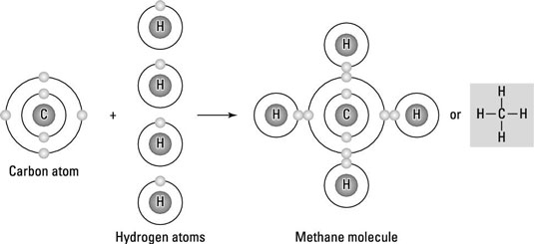
- Formation with double bond – CO₂
C + O₂→ CO₂ O = C = O
Covalent bonds i.e. where each atom contributes a pair of electrons
PROPERTIES
- Consists of molecules
- Electrostatic forces are not strong
- Low m.pt and b.pt
- Usually dissolve in non-polar solvent and insoluble in polar solvent
- Poor conductor of electricity and heat
Reason: Molecules do not contain charged ions
- They are often gases or volatile liquids e.g. iodine molecule.
- 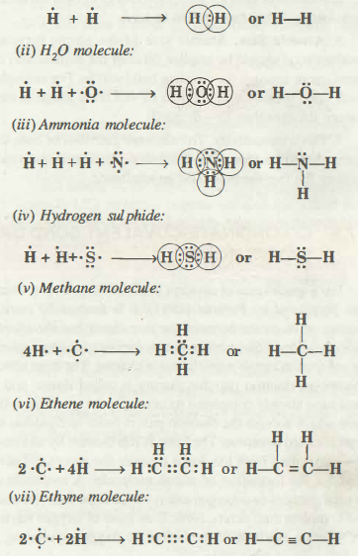

HYDROGEN BOND
Bond between hydrogen and any strongly electro negative elements e.g. N, O, and F. They are covalently bonded.
They form dipole i.e. coming together of a positive pole (H) and negative pole (N) or (F). The bond is weak.
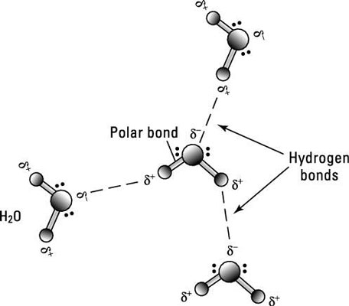
Exercise: HF, H₂O, NH₃
The hydrogen bond is responsible for:
- B.pt of water (100⁰C) is high than that of H2S (-65⁰C.). The oxygen in water has more affinity for e⁻ than sulphur hence H₂O has a stronger bond.
- Easy logue faction e.g NH₃
- Solubility of some organic compounds in water e.g. ethanol, sugar.

OTHER BINDING FORCES
- Metallic Bond: holds metal atoms together in crystal lattices.
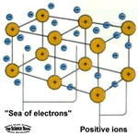
Note: the outer most e⁻ in the metal form the electron cloud which determines how strong the metallic bond is going to be i.e. the larger the number of e⁻ in the electron cloud the stronger the metallic bonding.
Metallic bonding is responsible for metals:
- High m.pt e.g. iron is 1535⁰C, Na = 98⁰C,
- because of few e⁻s in the outer most shell.
- Malleability and ductility. Because layers of metallic atoms can slide over each other
- High electrical and heat conductivity because close packing of particles
- Light densities e.g. Iron = 7.8gcm⁻³
v.High boiling point

Metallic Bond
Home → Metallic Bond
Metals constitute about three-fourth of all the known elements. They have characteristic properties such as bright lustre, high electrical and thermal conductivity, malleability and ductility and high tensile strength. The attractive force which binds various metal atoms together is called metallic bond. The metallic bond is neither a covalent bond nor an ionic bond because neither of these bonds are able to explain the known properties of metals. For example, neither ionic nor covalent compounds conduct electricity in the solid stale but metals are very good conductors of electricity. In order to explain bonding in metals different theories have been put forward. We shall be studying here electron gas model or electron sea model for metallic bonding.

ELECTRON GAS MODEL OR ELECTRON SEA MODEL
This is the simplest model that explains the properties of metals. This model was proposed by Lorentz. The main features of this modal are:
1. A metal atom is supposed to consist of two parts, valence electrons and the remaining part (the nucleus and inner shells) which is called kernel.
2. The metallic crystal consists of crystal packed metal atoms in three dimensions. The kernels of metal atoms occupy fixed positions called Lattice sites while space between the kernels is occupied by valence electrons. The arrangement of kernels and valence electrons is shown in Fig. 7.16.
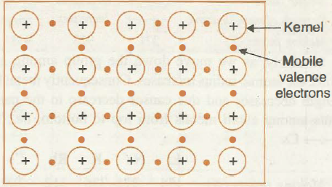
Fig. 7.16. Arrangement of metallic kernels.
3. Due to smaller ionisation energy, the valence electrons of metal atoms are not held by the nucleus very firmly. Therefore, they can leave the field of influence of one kernel and enter the field of influence of the other. This movement can take place through the vacant valence orbitals. Thus, the valence electrons are not localised but are mobile or delocalised. As the movement of electrons in metallic crystal is just like gas molecules, hence, the model is called electron gas model.
4. The simultaneous force of attraction between the mobile electrons and the positive kernels is responsible for holding the metal atoms together and is known as metallic bond.

The metallic bond is non-directional and is weaker than the covalent bond.

STRENGHT OF METALLI C BONO
Strength of metallic bond depends on the magnitude of attractive force between positive kernels and mobile valence electrons.
The average attractive force and metal bond strength increases with the decrease in atomic radius and increase in number of valence electrons. It must be noted carefully that both these factors at the same time decrease the metal character because of the tendency to form metallic crystal decreases. For example when we move along the period from left to right metallic character decreases. Among the elements of 3rd period metal character decreases from left to right. The metallic elements are only Na, Mg, AI, but strength of metallic bond increases from Na -7 AI. It is reflected from their melting points.
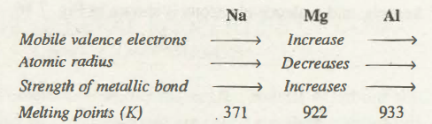
Similarly, as we move down the group among alkali metals, the atomic radius increases. Consequently metal bond strength decreases and this causes decrease in the melting points among alkali metals from top to bottom, i.e., from LiàCs
Li Na K Rb Cs
Melting points (K) 454 371 336 312 302

FACTORS THAT FAVOUR THE METALLIC BONDING
Metallic bonding is generally favoured by the following factors:
1. The atomic size of the element should be large.
2. Ionisation energy of the element should be low
3. Electron affinity of the element should be low
4. The Umber of valence electrons should be small (usually 1-2)
5. The number of vacant orbitals in the valence shell should be large.

EXPLANATION ON OF PHYSICAL PROPERTIES OF METALS
1. Metallic Lustre. When light falls on the surface of the metal, the free electrons absorb the photons of light and are set into vibrations. These vibrating electrons immediately emit energy and become a source of light. Thus, incident light appears to be reflected from the surface of the metal. Consequently the metallic surface acquires a shining appearance which is referred to as metallic lustre.
2. Electrical Conductivity. Whenever a difference is applied across the metallic strip, the free mobile electrons in the metal start moving towm-ds positive terminal At the same time the electrons from the negative terminal enter into the metallic crystal. Thus, metallic crystal maintains flow of electron from negative to positive terminal.
At high temperature, the metallic kernels start due to increase of the kinetic energy. This restricts the free movement of the electrons. Consequently, the resistance of metals increases with the increase in the temperature.
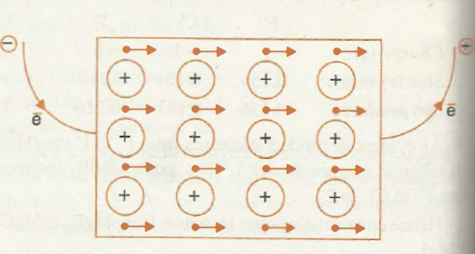
Fig. 7 .17. Electrical conductivity of metals.

3. Thermal Conductivity. The conduction of through the metals can also be explained on the basic electron gas mode\. On heating a part of the metal, the kinetic energy of the electrons in that region increases. These energetic electrons move rapidly to the cooler parts and transfer their kinetic energy by means of collisions with other electrons . In this way, the heat travels from hotter to cooler parts of the metals.

4. Malleability and Ductility. Malleability is the property of metals by virtue of which they can be beaten into sheets whereas ductility is the property by virtue of which they can. be drawn into wires. These properties are exhibited by metals on account of the of non-directional nature of metallic bond. Whenever any stress is applied on metal, the position of metallic kernels is altered without destroying the crystal The crystal lattice gets deformed by slippage of the layers of kernels moving past to another as shown in fig 7.18. whenone layer of kernels moves past another, the positive on metal ions are shielded from each other by the electrons.

The electron sea model could explain the properties metals qualitatively. However, the properties of metals be explained more quantitatively by molecular orbital which is beyond the scope of this book.
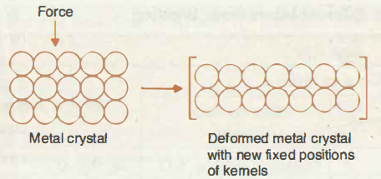
Fig. 7.18. Malleability and ductility of metals.

The general properties associated with three primary interatomic bonds are being summarized in tabular form as follows.

General Characteristics of Substances with different Interatomic Bonding
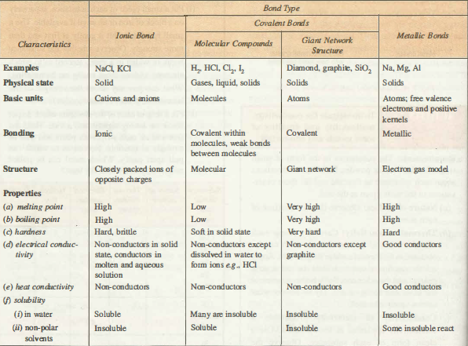

Van der waal forces
- Very weak
- Very important in the liquifaction of gases and in the formation of molecular lattices e.g. in iodine and Naphthalene crystals.

COORDINATE COVALENT COMBINATION
Electrons to be shared are donated by only one of the participating atoms. Such pair of e⁻ s are called Ione pair. This combination always leads to the formation of complex ions.

Co-ordinate-Covalent Bond or Dative Bond
Home → Co-ordinate-Covalent Bond or Dative Bond
It is a special case of covalent bond the formation of which was postulated by Perkins (1921). It is formed by mutual sharing of electrons between the two atoms but the shared pair of electrons is contributed only by one of the two atoms, the other atom simply participates in sharing. The atom which donates an electron pair for sharing is called donor and it must have already completed its octet. On the other hand, the atom which accepts the electron pair in order to complete its octet is called acceptor. The bond is represented by an arrow pointing from the donor towards the acceptor. Let us consider the formation of ozone molecule. A molecule of, -oxygen contains two oxygen atoms which share four electrons and complete their octets. Now, if an atom of oxygen having six valence electrons comes close to oxygen molecule, it shares a lone pair of electrons with one of the oxygen of the molecule. It can be represented as follows:
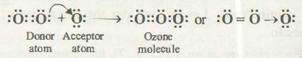
It is important to note that co-ordinate bond one formed, cannot be distinguished from covalent bond.
Some more examples of molecules/polyatomic ions having co-ordinate bond are as follows:
(i) SO₂ molecule
(ii) Ammonium ion
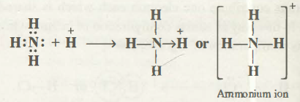
(iii) Hydronium ion
(iv) Carbon (II) oxide. In this molecule carbon and oxygen atoms contribute two electrons forming pure covalent bonds. At the same time oxygen also act as donor atom to form co-ordinate covalent bond.
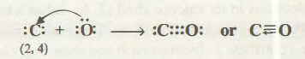

Exercise
1. Formation of ammonium ion
Reaction between NH₃ and HCl acid. The H⁺ of
the acid reacts with NH₃ and NH₄⁺ is formed.
2 .Formation of oxonium ion or Hydroxonium ion
QUESTIONS
What are the types of bonding that exist in the following compounds.
1.HCl
2. NH₄Cl
With diagram and equations only , illustrate the
formation of:
- Oxygen molecule
- Ethane molecule
- Ammonia molecule
- Nitrogen molecule
- Al₂O₃
Which of the compounds in 2 above is/are Triple covalently bonded?
1. Which of the following species the constituent atoms are held by non-directional bonds?
(a) NH3 (b) CsCl
(c) NF3 (d) BeF2.

2. X and Y atoms have 2 and 6 valance electrons in their outermost shells respectively, the compound which X and Y are likely to form is:
(a) XY 2 (b) XY
(c) YX2 (d) YX3.

3. Which of the following substance is a polar covalent molecule?
(a) Hydrogen sulphide (b) Nitrogen
(c) Potassium chloride (d) Oxygen.

4. Which of the following statement is/are correct?
I. Energy is absorbed when a chemical bond is formed
II. Energy is released when a chemical bond is formed
III. SF 6 is a super octet molecule
(a) I and III (b) III and II
(c) II only (d) III only
5.In electrovalency,valence electrons are transferred and the atomic number is
(A) .also reduced (B).stabilized (C) .unaffected (D).destabilized
6.Arrangement of ions in a regular pattern in a solid crystal is called
(A).configuration(B).atomic structure(C).lattice(D).Buffer
7.The bond type in a diatomic nitrogen gas is
(A).double covalent bond (B).triple covalent bond
(C).single covalent bond (D).double covalent bond
8.The bond type between copper( ii )ion and water molecules is
(A).electrovalent bond (B).covalent bond (C).Dative covalent bond
(D).Hydrogen bond
9.The bond between two iodine molecules is
(A).co-ordinate bond (B) electrovalent bond (C).ionic bond
(D)Van der waal’s forces
10.Bonds between a highly electronegative atom and a hydrogen from another molecule is called
(A).hydrogen bond (B).covalent bond (C).intermolecular forces (D).Ligand

WEEK 7
KINETIC THEORY OF GASES
The gas; laws, which explain the physical behavior of gases can be explained by the kinetic theory of gases. This states that:
- The gas molecules move randomly in straight lines, colliding with one another and with the wall of the container. Example: if a bottle of perfume is opened, the smell is quickly detected everywhere.
- The collision of gas molecules are perfectly elastic i.e. when the molecules collide with the wall of the container, they re-bounce like elastic balls without any loss of energy.
- The actual volume occupied by the gas molecules themselves is negligible i.e. the gas molecules are so small when compared with the volume of the container or distances between them.
- The cohesive forces between the gas molecules are negligible
- The temperature of the gas is a measure of the average kinetic energy of the gas particles
NOTE: the theory describes the behavior of an ideal gas, but not everything is true about real gas
PRESSURE EXERTED BY GASES
- Gas particles collide with each other and with the walls of the containers.
- Each time it happens, the gas exerts a very small force on the walls.
- This force per unit area is called gas pressure. It is constant.
- The gas pressure is measured in;
Atmosphere (atm)
Millimetre mercury (mmHg)
Pascal (Nm ⁻²)
Relationship between the units
1 atm = 760mmHg = 101325 Nm⁻²

SUMMARY OF KINETIC THEORY OF MATTER
Particles of matter are continually moving in a random motion so posses kinetic energy.
Using the Kinetic Theory to define the physical states of matter:
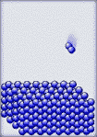
Solid - a substance whose particles have a low kinetic energy. The particles of a solid are held close together by intermolecular forces of attraction. Because the particles are so close together, they appear to vibrate around a fixed point.

When the temperature of a solid is raised, the velocity of the particles increases. The collisions between the particles occur with greater force, causing the particles to more farther apart. The ordered arrangement of the solid breaks down and a change in physical state occurs.
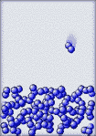
Liquid - a substance whose particles have enough kinetic energy to stretch the intermolecular forces of attraction. Collisions between the particles a strong enough to force the particles apart. The particles appear to have a moving vibration because they are still under the influence of the intermolecular forces of attraction.

As the temperature of a liquid is raised, the velocity of the particles increases. The collisions eventually become so great that the particles break all intermolecular forces, begin moving independently between collisions, and a change in physical state occurs.
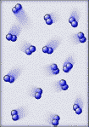
Gas - a substance whose particles have enough kinetic energy to break all intermolecular forces of attraction. The particles of a gas move independently of each other. The particles move at random because they have overcome the intermolecular forces of attraction.
When a gas is raised to extreme temperatures, over 5000 ºC, they have so much kinetic energy that their collisions will break electrons out of the atoms, and a change in physical state occurs.

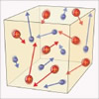
Plasma - a charged gas. The particle collisions are violent enough to break electrons out of the atoms, producing particles with charges (electrons and positive ions).

Because of its extreme temperature, plasma is not common on Earth. Wet-lab chemistry is not concerned with plasma and its characteristics.
Physical state at room temperature (25 ºC) and standard atmospheric pressure:
Under these conditions, the physical state of a substance is determined mainly by its chemical bond characteristics.
- Ionic compounds have strong electric charges holding the ions together as solids.
- Nonpolar molecular compounds of low molecular mass tend to be gases.

  - Greater molecular mass and greater polarity both tend to make substances more dense, producing either liquid or solid.
Intermolecular forces of attraction:
Within an atom, these forces are called weak forces, because they are much weaker than chemical bonds between atoms. Weak forces involve the attraction of the electrons of one atom for the protons of another atom.
When these forces interact between molecules, they are known as van der Waals forces.

PHENOMENA SUPPORTING KINETIC THEORY
- Nobody has seen the tiny particles that make up matter but scientist carried out
some work and ascertain that the particles are in constant motion
- The motion can be proved as follows:
- Brownian movement
- By Brown (a botanist in 1827)
- He dropped a pollen grain in a drop of water and examined it under
- Observation: There was irregular movement of the grain (zigzag)
- Conclusion: Movement was caused by the bombardment of the
pollen grains by the water molecules

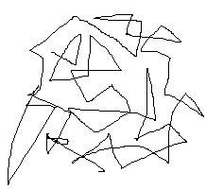
Brownian movement

- Diffusion
Movement of solute particles through a medium from a medium of higher concentration to a region of lower concentration.
Diffusion in Gases
- Fastest (in seconds)
- Particles have more kinetic energy
- Rate of diffusion is affected by the densities of the gases.

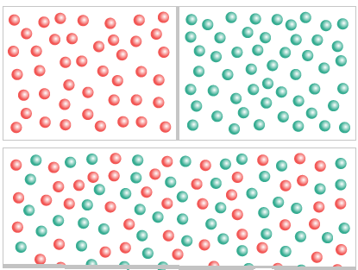
NOTE
- NH₃ gas diffuses faster than HCl because it is lighter than HCl.

- The evidence of the above statement is that NH₃ travels at one third of the tube (distance A) faster than HCl (distance B) i.e. A > B.
- The molecular masses of the gases are used to determine the lighter gas i.e. the lower the molecular mass the faster the rate of diffusion. But where the molecular masses are equal, the 2 gasses diffuse at the same rate.

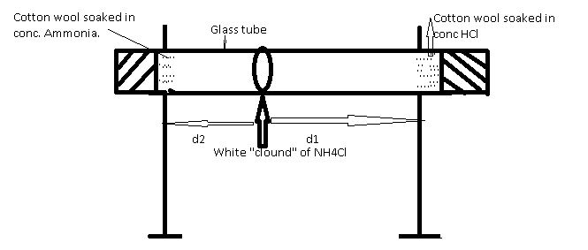

NOTE:d1and d2 stands for distance
Diffusion of Liquids
- slower than gasses (in minutes/hours)
- particles have less K.E

Jelly

CuSO4 CRYSTALS
....
.
Rubber bung

Note
- the fine jets acts as the boundary in the beginning.
- The blue CuSO₄ solution spreads upwards, against gravity. Therefore, it liquids overcome the force of gravity.
Diffusion in Solids.
- Slowest ( in years )
- Particles have least K.E

- Osmosis
- Special case of diffusion which involves the movement of water molecules
- Osmosis is the movement of water molecules, through a semi permeable membrane, from the region where they are in higher concentration to the region where they are in lower concentration.

Example: place some dried bean seed in a beaker of water and leave for some time.
Observation: The bean seed swell up
Result: water molecules have moved through the skin of the seed (semi-permeable) into the seeds by osmosis.
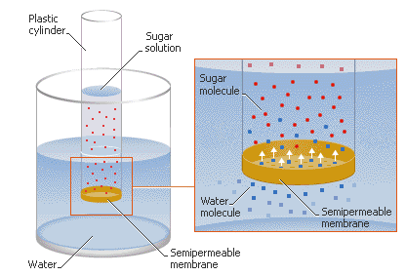
EVALUATION
1.The escape of molecules with more than average kinetic energy of the molecule
(A).melting (B).freezing (C).evaporation (D).efflorescence
2.The phenomenon whereby the atmospheric pressure equals the saturated vapour pressure is called
(A).freezing (B).latent heat (C).boiling (D).normal pressure
3 .Using the kinetic theory of matter, describe the nature of the following states of matter.
4.State the kinetic theory of matter and outline 3 natural phenomena which support it.

WEEK 8
GAS LAWS
Behaviour of gases is expected to differ from that of solids and liquids. This was investigated by many early scientists e.g. Boyle, Charles, Graham and Dalton, Avogadro’s. They studied the physical behaviour of gases. Gay-Lussac: he studied the chemical behaviour.
Boyle’s Law
- By Robert Boyle in 1662
- States that the volume of a given mass of a gas is inversely proportional to its pressure, provided temperature remains constant.
- Law is about the relationship between volume (V) and pressure (P)
As volume of a gas increases, the pressure decreases and vice versa
Mathematical expression
V α 1/p
V α k/p
K = PV
V = volume
P = pressure
K = constant
For initial and final pressure and volume, we have
P₁V₁ = P₂V₂
According to the kinetic theory,the gas pressure is caused by molecular collisions with the walls of the container.Therefore, the larger the number of molecules per unit volume,the larger the number of collisions and the higher the pressure.Reducing the volume of a gas container will increase the collisions on the walls of the container per unit time and consequently the pressure of the gas will incr

Using kinetic theory to explain Boyle’s Law

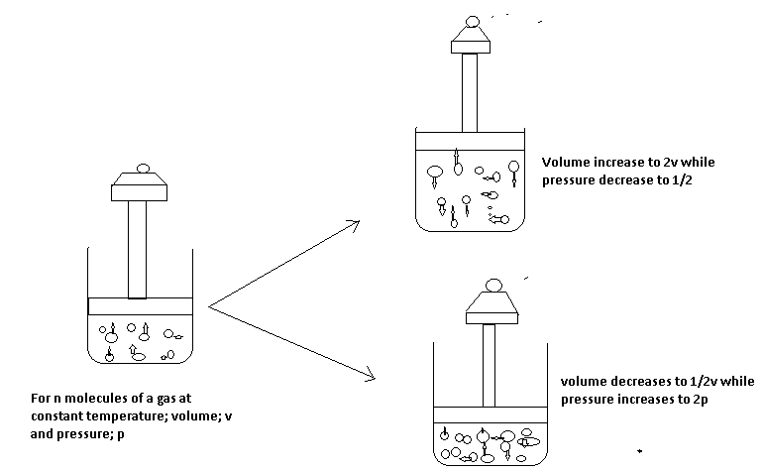
NOTE:
In stage 2:
- The piston is kept stationary by placing a heavy weight on it.
- The space occupied by the molecules is constant i.e. volume is constant.
- The gas exerts constant pressure.
In stage II:
- Weight of piston is replaced with a lighter one, so the piston moves up.
- The space occupied by the gas is doubled (increased volume).
- The pressure exerted by the gas is halved (pressure increases).

In stage III:
- Weight of the piston is now replaced with a heavier one, so the piston moved down.
- The space occupied by the gas is halved (volume decreases)
- The pressure exerted by the gas is doubled (pressure increases)
Therefore, at constant temperature; as the volume of a gas decreases, the pressure the gas exerts increases. Example, Ababio page 31, Fig. 5.15
V

0 ¹/_{P}
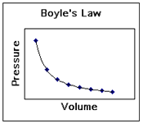
Calculation Involving Boyle’s Law
The volume of a gas means nothing unless the
conditions under which it was measured are known.
Tips for working with gas laws:
- All gas calculations must use Kelvin temperatures.
- The conditions 0 ºC and 1 atm are referred to as standard temperature and pressure - STP.
- The volume occupied by one mole of a gas at STP, 22.4 liters, is referred to as molar volume.
- Read the problem to see what conditions change.
- Decide which gas law to use and write its equation.
- Reread the problem to see what question is asked.
- If needed, manipulate the gas law equation.
- Plug numbers and units into the equation.
- Pickup your calculator and punch buttons.
- Write the answer to the problem, don't forget significant figures, and circle it.
Example 1
A sample of gas occupied 390cm3 ata pressure of 760mmHg.What volume will the gas occupy at 780mmHg, if the temperature remains constant?
Solution
P₁V₁=P₂V₂ (T constant)
P₁=760mmHg
V₁=390cm³
P₂=789mmHg
V₂=?
P₁V₁=P₂V₂ (Boyle’s law)
V2=P₁V₁/P₂
=760mmHg x 390cm³/780mmHg
V2=380 cm³

- 375cm³ of gas has a pressure of 770mmHg, Find its volume if the pressure is reduced to 750mmHg
Ans = 385cm³

ABSOLUTE TEMPERATURE
The temperature at which the volume of a gas would be theoretically reduced to O. This temperature is 0$°$C or 273K.
Note: practically, it is not possible as all gases liquefy above this temperature but it is significant because it is the lowest possible temperature that can be reached.
Temperature Conversion
0⁰C =273K, -273⁰C =0K (no degree sign)
C =Celsius or centigrade
K = Kelvin

To convert:
Celsius to Kelvin =K=⁰C + 273
Kelvin to Celsius = ⁰C = K-273

100⁰C 373K

0⁰C 273K

-273^{O}C 0K
CELSIUS SCALE KELVIN SCALE

CHARLE’S LAW
The volume of a given mass of a gas is directly proportional to its absolute temperature provided that pressure remains constant.
MATHEMATICAL EXPRESSION

V α T
V α KT
K= V
T
V = Volume, T = Temperature (in Kelvin), K= constant
For more than one gas, we have
V₁ ₌V₂
T₁ T₂
V₂₌ V₁ T₂
T₁
The volume of a gas is zero at a temperature of -273⁰C which is zero Kelvin.
Charle’s laws explains that the behavior of gases at differenttemperature changes when the pressure is constant.Gases expand when heated.The rate of expansion or contraction is summaried as follows.At constant pressure,a gas increases by 1/273 of its volume for each Celsius degree rise in temperature and this is true for all gases.For every one degrr centrigrade rise or fall in temperature.

The Kelvin temperature scale has -273oC as its starting point and it is called the absolute temperature scale.
Hence,O⁰C=273K
-273=0
The Kelvin temperature scale has -273oC as its starting point and it is called the absolute temperature

Charles' Law Problems
Example1
Whatvolume would be occupied by a given sample of gas at 45⁰C if it occupies 500cm³ at O⁰c assuming the pressure is constant?
Solution
Acertain mass of gas occupies300cm3 at 35⁰C .At what temperature willit have its volume reduced by half,assuming the pressure remains constant.
Solution
V1/T1=V2/T2
V1=300cm³
T1=35⁰C=(273+35)K=308K
V2=150cm³
T2=?
300cm³/308K=150cm³/T2
T2=308K X 150cm³/300cm³
154K =(-119⁰C)

USING KINETIC THEORY TO EXPLAIN CHARLE’S LAW. EXAMPLE.
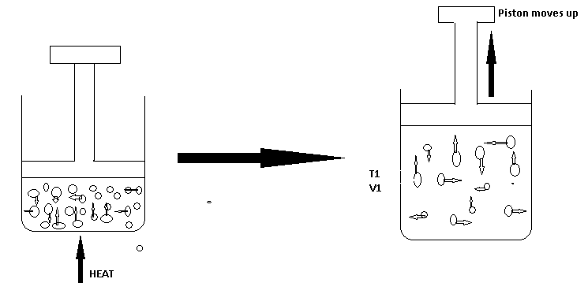
NOTE:
In stage:
The gas is heated, molecules acquire more kinetic energy, move faster and collide more often with the walls of the vessel, and hence, pressure is exerted.
In stage II:
The temperature is increased through heating (T₁ –T₂).
The pressure is still constant because the piston has been moved up but the volume occupied by the gas has increased.
Conclusion: As temperature increases, the volume increases and vice versa.

Graphical illustration of Charles law.
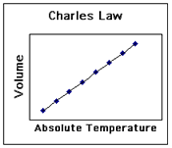
Ababio page 81, fig 5.16 and page 83
Vol (dm³) Vol

-273 O TempºC K
Calculations involving Charles law
- At 17⁰C, a sample of hydrogen gas occupies 125cm³. What will the volume be at 100⁰C, if the pressure remains constant? Ans. = 161cm³
- To what temperature in Celsius must a gas be raised from 0⁰C in order to double its volume? Ans. = 273⁰C
- 20cm³ of a gas at 55⁰C exerts 160mm Hg pressure. At the same pressure, calculate the volume of the temperature is doubled? Ans. = 23.35cm³
GENERAL GAS EQUATION
Boyle’s and Charles’s laws show that there is a relationship between the temperature, press and volume. The relationship is expressed by what is called general gas equation I.e.
Boyle’s law – V α 1/P
Charles Law - V α T i
Multiply (i) x (ii)
V α 1 X Vα T
V α (1/P X T)
V α T/P
V= KT/P
PV= KT
K= PV/T

Formorethan one gas,
P₁ V₁ = P₂ V₂V₂= P₁ V₁ T ₂
T₁ T₂ P₂ T ₁
where P1= initial pressure
V1=initial volume
T1= Initial Kelvin temperature
P2=New pressure
V2=New volume
T2=New Kelvin temperature

STANDARD TEMPERATURE AND PRESSURE (S.T.P)
It is the generally accepted standard temperature (0⁰C or 273K) and pressure (760mmHg or 1.01 x 10⁵Nm⁻²)
NOTE: if two chemists, one in a temperate country e.g. England and the other in tropical country e.g. Nigeria, should carry out investigations on the same gases. Their gas volumes would differ because of different in temperatures of the two countries. So, scientists decided to have standard temperature and pressure for calculations and experimentation.
CALCULATIONS
- At s.t.p, a certain mass of gas occupies a volume of 790cm³. Find the temperature at which the gas occupies 1000cm³. Ans. = 330.1K
- A given mass of a gas occupies 850cm³ at 320K and 0.92 x 10⁵Nm⁻² pressures. Calculate the volume of the gas at s.t.p Ans. = 660.5cm³
- A sample of N₂ occupies a volume of 1dm³ at 500k and 1.01 x 10⁵ Nm⁻². What will its volume be at 2.02 x 10⁵Nm⁻² and 400K?
- To what temperature must a given mass of N₂ at 0⁰C be heated so that both its volume and pressure will be doubled?
- 130cm³ of gas at 20ºC exerts a pressure of 750mmHg. Calculate its pressure if its volume is increased to 150cm³ at 35⁰C.
- Calculate the volume of hydrogen produced at s.t.p and r.t.p when 25g of zinc are added to excess dilute Hydrochloric acid at 31ºCand 778mmHg pressure (H= 1, Zn= 65, Cl= 35.5, GMV= 22.4dm^{3,} 24 dm³ )
- The combustion of butane in oxygen (air) is represented in the equation below: 2C₄H₁₀ + 130₂ 10H₂0 + 8CO₂

IDEAL GAS EQUATION
In all experimental works, measurements or calculation involving gases, four quantities are important-volume, pressure, temperature, and number of moles. The first three have been used in general gas equation. But the combination of four of them gives ideal gas equation as:
PV = nrt
Where
P = Pressure (in atm)
V = Volume (in dm³)
n = No. of moles
R = Gas constant (0.082 atm dm³ k⁻¹ mol⁻¹)
T = Temp (in K)
Gas density can also be calculated using the ideal-gas equation.
Density is equal to mass divided by volume, d = m/v.
The ideal-gas equation can be arranged to give density in g/L:
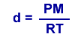
This equations shows the density of a gas depends on its pressure, molar mass, and temperature. The higher the molar mass and pressure, the greater the gas density; the higher the temperature, the less dense the gas.
Even though gases form homogeneous mixtures regardless of their identities, a less dense gas will lie above a more dense one if they are not physically mixed. The differences between the densities of hot and cold gases is responsible for CO₂ being able to keep oxygen from reaching combustible materials (thus acting as a fire extinguisher) and for many weather phenomena, such as the formation of large thunderhead clouds during thunderstorms.

- Under a pressure of 3000, Nm⁻² a gas has a volume of 250cm^{3.} What will its volume be if the pressure is changed to 100mmHgat the same
Temperature?
Solution to NO.3
Note: The pressure is not in the same unit. So conversion must be done first. 101325 Nm⁻² = 760mmHg
3000Nm⁻² =760 x 3000= 22.gmmHg
101325
P₁ ₌22.5mmHg
Using P₁ V₁ ₌ P₂ V₂
T₁ T₂
P₂ ₌ 100mmHg, V₁ = 250cm^{3,} V₂ ₌?
Ans= 56.25cm³
Dalton's Law of Partial Pressures, established by John Dalton, states that if there is a mixture of gases that do not react chemically together, then the total pressure exerted by the mixture is the sum of the partial pressures of the individual gases that make up the mixture i.e.
P_{Total =}P_{A} + P_{B} + P_{C} +…
Where

P_{Total =} Total pressure of the mixture
P_{A =} Partial pressure of gas A
P_{B} = Partial pressure of gas B
P_{C} = Partial pressure of gas C
Note:
- Gases A, B and C make up the mixture.
- If a gas is collected by water, it is likely to be saturated with water vapor and the total pressure becomes: P_{total}= P_{gas} + P_{watervapour}
The pressure of the dry gas will now be:
P_{GAS =} P_{TOTAL} -P_{WATER}

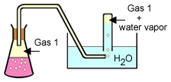
Dalton's Law is helpful when collecting a gas "over water". This diagram shows the collection of a gas by water displacement.
A collecting tube is filled with water and inverted in an open pan of water. Gas is then allowed to rise into the tube, displacing the water. By raising or lowering the collecting tube until the water levels inside and outside the tube are the same, the pressure inside the tube is exactly that of the atmospheric pressure.
A gas collected "over water" is a mixture of the gas and water vapor. Dalton's law of partial pressures describes this situation as:

P_{total} = P_{gas} + P_{H2O}
Charts like this one are readily available that give water vapor pressure at any common temperature.
EXERCISES
- A certain mass of hydrogen gas collected over water of 6º C and 765mmHg pressure has a volume of 35cm^{3.} Calculate the volume when it is dry at s.t.p. (s.v.p. of water at 6ºC=7mmHg).
Solution
To get the real pressure of H₂ gas i.e. when it is dry:
P_{DRY GAS} =P_{TOTAL} –P_{WATER VAPOUR =}765 -7 =758mmHg
Apply general gas equation to obtain the volume required in the question. Ans= 34.2cm³
2 .272cm³ of CO₂ were collected over water at 15ºC and 782mmHg pressure. Calculate the Volume of the dry gas at s. t. p. (s.v.p of water at 15 0C= 12mmHg)
3 .A given amount of gas was collected over water at 302K where the water vapour pressure of was 4.0 KNm^{-2.} Calculate the pressure of the dry gas if the atmospheric pressure at the same temperature was 101.3 KNm⁻²
4 .200cm⁻² of Nitrogen gas at a pressure of 500mmHg and 100cm³ of CO₂ at a pressure of 50mmHg were introduced into a 150cm³ vessels. What is the total pressure in the vessel?
Solution for No. 4
For N₂
V₁ =200 cm³, P₁ =500 mmHg

V2=150 cm³, P₂ =? mmHg
P₂= P₁V₁ = 666.67mmHg –Boyles Law
V₂
For CO₂
V₁ =10 cm³, P₁=50 mmHg, V₂=150 cm³, P₂ mmHg=?
P₂-33.33mmHg.
Total pressure =666.67 +33.33 =700mmHg
- A gas X was put in a 10dm³ vessel at 400K and 1.015 x 10⁵ Nm^{-2.} . Another gas Y at 400K and 3.035 x 105 Nm⁻² is put in a 5dm3 vessels. What will be the total pressure if:
- X and Y are put in a 5dm³ vessel at 400K?
- X and Y are put in a 15dm³ vessel at 400K?
- X and Y are put in a 10dm³ vessel at 400K?
- X and Y are put in a 20dm³ vessel at 400K?
SOLUTION
For X
- P₁= 1.015 x 105 Nm⁻², V₁ = 10dm³, V₂ = 5dm³, P₂=?
P₂ = P₁V₁ =2.03 X 105 Nm⁻². NOTE: Temp is constant
V₂
For Y
It already in 5 dm³ and it is 3.035 x 10⁵ Nm⁻²
P _{total} = Px + Py
=2.03 x 10⁵ + 3.035 10⁵
=5.065 x 10⁵ Nm⁻²
EVALUATION
EXERCISES
1.A certain amount of gas occupies 5.0dm³ at 2 atm and 10 ⁰ C. Calculate the number of moles present (R=0.082atm dm ³ K⁻ ¹mol- ¹⁾.
- 2.0 moles of an Ideal Gas are at a temperature of -13⁰C and a pressure of 2

Atm. What volume in dm³ will the gas occupy at a temperature?
(R=0.082 atm dm³ K- ¹ mol-¹)

3.A given mass of nitrogen is 0.12dm³ at 60$°$C and 1.01 X 10⁵ Nm⁻². Find its pressure at the same temperature, if its volume is changed to 0.24dm^{3.}
4.A certain mass of gas occupies 600cm³ and exerted 1.325 x 10⁵ Nm⁻² pressures. At what pressure would the volume of the gas be halved?
Ans = 2.65 x 10⁵ Nm⁻²

5.Convert the following Kelvin temperature to Celsius temperature
A. 405K B. 298K

6.Convert the following Celsius temperature to Kelvin temperature
A. 0⁰C B. -132⁰C

WEEK 9
GAY LUSSAC’S LAW: It states that when gasses react, they do so in volumes and these volumes are in simple ratio to one another and to volume of the product if gaseous provided the temperature and pressure remain constant.
Gay Lussac observed as follows:
H₂ + O₂ 2H₂O
Volume 2 1 2
Ratio 2 : 1 : 2
He noticed that the combining volumes as well as the volumes of the products were related by simple ratios of whole number, provided they are gases.
EXERCISE
- 2O cm³ of CO are sparked with 20 cm³ of Oxygen. If all the volumes of gases are measured at s.t.p, calculate the volume of the residual gases after sparking.
2CO _{(g)} + O_{2(g)} 2CO_{2(g)}
SOLUTION
2CO_{2 (g)} + O_{2 (g)} 2CO2 _{(g)}
Combining volume: · 2 : 1 : 2
Vol. before sparking: 20cm³ 20cm³ -
Vol. during sparking: 20cm³ 10cm³ 20cm³
Vol. after sparking: - 10cm³ 20cm³
Residual gases = Unreacted gas + Product formed
10 + 20 = 30cm³
2. 100cm³ of Nitrogen gases mixed together with 150 cm3 of Hydrogen. The mixtures were
made to react at low temperature at which the product cannot dissociate.
I. which of the two gases was in excess and by what volume?
ii. What was the volume of NH₃ produced?
Equation for the reaction; N₂ + 3H₂ 2NH₃
3. What is the volume of Oxygen required to burn completely 45cm³ of Methane gas (CH₄)?
Equation for the reaction: CH₄ (g) + 2O₂ (g) CO₂ (g) + 2H₂O (g)
SOLUTION BY GAY-LUSSAC’S LAW
1 Volume of CH₄ requires 2 volumes of oxygen
i.e. 1cm³ of CH₄ requires 2cm³ of oxygen
45cm³ of CH₄ requires 2 x 45 = 90 cm³
1
Alternatively:
By mole concept, from the equation, 1 mole of CH₄ requires 2 moles of O_{2,}
(1 X 22.4) dm³ of CH₄ requires (2x 22.4) dm³ of O₂.
22.4 dm³ of CH₄ require 44.8 dm³ of O².
Hence, 45cm³ require 44.8 x 45 = 90 cm³
22. 4
AVOGADRO’S LAW: By an Italian Professor Avogadro (1776 – 1856). It states that equal volumes of all gases at the same temperature and pressure contain the same number of molecules

AVOGARO’S LAW AND GAY LUSSAC’S LAW.
Avogadro’s law is used to convert the volume of gases into the number of molecules contained by those gases i.e.
Equation 2H_{2 (g)} + O_{2(g)} 2H₂O_{(g)}
Volume 2 1 2
Gay Lussac 2 : 1 2
Avogadro 2mols 1molecules 2molecules.
Therefore, Gay Lussac’s law can be re-stated that when gasses react, they do so in small whole numbers of molecules of reactant to produce small whole numbers of products.
RELATIVE VAPOUR DENSITY OF GASSES.
It is the number of times a given volume of a gas is as heavy as the same volume of Hydrogen gas at a particular temperature and pressure.
V.D = Mass of a given volume of a gas
Mass of an equal volume of Hydrogen gas
Relationship between V.D and R.M.M.
Applying Avogadro’s law into the formula of VD,
V.D = Mass of a given molecule of gas
Mass of an equal molecule of H₂
Where the molecule is 1,
V.D = Mass of 1 molecule of a gas
Mass of 1 molecule of H₂
However, H₂ is diatomic,
V.D = Mass of 1 molecule of a gas
Mass of 2 atoms of H₂
Mass of 1 molecule of a gas
2(mass of 1atom of H₂)
2 x V.D = mass of 1 molecule of a gas
Mass of 1 atom of H₂
NOTE: R. M. M= mass of 1 molecule of a gas
Mass of 1 atom of H₂
Substitute this equation
Hence 2 x V.D = R.M.M
V.D = R.M.M/2
GRAHAM’S LAW OF DIFFUSION OF GASSES
Graham in 1833 discovered that a less dense gas can diffuse faster than a denser gas, so the density of the gas determines the rate of diffusion of a gas.
The law states that at constant temperature and pressure, the rate of diffusion of a gas is inversely proportional to the square root of its density.
i.e. R α $1/√∂$
Where R = rate of diffusion
$∂$= density (Greek letter rho)
For two gases (say 1 and 2)$Type equation here.$

R₁α $1/√∂₁$ and R₂α $1/√∂$₂
On multiplication

R₁ = $√∂₁$
R₂ =$√∂₂$
Note: The rate of a gas is directly proportional to the square root of its molecular mass.
R₁ = $√$M₁
R₂ = $√$M₂ where M = Molecular mass

Note: In calculation, M where R is not given, it can be calculated as follows:
R = Volume
Time
CALCULATIONS
1.400 cm³ of a gas A diffuses through a porous partition in 5 seconds and 200cm³ of a gas B diffuses in 20 seconds under the same condition of temperature and pressure:
- Calculate the rates of diffusion of gases A and B
- Which gas is denser?
SOLUTION
- R_{A} = Vol = 400 = 80 cm³
Time 5
R_{B} =200 = 10 cm³
20.
- Gas B is Denser
2.A gas X diffused through a porous partition at the rate of 2.5 cm³/s . Under the same conditions, hydrogen diffused at the rate of 10cm³ /s . Calculate the RMM of the gas. (H = 1) Ans = 32

APPLICATION OF MOLE CONCEPT IN CHEMICAL REACTION
The mole concept can be applied to the following types of calculates which are based upon a
balanced chemical equation.

Calculation involving mass-mass relationship
Exercise 1: Calculate the mass of calcium oxide formed when 1.5g of calcium is completely burnt in oxygen
(Ca =40, 0 = 16)
2Ca_{(s)} + 0₂g 2Ca 0_{(s)} answer = 2.1g of Ca0(s)

EXERCISE 2
Calculate the mass of oxygen gas formed when 10g of potassium trioxonitrate (v) (potassium nitrate) is heated strongly.
Equation for the reaction
2KN03_{(s)} 2KN0_{2(s)} + 0₂(g)
Answer = 1.58g of 0₂(g)

EXERCISE 3
When 1.4g of impure calcium trioxocarbonate (calcium carbonate) reacts with hydrochloric acid, 0.01mole of carbon (iv) oxide (carbon dioxide) gas was evolved calculate
i. Percentage purity
ii. Percentage impurity of calcium carbonate (Ca =40, C=12, 0=16, H=1)

SOLUTION:
C_{a}C0₃(s) + 2HCl _{(aq)}CaCl_{2 (aq)} + H_{2 (aq)} + C0₂ (g)
1 mole C0₂ = 1 mole C_{a}C0₃
1 mole = (40 + 12 + 16 x 3) C_{a}C0₃
1 mole C02 = 100 C_{a}C0₃
:.0.01 mole C02 = 100 x 0.01 C_{a}C0₃
Mas of pure = 1g C_{a}C0₃
Total mass of C_{a}C0₃ = 1.4g
Mas of pure C_{a}C0₃ = 1.04g
Mass of impure CaC03
= 1.4 – 1.0 = 0.4g

i. Percentage purity
= mass of prime x 100
Total mass of C_{a}C0₃ ₁
= 1.0 x 100
1.4
= 71.4%

EXERCISE 2
Calculate the volume of ammonia gas formed at s.t.p and r.t.p when 0.01g of hydrogen reacts
with nitrogen gas
(N14, H=1 M.V = 22.4drm³ at s.t.p and 24dm³ at r.t.p )

SOLUTION:
Equation for the reaction
N_{2 (g)} + 3H_{2 (g)} ______2NH_{3 (g})

Answer:
0.075dm³ NH₃ at s.t.p
8dm³ NH³ at r.t.p

EXERCISE 3
Calculate the volume of oxygen gas at s.t.p and r.t.p needed to burn 1:20g of magnesium,
according to the equation below
2mg_{(s}) + 02(g) _________2mg0_{(s)}
(Mg = 24, 0 = 16, Mr. = 22.4dm³ at s.t.p, 24dm³ at r.t.p)

Answer:
= 0.56dm³ 0₂ at s.t.p
= 0.56dm³ 0₂ at r.t.p

EXERCISE 4:
The complete combustion of methane in oxygen is represented by the equation
CH_{4(g)} + 0_{2(g)}) _____ C0₂ (g) + 2H₂0_{(g)}
If 1000cm³ of methane was completely combusted in oxygen at s.t.p
Calculate
i. The mole of methane combusted
ii. The volume of oxygen used for the combustion
iii. The mass of carbon (iv) C0₂ produced
- The number of water molecule produced.

SOLUTION:
i. Answer = 0.04 mole of CH₄

ii. Answer = 2000cm³ of 0₂

iii. Answer = 1.96g of C0₂

iv. Answer = 5.38 x 10²² molecule of water

GAS VOLUME – GAS VOLUME RELATIONSHIP

EXERCISE 1:
40cm³ of nitrogen gas (N₂) reacts with 60cm³ of hydrogen gas to form ammonia gas. Calculate
the volume of unused and volume of ammonia gas formed at the same temperature and pressure
equation for the reaction

N_{2 (g)} + 3H_{2 (g)} ________2NH_{3 (g)}
IV 3vols 2vols
40cm³ 60cm³ ---

3vols 3H_{2 (g)} = 60cm³
1 vol = 60/₃ = 20cm³
:. 40cm³ 60
1 x 20cm³ 3 x 20 = 0cm³

20cm³ 60cm³ ___________2 x 2 = 40cm³
:.Volume of unused gas = nitrogen
40cm3n 20cm3 = 20cm³

EXERCISE 2
100cm³ of sulphur (iv) oxide (sulphur dioxide-so₂) gas reacts with 80cm³ of oxygen gas to produce sulphur (vi) oxide (sulphur trioxide). Calculate the volume of the resulting gas and the volume of unused gas measured at the same temperature and pressure.
Equation for the reaction 2S0_{2 (g)} + 0_{2(g)} __________2S0_{3 (g)}

Answer:
Volume of unused 0₂ = 30cm³
Volume of resulting gas 2S0₃ = 100cm³
MASS – LIQUID VOLUME CALCULATIONS
1. What volume of 2M HCl will be needed to react complete by with 4.0g of calcium.

SOLUTION:
Equation for the reaction Ca _{(g)} + 2HCl _{(aq)} ______CaCl2 _{(aq)} + H_{2(g})
1 mole Ca_{(s)} __________ 2 moles HCl_{(aq)}
40g Ca_{(s)}______________ 2 moles HCl_{(aq)}
1g Ca_{(s} _____________ 2 mole HCl
40
4.0g of Ca_{(s)} = 2 x 4 mole HCl
40
= 0.2 mole HCl
Concentration of HCl = 2M
Mole = cone in mol/dm³ x Vol in cm³
1000

0.2 mole = 2 x V
1000
0.2 x 1000 = 2 x V
1000
:. V = 0.2 x 1000
2
V = 1000Cm³

2. Calculate the mass of calcium which will complete by react with 500cm³ of 0.1 MHCl

SOLUTION:
Equation for the reaction
Ca_{(s)} + 2 HCl _{(aq)} _________CaCl₂ (aq) + H_{2 (q)}
Mole = cone mol/dm³ x Vol in cm³
1000
= 0.1 x 500
1000
= 0.05 mole

From the equation of reaction Ca_{(s)} +2HCl _{(aq)} _______ CaCl_{2 (aq)} +H2_{(q)}
2 moles of HCl _{(aq)} 1 mole of Ca_{(s)}
2 moles HCl _{(aq)} = 40g of Ca_{(s)}
1 mole HCl _{(aq)} = 40 moles HCl
20
:. 0.05 molHCl = 40 x 0.05 mole C
2
= 1g of Ca

THE MOLE FRACTION AND MOLE PERCENT

DEFINITION
The mole fraction can be defined as the number of moles of a particular substance in a mixture divided by the total number of moles of all the substances present in the mixture.

Example
A mixture of 1 moles of chloroform and 3 moles of ethanol were kept in a measuring cylinder calculate
i. The mole fraction of chloroform and ethanol

ii. The mole percent of chloroform and ethanol.

SOLUTION
Total number of moles of mixture = 1 + 3 = 4 moles

ia. The mole fraction of chloroform = 1
4
b. The mole fraction of ethanol = 3/4

iia. The mole percent of chloroform = ¼ x 100
1
= 25%
b. The mole percent of chloroform = 3 x 100 = 75%
4 1

NOTE:
i. When the masses of the substances in the mixture are given in grammes they are converted to moles by dividing with their relative molecular masses before the mole fractions are calculated.

ii. When the volumes of gasses at stated temperature and pressure are given, they are converted to moles before the mole fractions are calculated.

EXAMPLE 2
46g of ethanol was mixed with 36g of water in a reaction vessel, calculate:
i. The mole fraction of water and ethanol

ii. The mole percent of water and ethanol.

SOLUTION:
Rmm of water (H2⁰)
= (1 x 2) + 16 = 18glmol
Rmm of ethanol (C₂H5⁰H)
= (12 x 2 + 1 x 5 + 16 + 1) = 46g/mol
No of mole of H₂0 molecules
= 36`
18 = 2 moles
No of molecules of C₂ H₅OH
= 46
46 = 1 moles
Total number of moles present in the mixture = 2 + 1 = 3 moles
ia. Mole fraction of water 2
3
b. Mole fraction of ethanol = 1
3
iia. The mole percent of H₂0
= 2 x 100
3 1 = 66.7%
b. The mole percentage of C₂H₅0H
= 1 x100
3 1 = 33.3%

NOTE:
That one mole of a gas (the relative formula mass) will always tale up a volume of 24dm³ and 24000cm³ at room temperature and pressure (r.t.p)

This means that 28g of N₂ will take up a volume of 24dm³ as will 71g of Cl₂ also
R.f.m of N₂ = 14 x 2 = 28
R.fm of Cl₂ = 35.5 x 2 = 71
Formula
Vol of gas (dm³) = mass of gas (g)
24dm3 Rf.m of gas

= 8
2 = 4 moles

Vol of gas = moles x 24dm³
= 4 x 24 = 96dm³

This calculation shows that 8g of hydrogen will take up a volume of 96dm³

QUESTION
1.What volume is taken up by 10g of N_{e?}

2. What volume is taken up by 56g of N_{2?}
3. What volume is taken up by 14.2g of Cl_{2?}

4. If 0.1 mole of AgN0₃ reacts with HCl acid, what mass of AgCl could be produced according to the equation AgN0_{3 (aq)} + HCl _{(aq) _____}AgCl_{(s)} + HN0_{3 (aq)}
(Ag = 108, Cl = 35.5, H = 1, N = 14, 0 = 16)

Answer = 14.35g of AgCl

5. What mass of zinc metal would be required to react with dilute HCl to produce 0.5dm³ of H₂ gas at s.t.p according to the equation below?
Zn_{(s)} + 2HCl _{(aq)} ________ZnCl_{2 (aq)} + H_{2 (g)}
(Zn) = 65, H = 1, Cl = 35.5, G.m.v = 22.4dm³ at s.t.p)

Answer = 1.45g of Zn

6. Find the number of molecules of ₀₂ needed to convert 5.60dm³ of S0₂ gas measured at s.t.p to form S03
(G.m.v = 22.4dm³, N^{A}= 6.02 x 10²³molecules)

Answer =1.505 x 10²³ molecules

7. When 10g of N_{a}0H is dissolved in 1000cm3 of water, what will e the molar, concentration of the solution formed?
Answer = 0.25 moles

5. A gaseous mixture consist of 500cm³ of hydrogen 250cm³ of nitrogen and 1000cm3 of oxygen at s.t.p

i. The mole fraction of each component

- The mole percent of the gaseous mixture

WEEK 10
AIR AND FLAMES
Air is a mixture of gases - nitrogen, oxygen, carbon(IV) oxide, water vapor and noble gases. The following observations confirm air to be a mixture:
- The composition of air is not quite constant. Variations in composition have been found when samples of air are taken from different parts of the earth. This implies that if air were a compound, its composition would be definite or constant.
- If air is dissolved in water and boiled out again, it will be observed that the percentage of oxygen in the air is increased from 21% to about 30%. The increase in percentage of oxygen only shows that water usually contain dissolved oxygen, even more than nitrogen (oxygen is about twice more soluble in water than nitrogen). The dissolution and release of air from water is a physical process which implies that air is a mixture.
- When liquid air is heated, nitrogen evaporates earlier, leaving almost pure oxygen. This implies that components of air are easily separable by physical methods.
- A mixture of carbon(IV) oxide, nitrogen, oxygen, water vapor and noble gases in appropriate ratio does not produce any observable change identifiable with chemical reactions (such as evolution of heat, explosion and volume change), but the mixture is similar to ordinary air in everyway.
- The composition of air is not represented by any simple chemical formula, unlike if it were a compound. Composition of Air The constituents of air and their percentage composition are given below: Nitrogen - 78.1% - 4/5 of volume of air Oxygen - 20.9% -1/5 of volume of air. Carbon dioxide - 0.03%. Water vapor - variable. Noble gases - about 1%
Impurities (example, H₂S, SO₂, e.t.c.) - variable.
The above statistics shows that nitrogen and oxygen are the two main gases of the air, occupying about 4/5 and 1/5 by volume respectively

To Determine the Presence and Proportion of The Constituents of Air
Air is a mixture of gases - 78% nitrogen and 21% oxygen - with traces of water vapor, carbon dioxide, argon, and various other components.

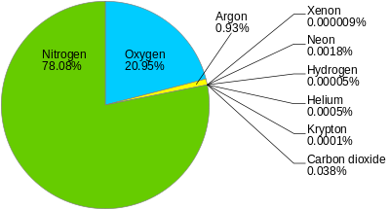
Oxygen
The presence and proportion of oxygen in air can be determined by burning certain metals, example, copper, lead and magnesium in air. The oxygen of the air combines with these metals to form oxides, which are greater in masses than the pure metals.
The difference in mass is the oxygen present in the volume of air used - this procedure can be employed to estimate the volume of oxygen in the air. The equations for the chemical reactions are:
2Cu(s) + O₂(g) → 2CuO(s) Copper(II) oxide
2Pb(s) + O₂(g) → 2PbO(s) Lead(II) oxide
2Mg(s) + O₂(g) → 2MgO(s) Magnesium oxide
Phosphorus can also be burnt in a measured volume of air to obtain by volume the proportion of oxygen in air. The equation of the reaction is:
P₄(s) + 5O₂(g) → P₄O₁₀(s) Phosphorus(V) oxide
For convenience, white phosphorus is used. White phosphorus catches fire very easily (for this reason, it is stored under water). Note: only the oxygen component of air supports combustion, others, i.e., CO₂, N₂, and water do not.

To obtain a more accurate determination of the proportion of oxygen by volume in air, we can use the smoldering of phosphorus in air, or by passing air into alkaline pyrogallol, or into benzene-1,2,3 - triol, which absorbs its oxygen.
When white phosphorus is exposed to a measured volume of air, it smolders as it absorbs oxygen from the air. The volume of the absorbed oxygen is measured, and the percentage composition is calculated to be about 20.8%. The chemical change that occurs is same with that of the combustion of phosphorus in air:
P₄(s) + 5O₂(g) → P₄O₁₀(s)
When a measured volume of air is passed into alkaline pyrogallol or benzene-1,2,3-triol, only the oxygen component is absorbed. The volume of the absorbed oxygen is measured and its percentage composition can also be determined.
Carbon(IV) Oxide
The occurrence of carbon(IV) oxide in air is traceable to the combustion of fuels, e.g. coal, wood, petrol and paraffin - these materials are composed mainly of carbon.
C(s) + O₂(g) → CO₂(g)
It is also present in the air through the process of respiration – all animals and plants produce CO₂ as a by-product of respiration, which is released into the atmosphere. The decay of organic material also releases CO₂ into the atmosphere. For the fact that plants require CO₂ to synthesis carbohydrates, and also for the fact that CO₂ dissolves in the water of the oceans, the percentage of CO₂ in air remains constant at 0.03% by volume, in spite of the enormous amount produced into the atmosphere.
The presence and proportion of CO₂ in the air can be determined by passing a measured volume of air into a solution of calcium hydroxide (also called lime water). Calcium hydroxide solution absorbs CO₂ in limited amount to give white precipitate of CaCO₃, and in excess amount to give a milky appearance.
Ca(OH)₂(aq) + CO₂(g) → CaCO₃(s) + H₂O(l)
CaCO₃(s) + H₂O(l) + CO₂(g) → Ca(HCO₃)₂(aq) Calcium hydrogen trioxocarbonate(IV).
The milky appearance is due to calcium hydrogen trioxocarbonate(IV), Ca(HCO₃)₂ produced. The volume of CO₂ absorbed is measured, and its percentage composition calculated. Other substances that can be used to absorb CO₂ are concentrated solutions of KOH and NaOH (these will produce soluble carbonates with limited CO₂ ; and hydrogentrioxocarbonate(IV) with excess

CO₂.
Solid NaOH can also be used. Solid NaOH absorbs water from the air to form a solution, which then absorbs CO₂ to form sodium trioxocarbonate(IV) decahydrate. The decahydrate loses 9 of its water of crystallization, absorbs more CO₂ and forms sodium hydrogen trioxocarbonate(IV).
2NaOH(s) + 9H₂O(l) + CO₂(g) → Na₂CO₃.10H₂O(s)
Na₂CO₃ .H₂O(s) + CO₂(g) → 2NaHCO₃(s)
Water Vapor
The evaporation of water from oceans, rivers, lakes etc, produces the water vapor of air. Its presence and proportion in the air can be found by passing a measured volume of air through some substances which absorb water, such as anhydrous calcium chloride and conc. tetraoxosulphate(VI) acid.
In a day or two, a solution of the compound will be obtained, while the volume of air decreases. The volume of water vapor thereby absorbed is measured, and its percentage composition calculated - the results vary from place to place. Nitrogen Nitrogen is almost inert; therefore, there is no suitable chemical procedure to test it in the presence of the other components.
Hence, the other components are usually removed from the air, leaving behind nitrogen for complex test procedures. The following is a procedure to separate nitrogen from air: A given volume of air is passed through a deliquescent substance to remove water vapor, after which, it is passed into a solution of slaked lime, i.e. calcium hydroxide, where the CO₂ component is absorbed.
It is moved onto a furnace where the oxygen component burns copper to give copper(II) oxide. The gas left after this process is mainly nitrogen, which is not removed by any known chemical method.
Note: * The presence of the noble gases in atmospheric nitrogen makes it denser than pure nitrogen obtained from its compounds. In the industry, either nitrogen or oxygen is obtained from liquid air (containing mainly oxygen and nitrogen) by fractional distillation. Nitrogen boils at 77 K, argon which is the major noble gas in the air boils at 87 K, while oxygen boils at 90 K.
* By fractional distillation, pure nitrogen is obtained.

Air Impurities or Pollutants
Air, especially in the industrial areas contains certain particles, which pollute it. These include hydrogen sulphide (H₂S), sulphur(IV) oxide (SO₂), the oxides of nitrogen, carbon monoxide (CO), dust and other solid particles such as lead. An evidence of these pollutants in the air is the tarnishing of silver- this is due to the presence of H₂S, which forms a black layer of silver sulphide on the sliver.

FLAMES

Flames occasionally flicker and dance over the surface of a burning coal fire, but most of the time the fire is flameless, illuminated only by the glow of burning solids. The flames leaping from it are areas in which gases are burning. When they burn, these gases combine with the oxygen in the air and in doing so, heat and light are given out making the flame hot and often visible.
If a gas will burn, then it always burns with a flame. For example, the gases carbon monoxide and hydrogen always burn with flames, carbon monoxide with a bright blue flame and hydrogen with a paler blue flame. But there is no hard and fast rule for solids. Some burn with flames; others do not. When hot iron filings are lowered into a jar of oxygen, they burn with a dull glow, but not with a flame. In contrast under similar conditions, warm yellow phosphorus will burst into flame and cannot be made to burn flamelessly. If the temperature is raised sufficiently for the solid to vaporize, it burns with a flame as the vapor catches fire. If no vapor is given off then there can be no flame. Volatile substances burn more often with flames than non-volatile substances.
To get a piece of paraffin wax to burn with a flame it must be heated quite strongly. But if a wick is inserted to make it a candle, no such strong heating is necessary. When a match is applied, some of the wax melts, and it is drawn up the wick by capillary action. The tip of the lighted wick becomes incandescent and the heat generated causes some wax to vaporize and catch fire. More wax rises up the wick to take its place.
Before any gas or vapor can burst into flame a certain temperature must be reached. The lowest temperature at which the substance will take fire is known as the ignition temperature. The ignition temperature is not a fixed value for a particular gas for it varies with the conditions. Gas pressure and the presence of catalysts can affect it. At very low pressures, gases are more difficult to set alight because the ignition temperature is much higher. For flammable liquids this temperature is known as flash pointest temperature at which the liquid gives off a vapor that will burst into flame

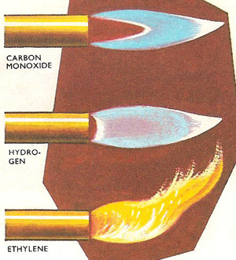

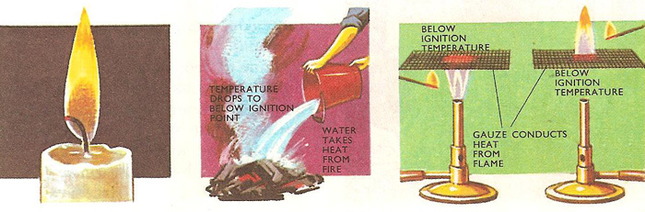

When a piece of metal gauze is held above a Bunsen burner and a lighted taper is applied below, the flame is stopped by the gauze because the metal conducts the heat away, preventing the gas above from reaching the ignition point and so it cannot catch fire. When the experiment is repeated this time by applying the flame above the gauze, for the same reason, only the gas above the gauze catches fire. There is no flame, only unburned gas beneath it.
Flames differ in appearance. There are several reasons for this. The flames may have different structures. Apart from at the center, a candle flame appears uniformly yellow throughout; so does a luminous Bunsen flame, whereas a roaring Bunsen flame has an inner blue cone surrounded by an outer transparent cone. All flames also have a central zone of unburned gas at the base. This is quite easily demonstrated by holding a piece of asbestos paper so that it cuts across the lower part of the flame. A hollow ring of soot is deposited by the burning gas or vapor but none by the unburned gases. Holding another piece of asbestos paper vertically in the flame shows the zone of unburned gases to be cone-shaped.
The candle flame and the outer cone of the Bunsen flame are both examples of diffusion flames (see diffusion). When the candle is lit, the vaporized paraffin was diffuses out from the wick and mingles with the air needed for its combustion. The gases which have bee only partly burnt in the inner cone of the Bunsen flame behave similarly, diffusing out to mix with the inward diffusing air.
The inner Bunsen cone is an explosion of traveling flame. If a match is applied to one end of a tube of coal gas, the gas catches fire at that end and the flame travels along the tube, as each successive layer of gas is burnt.
The blue cone is a flame of this type, only the gas issuing from the Bunsen is not stationary. The rate at which the flame travels down through the gas is balanced by the rate at which more gas issues from the burner to take its place. As the two balance, the flame appears to be stationary. The traveling nature of the flame can be further demonstrated by turning down the gas supply. Then the flame travels down into the burner faster than the gas can come out and the Bunsen lights at the bottom. This is known as striking back. The Bunsen should never be left to burn with this sort of flame as the bottom of the burner becomes overheated. Also the gas is only partially burned and the poisonous gases escape into the atmosphere.

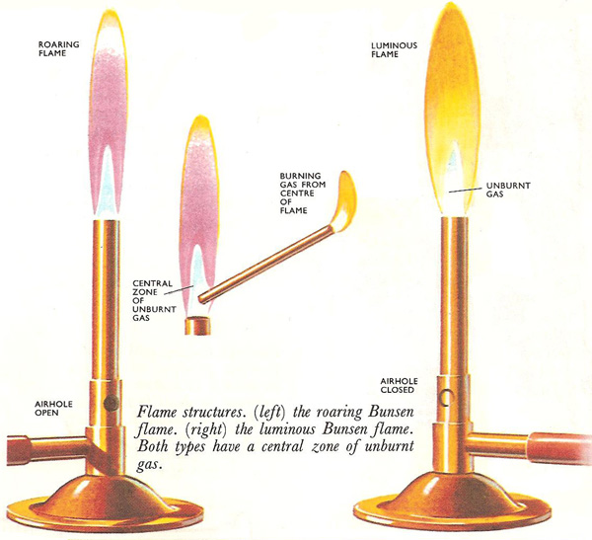

As for the Bunsen flame, flames of other burning substances can have various cones or mantles. The flame of burning ammonia consists of three different colored mantles or cones, an inner cone of unburned gas, a yellow middle cone, and an outer mantle of yellowish-green flame. The flame of burning carbon monoxide is bright blue, and a candle flame, bright yellow. The different colors of flames are caused by the different chemical reactions taking place within them. If a flame has three mantles, then there are three different chemical reactions taking place, one in each mantle. Certain substances in the flame give out light colors. If the reaction produces fragments consisting of a carbon atom bonded with a hydrogen atom, violet light is given out. The presence of two bonded carbon atoms tinges a flame green. Carbon particles give out red or white light.
No completely satisfactory theory has yet been put forward to explain the luminosity exhibited by some flames. At one time it was thought that the luminous flames had solid particles suspended in them. But it has been proved that although many luminous flames do contain particles of solid, this is not always so. It has also been suggested that with hydrocarbon flames the luminosity is caused by dense hydrocarbons rather than solid particles.

Cool flames
The mind automatically associates flames with heat, but some are actually quite cool. Over a pressure range, particular mixtures of vapor and air give flames which are comparatively cool, with temperatures around 300°C, compared with normal flame temperatures of over 1,000°C. Variation of composition or pressure may give rise to a normal flame or to an explosion. Naturally explosive mixtures must be avoided in car cylinders.

Bunsen Burner and Types of Flames
Bunsen Burner is still used today as it safely burns a continuous stream of a flammable gas like natural gas, etc.
The amount oxygen mixed with the gas stream determines whether the combustion is complete. Less air makes an incomplete and thus cooler reaction, resulting in a luminous flame. While a gas stream is well mixed with air creates a more complete and hotter reaction the non-luminous flame due to more oxygen available.

- Luminous flame is formed when the airhole is closed thus the gas will only mix with surrounding air at the point of combustion at the top of the burner and is yellow due to an incomplete reaction. It is also caused by the small soot particles which is carbon in the flame.

- Non-luminous flame is formed when the air hole is partially open and is less visible to the backgrounds. The hottest part of the flame is the tip of the inner flame, while the coolest is the whole inner flame. The non-luminous flame is due to the sufficient air flow when the air hole is partially open and that cause a complete combustion
- Strike back occurs when there is too much oxygen and create a green flame at the jet of the Bunsen Burner and creates a loud noise. This only occur when the air hole is fully open.

Bunsen burner parts :)

The air flow can be controlled by opening or closing the slot openings at the base of the barrel, the collar.

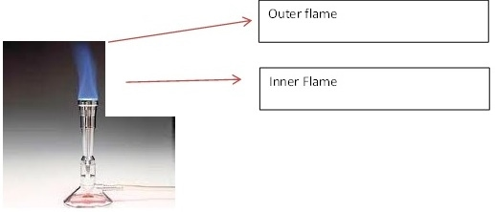
QUESTIONS
1.What happens when air is passed over alkaline pyrogallol.
2.State the constituents of Air and their percentage composition.
3.Describe the types of flames you know.
4.Describe an experiment to determine the composition of Air.

