SEED DORMANCY IN PLANT PHYSIOLOGY
Seed dormancy is a crucial adaptive mechanism in plants, which ensures that seeds do not germinate under unfavorable conditions. It is a state of metabolic inactivity or reduced metabolic activity that prevents premature germination, even when external conditions (e.g., moisture, temperature) might seem suitable. This strategy helps the seed to wait for optimal environmental conditions to ensure successful germination and seedling establishment. Dormancy plays a pivotal role in the survival and reproduction of plants across diverse environments.
Definition of Seed Dormancy
Seed dormancy is the inability of a seed to germinate, even when provided with favorable conditions like moisture, light, temperature, and oxygen. This state can occur due to various physical, physiological, or biochemical barriers within the seed. Seed dormancy is a survival strategy that allows seeds to wait for the best environmental conditions for germination, ensuring the young plant has the highest chances of survival.
Seed dormancy can also be defined as the state or a condition in which seeds are prevented from germinating even under the favourable environmental conditions for germination including, temperature, water, light, gas, seed coats, and other mechanical restrictions.
The main reason behind these conditions is that they require a period of rest before being capable of germination. These conditions may vary from days to months and even years. These conditions are the combination of light, water, heat, gases, seed coats and hormone structures.

Reasons or Causes of the Seed Dormancy
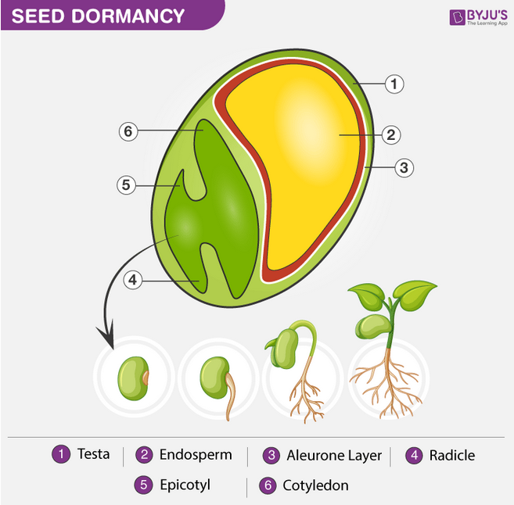

There are certain major causes for the seed dormancy. Listed below are the few reasons for the seed dormancy.
- Light
- Temperature
- Hard Seed Coat
- Period after ripening
- Germination inhibitors
- Immaturity of the seed embryo
- Impermeability of seed coat to water
- Impermeability of seed coat to oxygen
- Mechanically resistant seed coat
- Presence of high concentrate solutes
Types of Seed Dormancy
Seed dormancy can be classified into two major types:
- Primary Dormancy: Seeds are born dormant. It is present as soon as the seed is formed after fertilization and dispersal. This is common in many species of plants.
- Secondary Dormancy: Seeds that are not initially dormant enter dormancy during storage or under certain environmental conditions after dispersal.
Additionally, dormancy can be categorized into the following types based on its causes:
a. Physical Dormancy (Exogenous Dormancy)
This type of dormancy is caused by an external barrier, often the seed coat. The seed coat may be impermeable to water or gases, preventing the embryo from activating the germination process.
- Water impermeability: Many seeds have a hard, waxy seed coat that prevents water from entering the seed, which is necessary for germination.
- Mechanical resistance: Some seeds have hard coats that prevent the embryo from expanding. In some cases, external mechanical factors (like fire or digestion by animals) are required to break the seed coat for germination to occur.
- Seed coat thickness: A thick seed coat can prevent oxygen and water from entering, creating a physical barrier to germination.
Example:
- Legumes (e.g., peas and beans): These seeds often have a thick, tough seed coat that must be broken down through scarification (either by natural processes like fire or digestion by animals or artificial methods like sandpapering).
b. Physiological Dormancy (Endogenous Dormancy)
In physiological dormancy, the seed’s internal physiological mechanisms prevent germination, even in favorable environmental conditions. This type of dormancy can occur due to chemical inhibitors or hormonal imbalances within the seed that stop germination from taking place.
- Hormonal regulation: Hormones like abscisic acid (ABA) can inhibit seed germination by suppressing the growth of the embryo. ABA levels are usually high during dormancy, preventing premature germination. On the other hand, gibberellins (GA) are hormones that promote germination. The balance between ABA and GA determines whether a seed will remain dormant or start to germinate.
- Inhibitory substances: Some seeds produce chemicals that inhibit germination. For example, phenolic compounds and other growth inhibitors can prevent the seed from sprouting until they break down under specific conditions.
Example:
- Apple seeds: These seeds exhibit physiological dormancy, with a high concentration of ABA inhibiting germination. Over time, a cold period (stratification) can break this dormancy.
c. Morphological Dormancy
Morphological dormancy occurs when the seed is not fully developed at the time of dispersal, preventing immediate germination. The embryo is immature or underdeveloped and must undergo further growth and development before germination is possible.
- Immature embryo: In some species, the embryo is too small or undeveloped at the time of dispersal, and it requires additional time or specific conditions to mature before germination can occur.
Example:
- Tobacco seeds: They may exhibit morphological dormancy, as the embryo is not fully developed at dispersal and requires specific environmental cues to grow before germination.
Mechanisms of Breaking Seed Dormancy
Breaking seed dormancy is a complex process that often involves a combination of environmental factors, biochemical changes, and sometimes physical processes. The process of breaking dormancy is called after-ripening, and it can occur through several mechanisms:
a. Stratification (Cold Treatment)
Cold stratification is the process of exposing seeds to cold, moist conditions for a period of time to break dormancy. This is commonly required for seeds with physiological dormancy, particularly in temperate plants that need a cold winter period before they can germinate.
- Cold temperatures can either degrade inhibitors (such as ABA) or promote the synthesis of activators (like GA).
Example:
- Trees like maples and oaks: These seeds require a period of cold stratification to break dormancy and promote germination.
b. Scarification (Mechanical or Chemical)
Scarification is the process of physically or chemically breaking the seed coat to allow water and gases to reach the embryo.
- Mechanical scarification: This involves abrading the seed coat using sandpaper or a mechanical device.
- Chemical scarification: Seeds are soaked in acid or other chemicals to weaken or break the seed coat.
Example:
- Morning glory seeds: They require scarification (e.g., soaking in hot water or acid) to break the hard seed coat and initiate germination.
c. Light and Temperature Cues
Some seeds require exposure to specific light conditions (e.g., red or far-red light) or temperature fluctuations (e.g., a period of cold followed by warmth) to break dormancy.
- Photodormancy: Seeds require light to germinate. For some species, light serves as a signal that the environmental conditions are suitable for germination.
Example:
- Lettuce seeds: They require light for germination. If buried too deeply, they will not germinate due to the lack of light.
d. Fire (Smoke and Heat)
In some plants, especially in fire-prone ecosystems, seeds are adapted to germinate only after exposure to heat, smoke, or chemicals released by fire. These cues signal that the fire has cleared the land and that there is less competition for resources.
- Smoke: Some species’ seeds need chemical compounds found in smoke, like karrikins, to trigger germination.
Example:
- Eucalyptus and Banksia species: Seeds of these plants germinate after fire or exposure to smoke, ensuring that they grow in a nutrient-rich, low-competition environment.
Ecological Significance of Seed Dormancy
Seed dormancy is a crucial survival strategy that helps plants optimize their reproductive success by:
- Timing germination to favorable conditions: By maintaining dormancy, seeds avoid germination during adverse environmental conditions such as drought, frost, or excessive heat.
- Reducing seed predation: Dormancy can prevent seeds from germinating during times when predators (e.g., herbivores or insects) are more active, offering seeds a longer time to survive and wait for more favorable conditions.
- Avoiding competition: Seeds that remain dormant during harsh periods can germinate when competition from other plants is lower.
- Enhancing long-distance dispersal: Dormant seeds can remain viable in the soil for extended periods, which is especially useful for plants that rely on seed dispersal by wind, water, or animals.
Practical Implications of Seed Dormancy
Understanding seed dormancy has important agricultural and horticultural applications:
- Seed storage: Dormancy mechanisms need to be understood to optimize seed storage conditions for different plant species.
- Germination control: For crop production and horticulture, knowledge of how to break dormancy is essential for controlling germination timing, ensuring optimal planting schedules.
- Conservation: Dormancy plays a role in seed banks, where seeds are stored for future restoration projects or conservation efforts.

Conclusion
Seed dormancy is a fascinating physiological and ecological adaptation that enables plants to survive in environments where conditions are unpredictable or hostile. By delaying germination until the conditions are optimal, seeds maximize the chances of successful germination and seedling establishment. The complex interplay of physical, physiological, and ecological factors involved in dormancy ensures that seedling plants grow in the best possible environment, which is key to their survival and continued reproduction.
References
Baskin, C. C., & Baskin, J. M. (2014).
Seed Ecology, Biogeography, and Evolution of Dormancy and Germination.
Academic Press.
Bewley, J. D., Bradford, K. J., Hilhorst, H. W. M., & Nonogaki, H. (2013). Seed Biology: Physiology and Development of Seed Germination.
Springer.
Corbineau, F., & Côme, D. (2003). Seed Dormancy and Germination: Methods and Protocols.
Humana Press.
Finch-Savage, W. E., & Leubner-Metzger, G. (2006). Seed Dormancy and the Control of Germination.
New Phytologist, 171(3), 501–523.
Vleugels, T., & Oosterhuis, E. (2021). The Role of Hormones in Seed Dormancy and Germination. Journal of Plant Physiology, 258, 153328.
Shinozaki, K., & Yamaguchi-Shinozaki, K. (2007). Molecular Responses to Drought and Cold Stress. Current Opinion in Plant Biology, 10(3), 230–238.

